**Manual for PATMOS_MIDOM:**

Contents

**Introduction:** 3

**For help in using this manual here are various topics and where to find their discussion:** 12

**Video measurement recommendations:** 14

**ProjectMain.xlsx setup and structure:** 18

**A list of all components of ProjectMain.xlsx:** 18

**Camera Calibration:** 25

**PATMOS calibration procedures with ProjectMain.xlsx**. 26

**The Fiducial Object:** 28

**Installing Virtual Box and my Ubuntu build containing ORB_SLAM2 and PATMOS_MIDOM** 29

**ORB_SLAM2:** 33

**My modifications of ORB_SLAM2:** 34

**Installation of ORB_SLAM2:** 34

**An example of installing Ubuntu on VirtualBox and building ORB_SLAM2 and PATMOS_MIDOM dependencies** 35

**Starting ORB_SLAM2 with PATMOS and ProjectMain.xlsx:** 38

**Step by step instructions:** 38

**Converting camera metadata file into an H5 file.** 38

**Starting ORB_SLAM2 with Linux terminal:** 39

**Example of a yaml file:** 39

**Linux terminal command:** 40

**PATMOS_ORB_SLAM2 operating details:** 41

**Controls for the point cloud viewer on ORB_SLAM2—My version.** 42

**An Illustrated example for PATMOS running ORB_SLAM2** 43

**Preliminary set up with ProjectMain.xlsx** 43

**Working with the Yaml page:** 45

**Starting the program.** 47

**Co-visibility:** 50

**Map errors and problems:** 52

**This is an illustration of a quality and correct map suitable for tracking:** 58

**Tips for avoiding map errors**. 59

**Collecting the metadata for the camera:** 61

**Going from metadata to h5** 61

**From ORB_SLAM2 to analysis preparation:** 62

**Converting the text output from ORB_SLAM2 into an H5 file, and further manipulations of the file:** 62

**PATMOS and MIDOM analysis program:** 63

**Installing the python analysis program PATMOS and MIDOM:** 65

**Making the executable:** 68

**Running the premade executable:** 68

**Keyboard key reference:** 69

**Hand Tracking workflow for tracking insects or other animals:** 69

**An example of hand tracking workflow for tracking insects or other objects:** 72

**Measuring the fiducial object:** 79

**Mirroring:** 80

**Computing the paths**: 81

**Importing a Fiducial Marker from another project:** 81

**Measuring and using a subframe delay offset for improved accuracy:** 81

**Measuring the minimum error limit of the camera measurements in reference to the map:** 82

**Getting the surface of water:** 83

**Directions using MeshLab:** 83

**Discussion of mirroring:** 86

**Fitting an SLT to point cloud data:** 89

**Plotting and analyzing the data:** 93

**The PlottingSheet parameters and explanations are listed as follows:** 93

**The KinematicsGraph parameters and explanations are listed as follows:** 100

**Assigning and analysis of Kinematic variable for visualization:** 103

**Examples:** 113

**Importing and visualizing Paths in Blender:** 119

**Overlaying paths on video feed:** 122

**Other functionality available to the insect tracking part of the program:** 123

**Hand tracking for GoPro measurements of Squid:** 124

**Image compilations excel file for MIDOM:** 125

**Hand tracking for 3D overlays of squid, cuttlefish, and fish for MIDOM:** 125

**Extracting data from the Polarization H5 files for MIDOM:** 131

**IMU data only:** 131

**Description of keys used in the program:** 132

**The H5 data structure:** 136

**Organization of Squid_excel.h5 for MIDOM** 139

**Organization of the H5 file used in GoPro-VSLAM tracking for PATMOS** 142

**OBR_SLAM2 output h5 file for PATMOS:** 146

**Glossary:** 147

# **Introduction:**

This program collection is designed to track animals with two hand held GoPro cameras using VSLAM software and for mapping two-dimensional data onto a three-dimensional mesh or surface. These two subprograms are called PATMOS (Paths and Tessellated Meshed from ORB_SLAM2) and MIDOM (Mapping Image Data on Meshes). VSLAM is an exciting computer vision tool that will simultaneously make a point cloud map of the environment and measure the positions and orientations of the camera in that virtual environment. The goal of my program, PATMOS, is to use VSLAM to find the positions of the cameras within an environment and then triangulate the three-dimensional positions of objects viewed simultaneously by both cameras. There are several opensource VSLAM programs available to the public. I have chosen to use ORB_SLAM2 because of its versatility, and its emphases on accurate camera tracking. I have modified ORB_SLAM2 to obtain the data for triangulation and I have written a program to manually track objects with this data.

The python-based program PATMOS (Paths And Tessellated Meshes from ORB_SLAM2) uses an open-source VSLAM program called ORB_SLAM2 (Mur-Artal et al.,2015) to make a map of the environment and measure the positions of the camera in that environment. ORB_SLAM2 creates semi-dense 3D maps using a within textural feature-based SLAM system that simultaneously maps and localizes the camera systems using only visual information from the camera. Mur-Artal reports that the position error of the camera is accurate to the order of 1.0 cm in small room-sized environments (Mur-Artal et al.,2015).

I use ORB_SLAM2 as the engine for map-making but I have modified how the program is used to make it suitable for 3D object tracking. I have created the program PATMOS (https://github.com/scorpionjeger/PATMOS) to control ORB_SLAM2, to create tracked paths, and analyze and visualize the data. The user interfaces with PATMOS through a control excel sheet where all the details of the camera calibration, fiducial object, video file names are stored, and program instructions are stored. I have modified ORB_SLAM2 (<https://github.com/scorpionjeger/PATMOS_ORB_SLAM2>) to directly import MP4 files using the open-source computer vision software, OpenCV. While traditional ORB_SLAM2 only uses one independent monocular or fixed stereo camera system, this new code enables the user to employ two cameras with the ability to alternate between cameras while using the same virtual map inside of ORB_SLAM2. Furthermore, PATMOS enables the user with the capacity to pause, reverse, adjust the speed, and manually save the three-dimensional map. Finally, to enable three-dimensional triangulation, PATMOS extracts the camera position, orientation, and all the map points within the frame with their associated pixel value. I also give details on how to use ORB_SLAM2 to enable PATMOS with the ability to track objects. This is non-trivial because ORB_SLAM2 comes with very little structure or documentation for any specific use.

This tracking method relies on the user making a good 3D map of the environment based on how they film the environment and post-process the video material. Fortunately, the vast amount of information contained within a video and the algorithms of ORB_SLAM2 does most of the work for the user. There is however some amount of skill and intuition needed for filming and creating the map to accurately track objects in the environment. This map-making process is not a calibration procedure but is similar, in analogy, to building a physical scaffolding around an environment that can measure the precise locations of movable cameras at all times and physically measuring the locations of thousands of environmental points of the environment. The map is this collection of 3D points, also called a point cloud, that is associated with pixel values from the camera. ORB_SLAM2 uses this map to calculate the position of the camera in the environment. I will outline the necessary conceptual principles that are needed to create the map in this section and all the operational details can be found in the manual associated with PATMOS.

Not all environments are suitable for PATMOS and there are many considerations to be made when choosing an environment to use PATMOS to track moving objects. The objects that are to be measured need to be visible by both cameras. This may seem like a basic recommendation but this becomes nontrivial when trying to track animals with two handheld cameras. The user will have to evaluate whether the terrain is suitable for being able to control and monitor the cameras to be able to follow the objects (is the user sure the tracked objects are in both cameras, will the user ensure that the camera will not inadvertently be placed in front of a bush, etc). The lighting conditions need to ensure enough contrast to see the object.

The user will have to evaluate if there is enough structure in the environment to create a map. ORB_SLAM2 needs multitudes of different edge types and textures in the environment to uniquely identify points to create a map. Most outdoor structures, even a patchy cut lawn, will have enough structure for a map. The sky, the sky reflected from a pond, or a field of freshly fallen snow is not enough structure to create a map. An indoor area with very little structure (white walls, uniform floors, lack of clutter, etc) will not have enough information to make a good map. This texture diversity needs to be in the same area where the objects will be filmed. Trees or mountains in the distance will not provide accurate points for the map, because the scale of the camera movement will be very small for ORB_SLAM2 to notice textural differences in faraway objects.

The map point and pixel correspondence enable the calculation of the virtual 3D camera placement within the virtual world of the map so that the perspective of the camera will view the map points as pixels in its image. The computer vision technique called Perspective from n Points (PnP) selects a camera position that best fits the perspective of the 3D object the image is portraying (Bradski and Kaehler,2008). This is similar to face detection technology. ORB_SLAM2 uses hundreds to thousands of points to determine the camera positions. Having a small portion of leaves blowing in the background or light ripples underwater will not affect the PnP measurements. ORB_SLAM2 also weeds out unstable points when possible. But if the whole field of view has swaying plant matter then ORB_SLAM2 will either not be able to map and track the environment or, if it does, the process will be significantly error-prone. These errors will be obvious in the map-making process as the virtual camera position will be very unstable. Also, the user should avoid letting objects that take up a significant portion of the field of view, such as a tree branch, suddenly come between the camera and the subject matter.

The maps that ORB_SLAM2 produces do not have an associated scale with them. The dimensions of the map are arbitrarily made by ORB_SLAM2 and these dimensions will need to be calibrated to the real world with a fiducial object. The user will have to construct and physically measure a fiducial object to calibrate the scale within the map. The fiducial object should be large enough to be seen in the measurement arena. It should have distinguishable points in all three dimensions and those points should be measured from the origin and should be in a standard cartesian coordinate system. The fiducial objects used in this study have been boxes, both plastic and cardboard, with dimensions 30.4 X 27.5 X 30.8 cm and 16 X 8.8 X 8.8 cm.

PATMOS uses a Direct Linear Transform (DLT) to perform the spatial calibration for the map. This is, however, much different than former DLT camera calibrations of fixed camera tracking setups as in Hedrick (2008). Traditional DLT for camera calibration uses a PnP procedure (described above) to obtain the perspective of the camera from points selected from a fiducial object. This DLT calibration is only accurate within the volume of the fiducial points used to calibrate the camera system. PATMOS measures the points from the fiducial object the same manner it tracks paths, and thus collects 3D distributions of the fiducial points. The DLT is found by fitting a scaled rotation matrix plus a translation vector or

$$mR\left(θ_{x},θ_{y},θ_{z}\right)+T(x,y,z)$$

between the PATMOS measured points and the points measured directly from the fiducial object. Thus, PATMOS calibrates the map and not the PnP pose from the fiducial object. Problems with the PnP calculation from the fiducial object are circumvented. ORB_SLAM2 is providing the PnP camera position over the entire map, which is sometimes over 1000 points. The map volume then serves as the calibration volume in PATMOS as the DLT fiducial object does in earlier fixed camera works.

The user will have to calibrate the cameras with a standard camera calibration method to remove lens distortion that uses a 9 x 6 checkerboard filmed at several different orientations (Bradski and Kaehler,2008; see also Supplemental materials). PATMOS can perform this calibration which will need to be made for every different field of view (narrow, wide, etc) or image size setting of the camera that is to be used. In my experience, the same settings across GoPro’s of the same make have functionally similar calibration values. Both cameras should be set to the same settings. The cameras in this study were (GoPro Hero 5) were set to 240 fps at 720p with a narrow field of view setting.

Triangulation requires that the cameras be synched in time. Electronic synchronization is difficult and impractical using conventional cameras because they have unalterable and unreachable independent timing circuits. Recently, however, compact high frame rate, high-resolution cameras have become commercially available making visual or audible synchronization pragmatic with low timing errors as in (Jackson 2016). The cameras used in this work (GoPro Hero 5) have a framerate of 240 frames per second (fps) which, when visually synced, gives a maximum timing error of 2.0 ms or half a frame. A fast and definite visual signal is required to time sync the cameras. A fast snap is fast enough to be distinguishable at 240 fps. The user will be looking for a similar position in the snap in the analysis. I hold the cameras together and snap in front of both cameras. There are of course numerous ways this could be accomplished, a film clapper for instance, but a finger snap has proved most convenient for fieldwork.

The video measurement needs a map scan segment, an object tracking segment, a time syncing segment, a fiducial object measurement segment, and smooth transitions between these segments. All of these segments are needed for a complete measurement. The entire measurement can be broken up in time over multiple video files. The time difference between video files can be any length if the video files start in the same position where the map segment was created and the environment remains very similar during the measurements. Each coincident video file grouping needs to be time synced. Setting cameras in fixed locations can be risky with this method because ORB_SLAM2 usually requires some movement in the video to fix the video onto the map. Therefore, in addition to having each video file segment with a time synching segment, I also recommend a mini environmental scan. The order of these segments can be strategic. The environment can be mapped out first and then the user can track objects. Or if a rare animal movement event happens with enough time to be filmed with two cameras, the behavior can be measured first, then the cameras can be brought together and time synced with a snap, and then the environment can be scanned.

The recommended scan pattern to create a map of an environment is to use a series of inward-facing radial scans. To illustrate, a virtual string should be tied to the camera from the middle of the environment to the camera and the user scans radially from a similar radius. It is recommended that the user not only make horizontal scans with this method but also vertical scans. Conversely, outward radial scans from the camera's position cannot produce a map. The reason for this is similar to the theory behind triangulation. Just as in fixed two camera tracking systems the cameras have to be facing the same subject matter to create a triangulated solution. The same is true with consecutive frames of the camera tracking in VSLAM. The scan does not need to take long, usually less than 30 seconds. The scanning arc does not need to be large. The larger the arc the more detail and accuracy the map will pick up. This method does not need to be exact. The arc should intersect approximately where the user will make their tracking measurements. During the map-making portion of the measurement, both cameras should be held together as closely as possible.

There needs to be a smooth transition from the area where the map scan was made and the area where the objects will be tracked with the cameras still facing the center of the environment. Once that transition is made the cameras can be separated. The cameras can be held by one person at arm’s length or they can be separated between two people to get a larger angle for measurement. The travel to those new spots should be through the same area where the map scan was made and still facing inward toward the environment.

When the cameras are in place for the object tracking phase, the user can make outward radial turns of the camera to follow the subject matter and the user can move around to follow the animals within reason. The user should avoid the temptation to follow an animal outside the map range or else the map will fail. For example, if the user is filming dragonflies around a pond and they begin to chase each other far outside the pond up into the canopy of the trees, avoid following the dragonflies up into the tree if the user has not made a map or scan of that area. If the user does make such a measurement the user should make sure to bring the camera back to the same space to continue recording. Additionally, moving the camera quickly along a path that changes scale (from a 10.0 m field of view immediately to a 1.0 m field of view, for example) or to a new place in the environment without enough intermediate camera positions to produce good statistics for ORB_SLAM2 will cause problems. This will result in the program losing its ability to track the environment.

The user will have to evaluate the placement of the Fiducial Object so that it will be in the frame for parts of the measurement, and that the user will not require any significant deviation from the mapping scan area for both cameras to measure the fiducial object. And the user should measure the fiducial box with the cameras held apart at a deliberate point in the measurement and in a way that the points of the fiducial box can be seen by both cameras. The fiducial object can be leveled and oriented in a particular direction (e.g the sun) to give more information to the map.

ORB_SLAM2 requires some monitoring during the map-making process. ORB_SLAM2 uses a statistical process to create the map and even if the video starts at the same place the produced maps will always be slightly different. As such the way the user makes the map with ORB_SLAM2 is important. The main principle for monitoring ORB_SLAM2 is ensuring that the map has enough redundant data to get good statistics of the environment. As the map updates, it is constantly evaluating the points it adds to the map, choosing which ones to rescale, which ones to delete until it converges on a robust solution. PATMOS controls ORB_SLAM2 and has implemented ways of changing frames, changing video direction, etc. so that the user can aid in providing the redundancy for the map-making process. The user should let ORB_SLAM2 map the environmental scan with both cameras held together first. Then the user should let ORB_SLAM2 map the object tracking segment by alternating between both cameras. The mapping is finished when the ORB_SLAM2 can localize the map at any position on the tracking measurement.

The user will have to monitor for common mapping errors. One great tool that ORB_SLAM2 gives to help with map errors is that of co-visibility. Map points are co-visible if they are viewed by more than one keyframe. Each map point is associated with at least one keyframe, and a keyframe contains a group of points visible in that frame. Two points are co-visible if the intersection of the sets of all points associated with the keyframes of both points is nonempty. Co-visibility is also a measure of how much points are correlated with each other in ORB_SLAM.

If the camera follows the path in making a long map. The beginning of the map is very distant from the end of the map in terms of co-visibility. This means that there are no redundant checks or correlations within ORB_SLAM2 of the beginning of the environment to the end of the environment. Relative errors accumulate the farther you go from a co-visibility checked region. If this happened to be a circular path, when the camera comes back to the original part of the path, there will be so many accumulated errors in the path that the path will not meet up with the original path in the environment. Thus, for making measurements with this method, the map should be created in a semicircular manner so that all elements are co-visible with each other. ORB_SLAM2 has come up with a way of renormalizing the map if a circular path occurs, but these circular connected paths are not useful for PATMOS tracking. That is why semi-circular paths inward-facing paths are ideal for tracking. When a central point is monitored by the camera in a semicircular orbit then many points remain co-visible. Co-visible points are marked in red in ORB_SLAM2

A map can fail when the camera moves away from the co-visibility of the rest of the map and then comes back to the same area but does not recognize familiar points and starts creating new map points where it should have recognized the other points. This is manifest by double representations of the same object. This is also manifest when the co-visibility indicator (red vs black) is very disproportionate or red and black splotches are mixed where they should be co-visible. When the program struggles to assign new map points to the map the points get clumped up in a dense conical distribution emanating from the camera that has no physical basis in the environment. When the lens calibration of the camera is not calibrated correctly many map features will appear warped such as flat path warped into a wave-like structure. A good map is a map where the points are not changing significantly while they are being updated. Map errors can be remedied by the user loading back a version of the map file that was previously saved and run the program again slower, with different parameters, or avoiding a problematic part of the video entirely. The better the user measures the environment the easier the map-making process will be and the fewer map errors will occur.

With a map created the PATMOS can record the metadata from the camera and map points giving the virtual camera positions, indexed map points, and the time of observation of each frame. PATMOS enables the user to annotate positions of any distinguishable point within the image (parts of an animal or the center of an animal etc.) in both synchronous videos simultaneously. The program aids in object measurement by casting a line (called the epipolar line) on the coincident frame of triangulated point possibilities to the point selected on the other frame (see supplemental Fig 1, Hedrick 2008). This aids in finding the object in the coincident frame, to distinguish between multiple objects, or to qualitatively determine the quality of the camera data used in triangulation. The points on the fiducial object must also be measured this way.

If objects are filmed around a calm pond PATMOS can measure the 3D position of the object in a single camera by measuring the object and reflection of the object in the water. Two cameras are still required to measure the fiducial object, however, unless that fiducial object is also on the water with reflections observable.

When two synchronous points are found on the coincident camera frames PATMOS calculates the 3D point associated with these two values using vector geometry. For this geometrical calculation, PATMOS identifies the ray passing from the camera to infinity through the lens calibrated pixel values as $\vec{J}=\vec{CO}+t\vec{w}$, where $\vec{CO}$ is the camera origin, and $\vec{w}$ is the unit vector pointing out of the camera origin into space associated with the calibrated pixel point. PATMOS finds the points of closest approach, $\vec{{CP}_{1}}$ and $\vec{{CP}_{2}}$, of the two rays associated with the coincident cameras to find the three-dimensional position of the object. PATMOS calculates, from vector geometry, $\vec{{CP}_{1}}=\vec{{CO}_{1}}+c_{1}\vec{w_{1}}$ and $\vec{{CP}_{2}}=\vec{{CO}_{2}}+c_{2}\vec{w_{2}}$, where $c_{1}=\left(\vec{{CO}_{2}}-\vec{{CO}_{1}}\right)∙\vec{n_{2}}/{(\vec{w}}_{1}∙\vec{n_{2}}), c_{2}=\left(\vec{{CO}_{1}}-\vec{{CO}_{2}}\right)∙\vec{n_{1}}/{(\vec{w}}_{2}∙\vec{n_{1}})$, and $\vec{n_{1}}=\vec{w_{1}}×\left(\vec{w_{2}}×\vec{w_{1}}\right)$, and $\vec{n_{2}}=\vec{w_{2}}×\left(\vec{w_{1}}×\vec{w_{2}}\right)$ (see Supplemental Fig 1). The three-dimensional object position is the average of $\vec{{CP}_{1}}$ and $\vec{{CP}_{2}}$.

The resulting paths have a significant amount of noise. To smooth out the tracked paths PATMOS uses a moving average, averaging the path by a user prescribed number of points before and after the central point. PATMOS uses a tapering average as the path approaches an edge or endpoint of the path data. PATMOS also uses splines to fit the data. The data in this paper uses a spline to fit the data. The error for each point uses the moving average point selection to provide an error distribution for the point. The velocity, $\vec{v}$, and acceleration, $\vec{a}$, of the paths are calculated by numerical differentiation in the case of the moving average or by spline differentiation when used with spline fitting. The curvature of a path is given by $ℵ={\left\|\vec{v}×\vec{a}\right\|}/{{\left\|\vec{v}\right\|}^{3}}$ and the radius of curvature is given by $R=1/ℵ$. PATMOS can calculate and plot these values from inputs used in the control excel sheet.

ORB_SLAM2 does not return an error for the map and even if such functionality existed it would likely not be very useful. To get an estimate about what kind of errors we could expect from the tracking process I use the map and camera metadata as collected by PATMOS. Map points that are coincidently observed by both cameras can be identified by the map points’ unique identification numbers. This identification number is stored in the map’s metadata as well as the pixel points associated with those map points for each camera. The 3D point can then be measured by PATMOS using these pixel values over many frames of the video. This will not return the map point value as recorded by ORB_SLAM2, but will record a 3D point just as if a point was tracked in PATMOS. This point is likely to be more accurate than a point that is hand tracked with PATMOS because the error in visually selecting the point is not in play.

A large selection of points can be recorded over the time in which measurements are being made. The standard deviations of these distributions can be investigated as referenced to the average point of the set of both camera positions throughout the measurement. The standard deviations can be mapped as a function of distance from this average position of the camera. The more distant the points are from the camera the error is more likely to be larger which is what is seen (see Supplemental Fig 2c-f). We can break the distributions up into components that are axial to the camera position or that which is perpendicular to the camera and also in the vertical plane. The axial error is likely to be much larger than the vertical error because there is less information to cross-reference in the axial direction. This distribution can be fit to a line and would represent the best-case scenario for error within the map. This further defines the calibration volume of the map from this line. This error will likely be much smaller than the average errors obtained by the path measurements.

A fitted Standard Tessellation Language (STL) surface to an point cloud map enables the quantification of object proximity to the environment. PATMOS can fit an STL mesh such that the resulting surface values are an average of a subset of map points. This algorithm uniformly grids the horizontal plane of the environment and takes the vertical average of all the points within each grid unit. The point cloud map data is prepared for this algorithm in a point cloud manipulation program, such as MeshLab, by cleaning up spurious map points and deleting points or parts of the map that would interfere with the desired vertical average (such as a branch hanging over an environment or reflected virtual map points from the water’s surface). A map transformed with the fiducial transformations will have a horizontal plane perpendicular to gravity and resulting in a natural symmetry for which to take a vertical average. PATMOS organizes the resulting average values into a triangulated surface and save the result as an SLT. S mall holes in the surface are given interpolated values when surrounded by a sufficient number of points.

Water surfaces measured with ORB_SLAM2 often have sharp boundaries with objects intersecting the water and are often chosen as ORB mapping points. These points form a distinct plane that can be fitted to an analytic plane. This water surface plane can be incorporated into the above STL algorithm by setting all voided areas in the map corresponding to the water’s surface to the values of this analytic plane. PATMOS measures the distance between objects and the STL mesh. PATMOS can find the distance between the object and the STL mesh in the z direction or it can find the minimum distance between the STL and the path point using a minimization algorithm.

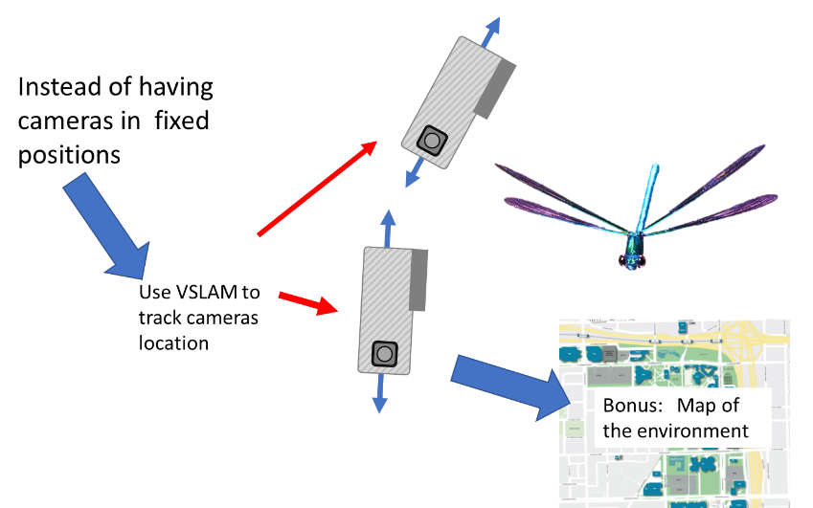

Instead of making a GUI (graphical User Interface) I have made the program interface with an excel spreadsheet. I did this because spreadsheets are a useful way to organize, view, and keep track of scientific data. The spelling and phrasing of certain entries within the spreadsheet need to be exact. In most cases I have the data read from the spreadsheet based on the text in the header information of the sheet. This can alleviate problems of moving data around and making new columns within the spreadsheet. It is possible to alter the program by searching for the phrases within the program. Using the spreadsheet as a type of GUI is accomplished by implementing ways of selecting data, such as putting asterisks next to quantities where indicated to select for data, and by imputing lower case y’s and n’s in certain cells. At this point MIDOM is not as developed as PATMOS so the documentation is not as complete.

## **For help in using this manual here are various topics and where to find their discussion:**

For instructions on how to load an Ubuntu system on VirtualBox see

**Installing Virtual Box and my Ubuntu build containing ORB_SLAM2 and PATMOS_MIDOM**

This takes out a lot of the difficulties of installing ORB_SLAM2 and all the dependencies of PATMOS_MIDOM, and you can run it from your Windows or Mac desktop.

For instructions on how to run the precompiled executable of PATMOS_MIDOM on your Windows desktop see

**Running the premade executable**

Here you do not need to install python or any dependencies, you can just download this folder and run the executable. You will not be able to alter the program using this option though.

ProjectMain.xlsx is the control center of the program and it is important to know how to use this. The best way, in my opinion, is to look at examples of ProjectMain.xlsx (which are included) and modify ProjectMain.xlsx for your purposes.

This section of the Manual:

**ProjectMain.xlsx setup and structure**

is an overview of ProjectMain.xlsx and is best used as a reference.

For step by step instructions for setting up ProjectMain.xlsx for controlling ORB_SLAM2 to map environments with video files on Linux see:

**An Illustrated example for PATMOS running ORB_SLAM2**

Or

**Starting ORB_SLAM2 with PATMOS and ProjectMain.xlsx**

For instructions on how to convert the output of ORB_SLAM2 and PATMOS to data to be used with the PATMOS tracking program

**Converting camera metadata file into an H5 file.** 26

Or

**Going from metadata to h5** 47

For step by step instructions for using ProjectMain.xlsx for the PATMOS_MIDOM analysis program to hand track animals see:

**Hand Tracking workflow for tracking insects or other animals:** 55

Or

**An example of hand tracking workflow for tracking insects or other objects:** 57

I have written an analysis program to visualize the kinematics and paths of the data, and for instructions on how to visualize and output the data go to (This can be done without the video files)

**Plotting and analyzing the data:** 78

# **Video measurement recommendations:**

**Choosing the camera:**

I have done all my measurements with GoPro 5 or 6 cameras, but in theory, any camera should work, keeping in mind a few principles. GoPro type cameras have a fixed zoom and field of view angle. This keeps the camera calibration fixed. If you are using a camera with a zoom on it or a detachable lens then the calibration will change whenever you adjust the camera. In principle, the camera calibration will change when you change the zoom, the field of view, or the resolution. So, these variables should not change during the measurement. I have chosen to use camera video feeds with 240 frames per second. This enables the observer to visually time sync the two camera feeds and to measure fine-scale movements of the objects in question.

Be aware that GoPro cameras later than 6 can film 1080p video at 240 fps, while the GoPro 5 cameras can only film 720p video at 240 fps, but the 1080p video at 240 fps records the video in a newer codec H.265. This codec is not supported by the 14.04 Ubuntu Linux operating systems that I have been able to use ORB_SLAM2 on, so ORB_SLAM2 has not worked for me with that codec. I have been able to convert the video into the old codec with a longer fps (the fps is not important for the analysis) using PATMOS and then use it with ORB_SLAM2. There are a few caveats to this like you lose the first 300 frames of the video. The newer codec can be used for analysis on PATMOS from the data obtained with the converted video, but moving between frames on the video beside the next frame takes a very long time. You can also record the 1080p video as 720p and run it on ORB_SLAM2 so that it does not take up as much computing power, then use that data with the 1080p on PATMOS.

On a new 16.04 Ubuntu system this new codec can work, but I have not tested it extensively.

**Choosing the environment:**

There are many considerations to be made when choosing an environment to use this system to track moving objects. Here is a list of principles that should be followed when considering a suitable measurement environment.

* The objects that are to be measured need to be visible by both cameras.
* The lighting conditions need to be such that there will be enough contrast to see the object
* Will there be obstructions to the object or to the environment you need to map?
* Is there enough structure in the environment to create a map. The sky or the sky reflected from a pond is not enough structure to create a map. An indoor area with very little structure (white walls, uniform floors, lack of clutter, etc) will not have enough information to make a good map.
* Is there a place to put a Fiducial Object to get scale in the map. Will it be physically possible to film the Fiducial Object in the same manner that you are filming the objects?
* Are you filming in an environment that you can pay attention to whether or not both cameras are facing the target objects or do you have enough room to coordinate with another person to use the other camera to help track objects?

**Choosing the mapping path:**

There are specific requirements for mapping an environment with cameras and how the cameras should be used while the measurements take place. Two different camera frames can only produce a three-dimensional solution in ORB_SLAM2 when both camera frames view the same set of feature points from different perspectives with enough displacement of the camera origin to provide a nontrivial solution to the fundamental matrix calculation of ORB_SLAM2. A radial turn of the camera about its origin cannot solve the fundamental matrix. Semicircular movements around an environment with the camera facing inward are the best camera measurements for ORB_SLAM2. ORB_SLAM2 can accumulate localization drift errors as the camera moves visually farther away from the areas that are not co-visible, where co-visibility is the property of map points being visible in more than one keyframe. Keeping the measurements in a semicircular pattern around an open environment will result in a map with a high degree of co-visibility. Radial movements of the camera are not good for map-making but once sufficient information is gathered for the map an animal can be followed within the mapped area with radial camera movements.



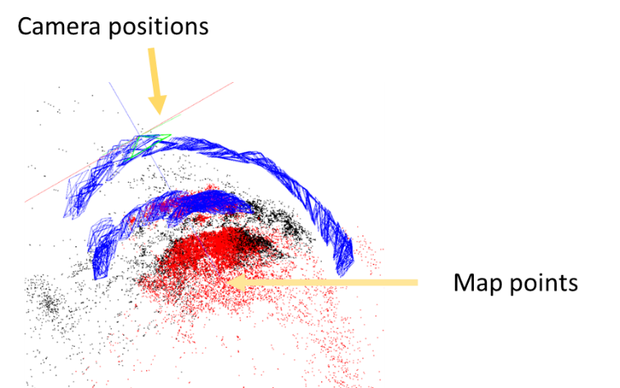

**Figure:** In this figure, the cameras in blue represented by triangles with the base of the triangle facing where the camera is facing and the red and black dots are the map of the environment. The semicircular path of the cameras is ideal for measuring the environment.

Additionally, moving the camera quickly along a path that changes scale (Say from a 10.0 m field of view immediately to a 1.0 m field of view) or to a new place in the environment without enough intermediate camera positions to produce good statistics for ORB_SLAM2 will cause problems. This will result in the program losing its ability to track the environment. Or cause distinctive errors in the map-making process such as dense unphysical clusters of points emanating from the camera origin or double features in the map. Some tracking errors will be subtle and will have to be monitored by tracking fixed points in the environment, such as a fiducial marker point. The program will point out to the user the degree of co-visibility of the map by marking all co-visible points in red and non-co-visible points in black. As a suggestion, the user should begin from a distance such that the entire area of interest is scanned within a semicircular movement, then move closer to the environment in later frames.

The cameras should not pan over featureless environments, such as a clean surface of water or the sky. ORB_SLAM2 needs unique points to be able to track the camera. Having a small portion of leaves blowing in the background or waves or light ripples underwater will not affect the measurements. ORB_SLAM2 weeds out unstable points, and in natural environments, there is a multitude of stable points to for the program to choose from. But if the whole field of view has swaying plant matter then ORB_SLAM2 will either not be able to map and track the environment, or if it does the process will be significantly error-prone. These errors will be obvious in the analysis as the camera position with not be stable. The user should avoid letting large objects, such as bushes or large trees, come between the camera and the subject matter.

Other principles for good map-making:

1. put the fiducial object in the measurement area. The fiducial object does not need to be in the camera frame the whole time but it should often appear in the camera frames. Choose the fiducial object so that it can be placed level to the gravitational horizontal, be three dimensional, and have highly visible measurement markers.
2. hold two cameras together and start the cameras synchronously.
3. to provide a simultaneous visual cue to both cameras for timing synchronization: snap with fingers in front of both cameras. Repeat the same step at the end of the recording.
4. Hold the GoPros together and scan the environment (~30 sec) perpendicular (in both *x* and *y*) to the field of view, with the area of interest remaining in the frame. 5) separate the cameras at arm’s length to view the target environment with the cameras both pointing toward the environment (See fig 1a) or hand the camera to another person. The triangulating tracking algorithm will give the most accurate results if the cameras are facing the environment at a 90° angle from each other. When two people hold their camera the measurement angle can get close to 90° taking advantage of the lower measurement error and each person will be able to pay better attention to where their camera is facing. However, coordinating the movements of the two cameras to focus on the same animal will be more challenging. Using one person to film with both cameras has the advantage of doing the measurement alone and has a greater measurement volume. This method suffers from slightly less accuracy and it is more challenging for the single user to keep track where each camera is pointing. Overall this system gives the versatility to follow the animal around the environment through panning and small movements.

# **ProjectMain.xlsx setup and structure:**

ProjectMain.xlsx is a spreadsheet containing all the input parameters for the PATMOS and MIDOM programs. This worksheet is separated into various sub-sheets with different functions. PATMOS and MIDOM have three main functions: Running ORB_SLAM2 from ProjectMain.xlsx, Tracking objects in three dimensions with GoPros, and mapping 2D polarization information onto 3D virtual meshes. PATMOS and MIDOM run exclusively from the contents of **ProjectMain.xlsx**. Named projects within ProjectMain.xlsx are selected using a “**\***” symbol in columns labeled “**ToUse**.” The lists below describe in detail the contents of PATMOS and MIDOM, and representative examples of the use of ProjectMain.xlsx will be listed in subsequent sections. **If you work on ProjectMain.xlsx in Libre Office make sure you save ProjectMain.xlsx in the default Microsoft excel file format and not the Libre Office file format.**

## **A list of all components of ProjectMain.xlsx:**

* **Main**
  + **ProjectWorkbook ---** This list four analysis choices for running PATMOS and MIDOM.
    - **DualGoPros ---** This analyzes data for projects tracking objects with two GoPro cameras.
    - **ImageCompilations ---** This analyzes data from images of polarization video and fits STL meshes with the images. For use with MIDOM
    - **SingleVideos ---** This takes polarization videos and saves and records images from said videos to be analyzed with ImageCompilations.
    - **ORB_projects ---** This is an interface to ORB_SLAM2. This can run ORB_SLAM2 from PATMOS and MIDOM and utilize the excel sheet for file organization.
  + **ToUse ---** the program will use the selected ProjectWorkbook when an “*” is marked to the right.
* **DualGoPro**
  + **Name** --- This is a name for the project.
  + **ToUse ---** the program will use the selected DualGoPro name when an **“*”** is marked to the right of the name.
  + **Path** --- Place the name of the path group from the path worksheet in this column.
  + **FileName** and **FileName2** --- are the names of two cameras used for triangulation
  + **Time_delay** --- is the time delay in frames of the two cameras. Which is the frame number of FileName minus the frame number of FileName2.
  + **Subframe_delay ---**  This is a subframe or between frame delay that give more accuracy for the measurement. The default is 0.
  + **output_file** --- is the output file for the program. It is an H5 file that will contain the tracked points and the calculated paths.
  + **ORB_Name** --- is the name that links to the corresponding ORB page that contains more information for the program, such as the camera metadata files.
  + **Initial_Frame_to_Start** --- This is the frame that PATMOS will open the video file to in the initial part of the program.
  + **Fiducial_Box** --- is the name of the box that will be used as a fiducial marker. This links the program to a list of points in 3D that can be marked in the video feed to give the project a physical scale.
  + **Fiducial_Box_Information_from_Other_Project ---** This lists which project the Fiducial box is taken from.
  + **STLfile** --- This is the STL of the background made from the point cloud.
  + **Water_Surface_Plane ---** These are the parameters for the plane defining the water’s surface if such a surface has been measured. It is comma-separated.
  + **SquidVideo ---**
  + **Description ---** These entries are general notes about the measurement.
  + **PointsONObjects ---**
* **Paths**
  + **Name ---** this is the reference name for the path group.
  + **Paths_to_videos ---**  This is the path to the videos used in the project.
  + **Paths_to_H5 ---** This is the path to where the H5 files are stored.
  + **Paths_to_ImageFolder ---**  This is the path to folders containing images files that are used in image analysis.
  + **Path to ORB_SLAM2 ---** This path is used when PATMOS is controlling ORB_SLAM2 in Linux. It is the path to the ORB_SLAM2 folder
  + **Path to ORB_SLAM2 output ---** This is the path for the output of ORB_SLAM2 in Linux.
* **ORB_projects**
  + **Name** --- this is the name of the **ORB_project** that is referred to in the **DualGoPro** page.
  + **ToUse** --- the program will use the selected **ORB_projects** name when an **“*”** is marked to the right of the name.
  + **path** --- Place the name of the path group from the path worksheet in this column.
  + **link_to_video** --- This is the name for the corresponding video project in the DualGoPro page in ProjectMain.xlsx.
  + **Map_metadata_name1** --- This is the H5 file for the ORB_SLAM2 metadata for camera1
  + **Map_metadata_name2** --- This is the H5 file for the ORB_SLAM2 metadata for camera2
  + **MakeYaml ---** When the name of a yaml project in the yaml worksheet. (yaml is a type of file used in python for data input)
  + **MakeH5 --- “y”** or “**n**”. If “**y**” is inputted here then the project will not run ORB_SLAM2 but will convert the metadata output files inputted in **Map_metadata_name1** and **Map_metadata_name2** to h5 files to be read with PATMOS. This only records the camera information, not the metadata for the map points. To read the map metadata you will need to go to the additional python files. See “**Converting the text output from ORB_SLAM2 into an H5 file, and further manipulations of the file**” for more information.
  + **Use_Map_File_for_ORB_SLAM2 --- “y”** or “**n**”. This indicates whether ORB_SLAM2 will load and use a map.
  + **ORB_pointcloud_output ---** This saves a “space delineated list” of the map points in the program.
  + **Map_In ---** This is the map file name to be inputted into ORB_SLAM2
  + **Map_Out ---** This is what the program will save the map file as. If this is blank the program will save over the **Map_In** file.
  + **Starting_frame ---** This is the frame ORB_SLAM2 will start on.
  + **Camera1_metadata ---**This is the name of the file ORB_SLAM2 will save the camera1 metadata as.
  + **Camera2_metadata ---** This is the name of the file ORB_SLAM2 will save the camera2 metadata as.
  + **Map_pointcloud_name** --- this is a file with a list of map points that are saved from ORB_SLAM2
  + **Map_used** --- this is the name of the map file in used in ORB_SLAM2
  + **Map_info_h5** --- this is the metadata for the video feed in ORB_SLAM2. It saves the map data for each video frame, along with other characteristics of the map data.
  + **secondary_Map_pointcloud_name ---** If another point cloud is associated with the project.
  + **Secondary_Map_info ---**  If another metadata file is used with the map analysis.
* **PlottingSheet**
  + **Plotting Sheet Header:**
    - **The top entry** is the current project name—for example tom_322_jill_265
    - **The type of plot ---** Place a **“*”** to the right of the **“3D”** or “**kinematic plots**” to choose which type of plot to view. They can be selected simultaneously.
    - **Output path ---** Place the **output path** to the folder you wish to store the output in this cell Make sure that the folder delineation slashes are forward (“/”) and that the folder exists.
    - **Save images** --- To **save the plotted images** to the folder put a “y” in this cell
    - **Save file name** --- The name of the saved images are derived from this name.
    - **Path of STL to display** --- This is the path to **the STL to display** in the 3D plot
    - **Display STL in 3D plot** --- “y” will **plot the STL**
    - **3D plot viewpoint** --- This is the viewing position for the 3D graph, which consists of two numbers separated by a comma (you may need to format the cell as text). The first number is a rotation around the y-axis, the second number is a rotation around the x-axis
    - **Output CVS ---** To **output the data** in an **excel file** choose **“y”** Or **“full”** here. **“y”** will list **only** the data plotted in **the kinematic plot. “full” will list all of the kinematic data for the insect numbers selected**
    - **Output CVS for Meshlab** --- This will make **a “space” separated list** of all points in the 3D plot, with associated colors that can then be imported into Meshlab or Blender.
    - **Output CVS name** --- This is **the name** for which these CSV file names will be derived from.
    - **Number of simultaneous insects** --- is the type of plot that simultaneously calculates insect paths.
    - **Point of reference** --- This is a **point of reference** that kinematic calculations can be made from the difference of the paths to the reference point. The reference points is an **x,y,z point** separated by commas
    - **Color gradient distinguishing multiple paths** ---This is a Color gradient to distinguish multiple paths. Putting a matplotlib gradient here will divide up the colors within that gradient based on the insect number.
    - **Path color gradient ---**  This enables a 3D plot to color coordinate various quantities. The program calculates the max and min of this value along the path and plots a **rainbow color gradient** with warm colors being high and color colors being low.
    - **Mark Coincident Points With Lines ---**  This connects coincident points with lines, use y or n. Putting a “y” in this cell will **join coincident points** between two paths.
    - **Coincident lines color gradient** --- This enables a 3D plot to color coordinate the joining coincident lines. The program calculates the max and min of this value along the path and plots a **rainbow color gradient** with warm colors being high and color colors being low.
    - **Kinematics Graph Reference ---** This is the name of the sheet used for the Kinematic Graph parameters.
  + **Operation header**
    - **ToUse** --- the program will use the selected paths when an **“*”** is marked in this column.
    - **object numbers 1---** The object numbers are the numbers of the object within the program. There can be any number of simultaneous object numbers if done in the format “object numbers #” all spelled correctly and no extra spaces.
    - **object numbers 2 ---**  same as “object numbers 1”. One can plot multiple object numbers in different columns with sequential integer label numbers.
    - **object label 1 ---** A short label for graphs.
    - **object label 2 ---** same as “object label 1”. One can plot multiple object labels in different columns with sequential integer label numbers.
    - **group---** here you can group your object numbers
    - **colors 1 ---** colors for each object number. They can be in a tuple format eg…0,0,1 they must be inputted as three numbers separated by commas, with no bounding parenthesize. or matplotlib gradients (rainbow, jet, etc. ) and then a “,” and then a number between 0 and 1.
    - **colors 2 --- ---** colors for each object number. They can be in a tuple format eg…0,0,1 they must be inputted as three numbers separated by commas, with no bounding parenthesize. or matplotlib gradients (rainbow, jet, etc. ) and then a “,” and then a number between 0 and 1.
    - **Size 1 ---** The size of the marker in the 3D plot
    - **Size 2 ---** The size of the marker in the 3D plot
    - **Start frame ---** start frame of the path you wish to measure (measured from camera 1)
    - **End frame---** end frame of the path you wish to measure (measured from camera 1)
    - **From another project ---** if you have paths from another project that share the same map place the name of the project here.
    - **Notes ---** general notes about the path.
    - **status ---** general notes about the path.
* **KinematicsGraph:** The **Kinematics Graph** worksheet enables control of the parameters to be measured with respect to time.
  + **Header quantities:**
    - **Panel number** --- The number of panels desired on the graph
    - **Panel Size x** --- The width of the graph
    - **Panel Size y** --- The height of the graph
    - **From relative start** --- y or n This functionality plots non-coincident paths from the first time point of the path.
    - **Sync X axis** --- “y” in this cell **syncs** the x-axis to the same scale
    - **Reference vector ---**  This is a reference vector that can be used to measure the relative angle of the object's velocity in relation to that vector. This is a list of three numbers separated by a comma.
    - **Polar Plot** --- Setting this to **“y”** will output a **polar plot** between the X and Y values given in the sheet.
    - **Box Plot** --- Setting this to “y” will output the box plot.
    - **Calculate distance to STL** --- Setting this to “y” will calculate the distance in the z-direction of the **path above** the **STL mesh**, as well as the minimum distance of the path point to the STL mesh. This takes a lot of time to calculate.
    - **Smoothing Window** --- **Convolving point window**
    - **Smoothing Iteration** --- **number of times** the convolution is performed
    - **Show Error Bars** --- **Error bars** can be graphed on the path when “y” is inputted into this cell.
    - **Color gradient across plots** ---This distributes a color gradient across the plots printed with the color gradient specified… rainbow, jet etc.
  + **Panel Header**
    - **Parameters to graph (comma separated)** --- Multiple quantities can be graphed in the same graph. One just needs to list the quantities with a comma separator. For those quantities involving two paths: these all need to be pared with this format: **Name-(number1)-(number2)** with **number1<number2**… That is the name of a kinematic quantity then a **“-“** then another number called **number1**, then a “-“, followed by **number2**. **Number1** must be less than **number 2**.
    - **Y-axis range (comma separated)** --- Here we can put the **X and Y range** for the graph. The min and max numbers are listed with a comma separation. You may need to format the cell as text.
    - **Y-axis label** --- This is the **X and Y -axis** label.
    - **X-Parameter to graph (single)** --- **X-Parameters** to the graph. There can only be one value imputed here. If this is blank, time will be the X-axis.
    - **X-axis range (comma separated)** --- Here we can put the **X and Y range** for the graph. The min and max numbers are listed with comma separation. You may need to format the cell as text.
    - **X-axis label** --- This is the **X and Y -axis** label.
    - **Graph Title** --- Label for the **top** of the plot.
* **SingleVideos**
  + **Name** --- Name of the SIngleVideos project
  + **ToUse** --- the program will use the selected **SingleVideos** name when an “*” is marked to the right of the name.
  + **Path** --- The name of the paths from Paths page for the SingleVideo project
  + **FileName** --- Name of the video file
  + **Save_Function** --- Number that reference what pressing “s” will do in terms of saving images
    - **0 This saves one image**
    - **1 Saves images as well as an excel file with image information**
* **2 Saves images with all the annotations in the program.** If you want to save the image press “**s**”. It will continuously save the image when you change frames unless you press “**s**” again. It will save it to the path specified in “**Output path**” in the plotting sheet in a folder named “**AnnotatedImages**”
  + - **3 Resaves the video in a H.264 not H.265 format**
    - **4 Saves one image**
  + **Initial_Frame_to_Start** --- This initial frame the video file will start when the program runs.
  + **output_file** --- an output h5 file
  + **ORB_projects** --- link to ORB_projects if there is an ORB_project linked with this project.
  + **ImageCompilationProject** --- Link to the **ImageCompilationProject.**  This is if further analysis is to be made with the images.
  + **Fiducial_Box** --- What type of Fiducial Box would be used with the project.
  + **short_description** --- a written description of the project
  + **polH5Path** --- Path to a corresponding polarization file if one is used.
* **ImageCompilations**
  + **Name** --- Name of the project to use.
  + **ToUse** --- When this has an “*” in this cell the project on that line will be selected
  + **FileName** --- This is the folder name of the folder containing all the images
  + **FIleName2** --- not used
  + **Path** --- The path information used in this project as prescribed in the Paths page
  + **output_file** --- The output h5 file.
  + **ORB_projects** ---
  + **excel file** --- This is the excel file that has specific information for each image. This was created using the SingleVideo projects
  + **PointsONObjects** --- This is the list of points that correspond to recognizable image points with 3D points on the corresponding STL file.
  + **STLfile** --- The STL of the model that is to be fit or projected onto the image
  + **short_description** --- this is a written description of the project.
  + **Panel** --- This is if the image is split into specific panels.
* **Yaml_files #**See “Working with the Yaml page:” and “Example of a yaml file:” for more details.
  + **Name---** The name for a particular yaml list.
  + **Camera parameters:**
    - **Camera.fx**
    - **Camera.fy**
    - **Camera.cx**
    - **Camera.cx**
    - **Camera.k1**
    - **Camera.k2**
    - **Camera.p1**
    - **Camera.p2**
    - **Camera.k3**
    - **Camera.fps**
    - **Camera.rgb**
  + **ORB_SLAM2 mapping parameters:**
    - **ORBextractor.nFeatures**
    - **ORBextractor.scaleFactor**
    - **ORBextractor.nLevels**
    - **ORBextractor.iniThFAST**
    - **ORBextractor.minThFAST**
  + **Viewer parameters:**
    - **Viewer.KeyFrameSize**
    - **Viewer.KeyFrameLineWidth**
    - **Viewer.GraphLineWidth**
    - **Viewer.PointSize**
    - **Viewer.CameraSize**
    - **Viewer.CameraLineWidth**
    - **Viewer.ViewpointX**
    - **Viewer.ViewpointY**
    - **Viewer.ViewpointZ**
    - **Viewer.ViewpointF**
* **PointsOnObjects**
  + **Squid** --- list of 3D positions of recognizable tracking worthy points for a squid STL mesh.
  + **Box** --- list of 3D positions of recognizable tracking worthy points for a larger cardboard fiducial box.
  + **Rachel Box** --- list of 3D positions of recognizable tracking worthy points for a small plastic fiducial box.
  + **horseEyeJack** --- list of 3D positions of recognizable tracking worthy points for a horse eye jack STL mesh.
  + **Cuttlefish** --- list of 3D positions of recognizable tracking worthy points for a cuttlefish STL mesh.
  + **BarJack** --- list of 3D positions of recognizable tracking worthy points for a bar jack STL mesh.
  + **Creole_Wrasse** --- list of 3D positions of recognizable tracking worthy points for a Creole wrasse STL mesh.
  + **BlueHead** --- list of 3D positions of recognizable tracking worthy points for a bluehead wrasse STL mesh.
  + **Creole_Wrasse_2** --- list of 3D positions of recognizable tracking worthy points for a squid Creole Wrasse STL mesh.
  + **BarJack2** --- list of 3D positions of recognizable tracking worthy points for a BarJack STL mesh.

# **Camera Calibration:**

For computer vision programs not to give spurious results, the camera must be calibrated to the pinhole camera approximation to remove distortion in the camera. The calibration of the camera measures the camera distortion to an image and provide the parameters to map a raw image to an undistorted image. ORB_SLAM2 uses OpenCV (an open-source computer vision program) to undistort the images from the camera into its bundle adjustment program. There are two methods that I have used for camera calibration, and both of them use a 9 x 6 checkerboard filmed at several different orientations. They are an OpenCV program and a ROS program. The OpenCV program uses only imputed picture frames, but the ROS program can use video files using video_stream_opencv. The ROS program also updates the measurement of positions of the checkerboard required for a good calibration when the video is running. The camera calibration outputs several parameters. These are the camera matrix parameters fx and fy which are the focal position of the lens in the x and y directions respectively and cx and cy which are the coordinates of the effective centers of the video frame. There are also distortion parameters. K1, k2, and k3 are the radial distortion parameters which are the parameters that describe the fisheye distortion that is prevalent in wide-angle lenses. ORB_SLAM2 has the option of whether or not to use the k3 parameter. I use the k3 parameter in my simulations. There are also the tangential distortion parameters p1 and p2 that describe what happens to the image when the lenses are not perfectly parallel to the imaging chip (**Bradski, G., & Kaehler, A.** (2008). *Learning OpenCV: Computer vision with the OpenCV library*. " O'Reilly Media, Inc.). I put the OpenCV calibration version into PATMOS with will be discussed below. See section “Video measurement recommendations:” for more camera choice and calibration information.

For further reading on calibration procedures read:

<https://docs.opencv.org/2.4/doc/tutorials/calib3d/camera_calibration/camera_calibration.html>

<https://opencv-python-tutroals.readthedocs.io/en/latest/py_tutorials/py_calib3d/py_calibration/py_calibration.html>

## **PATMOS calibration procedures with ProjectMain.xlsx**.

Choose “SingleVideos” in the Main sheet in ProjectMain.xlsx by putting and “*” on the right of the “SingleVideo”

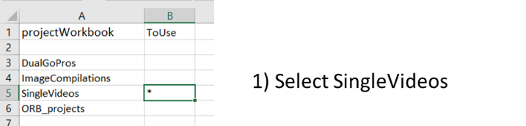

In “SingleVideos” write the paths folder and the name of the video, with the appropriate file path to that folder in the Paths folder

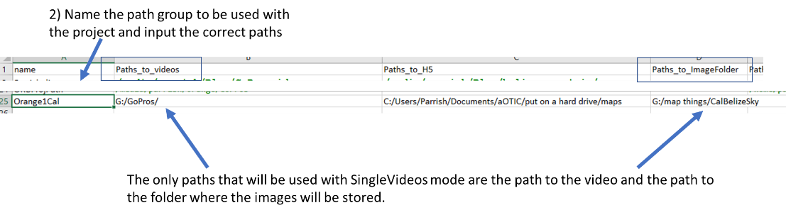

Make a folder to output the images to and then put the path to that folder in the “Paths_to_ImageFolder” in the paths folder.

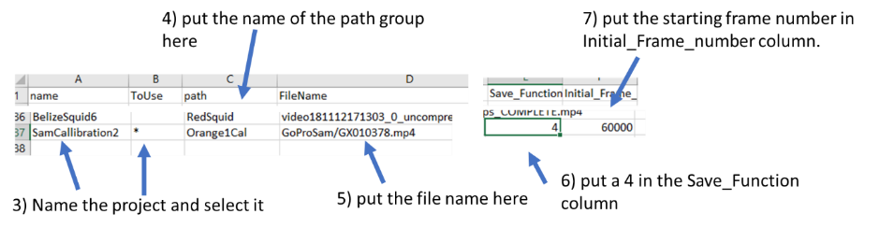

Select images of the checkerboard with as many different angles and distances from the camera and regions of the camera image as possible, for example:

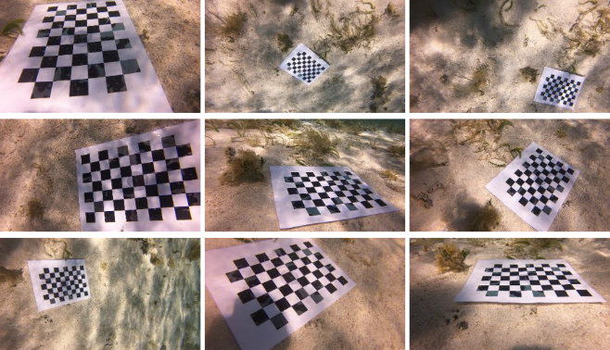

Take over 50 images for the analysis.

After the images are selected press “r”. The calibration procedure will commence. 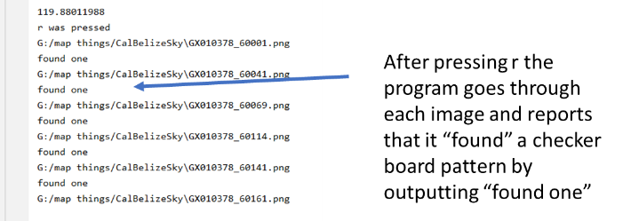

After the calibration procedure is over you will see the following output:

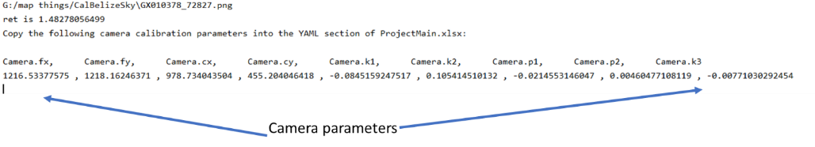

you will then have to copy and paste the camera calibration parameters into the Yaml sheet in ProjectMain.xlsx. Then you will have completed the camera calibration procedure. The program is set up to have one calibration for both cameras. If both cameras are commercially made, i.e. you don’t have a detachable lens on the camera, then the calibration should be very similar for both cameras (see Video measurement recommendations: for more information)

# **The Fiducial Object:**

The fiducial object should be large enough to be seen in the measurement arena. It should have distinguishable points in all three dimensions. There should be at least three points used for accurate position measurement in multiple dimensions… i.e. all points should not just be on a plane or a line. An origin should be chosen for the object and district points should be chosen. The points should be measured from the origin and should be in a standard cartesian coordinate system i.e.make sure you choose the x,y,z, directions below with the arrows point in the correct positive directions.

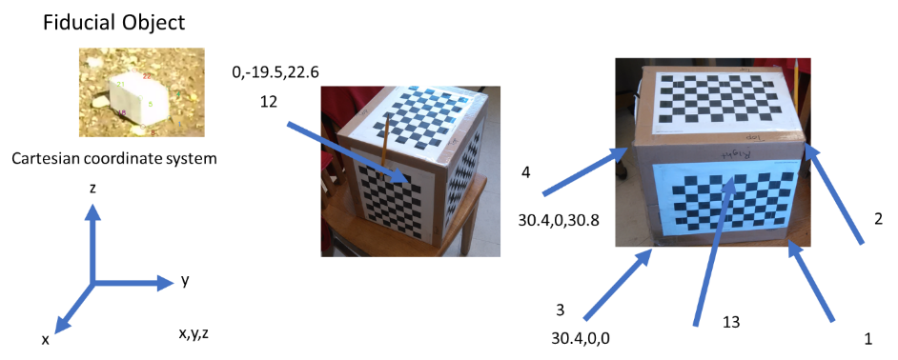

These numbered points should be listed in the “**PointsOnObjects**” page in ProjectMain.xlsx. The numerical list should be in the first column and should start on row number 3. The name for the fiducial object should be in the first row and the x,y,z coordinates should be just below the name and occupy the next two columns. The name can be placed in any column except the first one and provided it does not interfere with another group. The values should be placed in the x,y,z columns as shown below:

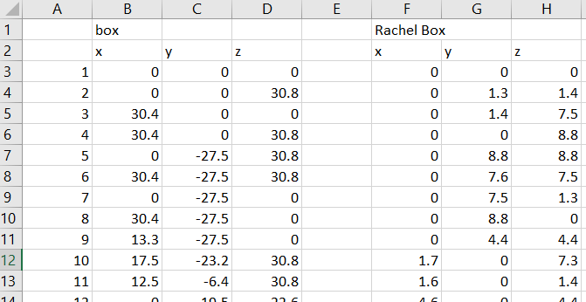

The Fiducial object is found by fitting a scaled rotation matrix plus a translation vector

$$mR\left(θ_{x},θ_{y},θ_{z}\right)+T(x,y,z)$$

Between the measured points and the points listed as the scale of the real world. There are only seven variables to this transformation so in theory, only 3 points (each containing 3 pieces of information) are needed to solve the transformation, but the more distinct points provided the more accurate the transformation will be.

# **Installing Virtual Box and my Ubuntu build containing ORB_SLAM2 and PATMOS_MIDOM**

Install Oracle virtual box

<https://www.virtualbox.org/wiki/Downloads>

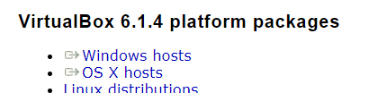

Click on Windows hosts

Then run the executable and follow the recommended instructions for installation.

Download the “**patmos.ova**” file to your computer

Run Import virtual appliance and put “**patmos.ova**” as the virtual appliance.

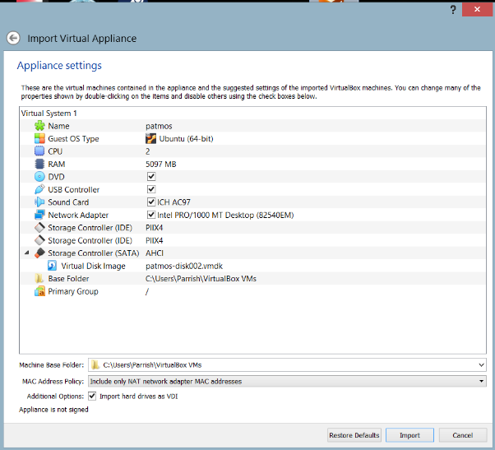

Then press import.

The program will install the Virtual box.

Then when it is installed open virtual box. Open virtual box by right clicking virtual box and selecting “run as administrator”.

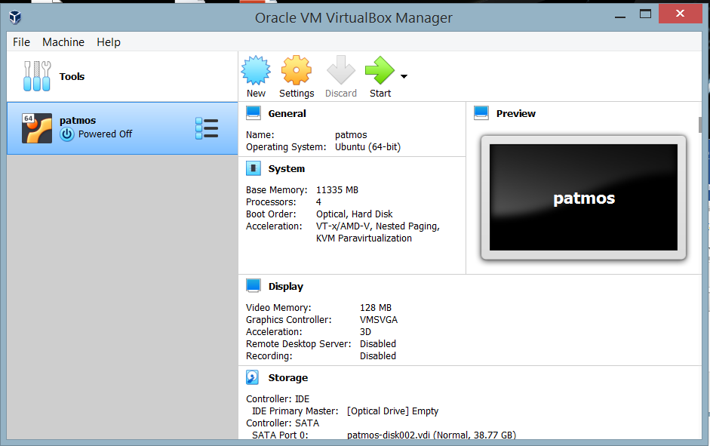

It should show that patmos is loaded. Select settings and then go to system:

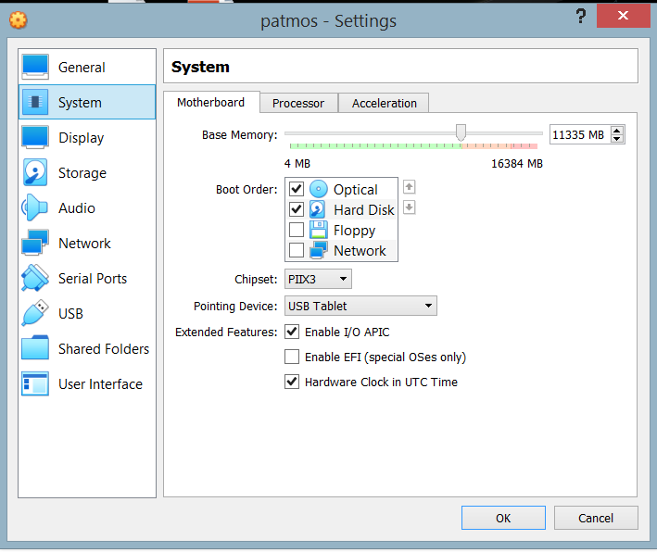

Increase the memory as much as you can… at least until the end of the green.

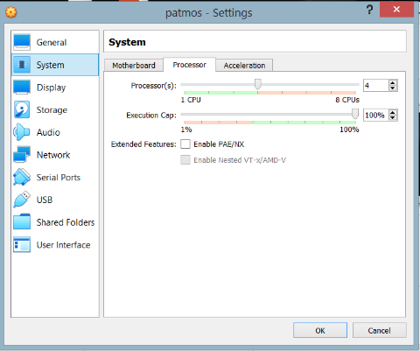

Select “**processor**” and do the same with cpu’s, increasing them as much as you can and then press ok and close the window.

The press the green arrow to run the program, and Ubuntu should load in another window.

You can adjust your screen resolution by selecting “**view**” and then “**virtual screen**”.

Mount your external hard drive containing the video files, or set up a shared folder to put the video files into.   
To mount the external hard drive select “**devices**” then “**usb**” and select your external drive.

Select file explorer to get to the folder named “**python**” in the Documents folder. Double click on **ProjectMain.xlsx** and make all the corrections to get the program to work as outlined in this manual. Then save the file. **If you work on ProjectMain.xlsx in Libre Office make sure you save ProjectMain.xlsx in the default Microsoft excel file format and not the Libre Office file format.**

Press **Ctrl+Alt+T** to open the terminal.

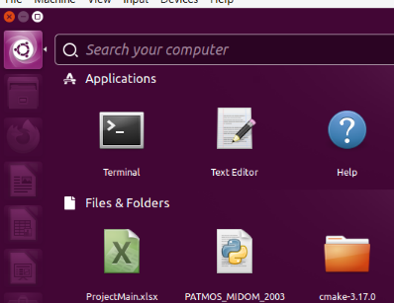

Type:

**cd Documents/python**

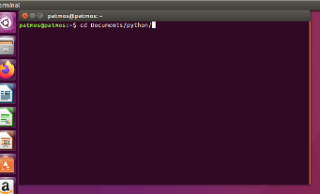

to get into the python folder. Then type:

**python PATMOS_MIDOM_200324.py**

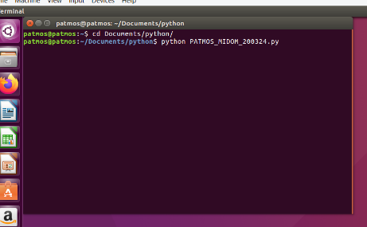

press return and the program will run.

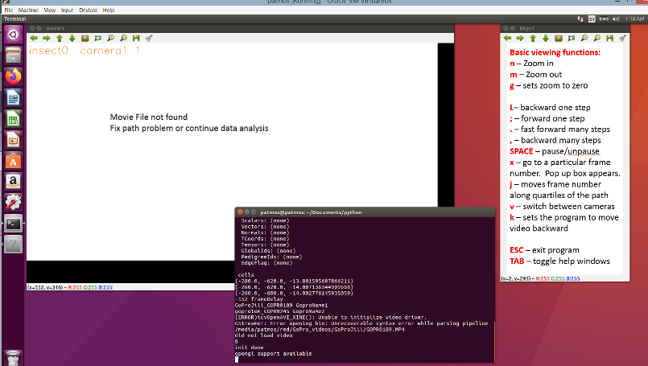

# **ORB_SLAM2:**

This mapping and tracking method uses an open-source VSLAM program called ORB_SLAM2 (Mur-Artal et al.,2015, <https://github.com/Alkaid-Benetnash/ORB_SLAM2>). ORB_SLAM2 creates semi-dense three-dimensional maps using a feature-based monocular SLAM system. When ORB_SLAM2 determines that two frames in the video sequence provide enough information to choose additional points in the map a new keyframe is produced, and the points are added to the map. ORB_SLAM2 searches for robust points that do not change their physical position frame to frame and rejects unstable points like leaves blowing in the wind. The length scale from this map is arbitrary. The physical scale of the map can be obtained using an object of known dimensions within the measurement sequence.

For small room-sized environments (~5 m) the position error of the camera is on the order of 1.0 cm (**Mur-Artal, R., Montiel, J. M. M., & Tardos, J. D.** (2015). ORB-SLAM: a versatile and accurate monocular SLAM system. *IEEE transactions on robotics*, ***31*(5)**, 1147-1163.). I have modified ORB_SLAM2 (<https://github.com/scorpionjeger/vvtORB_SLAM2>) to directly import MP4 files using the open-source computer vision software, OpenCV. While traditional ORB_SLAM2 only uses one independent monocular or fixed stereo camera system, this new code enables the user to employ two cameras with the ability to alternate between cameras while using the same virtual map inside of ORB_SLAM2. Furthermore, this modified ORB_SLAM2 code enables the user interface with the capacity to pause, reverse, adjust the speed, and manually save the three-dimensional map. Finally, to enable three-dimensional triangulation, the modified code provides the user the camera position, orientation, and all the map points within the frame with their associated pixel value.

## **My modifications of ORB_SLAM2:**

I have modified the <https://github.com/Alkaid-Benetnash/ORB_SLAM2> version of ORB_SLAM2 which has a map saving feature. My changes to the program are listed below:

* Outputs camera metadata and map metadata in a text file. See section “OBR_SLAM2 output h5 file for PATMOS:” for detailed information about the metadata.
* Can be run from Python using an excel spreadsheet as data input
* Uses MP4 video input
* It has many more controls in the control panel. See section “Controls for the point cloud viewer on ORB_SLAM2—My version” for details.
* Uses two video files within the program simultaneously, although they cannot simultaneously be in the mapping program.
* Outputs the map points in a space-separated list.

## **Installation of ORB_SLAM2:**

To install my version of ORB_SLAM2 follow the instructions for installing ORB_SLAM2 in the original ORB_SLAM2 readme:

<https://github.com/raulmur/ORB_SLAM2>

or

<https://github.com/Alkaid-Benetnash/ORB_SLAM2>

There are many searchable resources for getting ORB_SLAM2 working on a specific Linux operating system platform, so following the links from the original program would be more valuable than what I can write here. I will write out what is important for getting the program to work the way I have designed it to be used. So far, I have only seen ORB_SLAM2 operational on Linux systems. See also the example of an installation I made. Also see “Installing Virtual Box and my Ubuntu build containing ORB_SLAM2 and PATMOS_MIDOM” for installing this already built version easily onto virtual box.

Running the program consists of 2 main parts. The first is inputting the data for the program in a YAML file, which is a text file that allows the user to input various parameters for the program. The second is an inline command from the Linux terminal. I have taken these two input methods and put them in the excel spreadsheet, ProjectMain.xlsx, to make keeping track of the data easier among projects. I will list two methods for getting ORB_SLAM2 running, on with my program and the other with Linux inputs.

### **An example of installing Ubuntu on VirtualBox and building ORB_SLAM2 and PATMOS_MIDOM dependencies**

Install ubuntu 16.04 by downloading the iso file from the web and setting it up as a boot CD drive.

Then follow instructions.

Install guest additions for Ubuntu

<https://www.tecmint.com/install-virtualbox-guest-additions-in-ubuntu/>

To do this you have to add an empty optical drive to VB

Then when Ubuntu is installed open a terminal, by selecting terminal in the applications in the upper left hand side. Then add the following in the terminal. Use the cited websites for help and more information. These are a list of things I did to install all the necessary programs onto Ubuntu.

installed git

sudo apt-get install git

Installed Pangolin:

<https://github.com/stevenlovegrove/Pangolin>

all sudo’s from this page

sudo apt install libgl1-mesa-dev

sudo apt install libglew-dev

sudo apt install cmake

sudo apt install libpython2.7-dev

sudo apt install pkg-config

Wayland and EGL:sudo apt install libegl1-mesa-dev libwayland-dev libxkbcommon-dev wayland-protocols

sudo apt install ffmpeg libavcodec-dev libavutil-dev libavformat-dev libswscale-dev libavdevice-dev

sudo apt install libdc1394-22-dev libraw1394-dev

sudo apt install libjpeg-dev libpng12-dev libtiff5-dev libopenexr-dev

git clone https://github.com/stevenlovegrove/Pangolin.git

cd Pangolin

mkdir build

cd build

cmake ..

cmake --build .

Installed OpenCV 3.2

<https://github.com/BVLC/caffe/wiki/OpenCV-3.2-Installation-Guide-on-Ubuntu-16.04>

sudo apt-get install --assume-yes build-essential cmake git

sudo apt-get install --assume-yes pkg-config unzip ffmpeg qtbase5-dev python-dev python3-dev python-numpy python3-numpy

sudo apt-get install --assume-yes libopencv-dev libgtk-3-dev libdc1394-22 libdc1394-22-dev libjpeg-dev libpng12-dev libtiff5-dev libjasper-dev

sudo apt-get install --assume-yes libavcodec-dev libavformat-dev libswscale-dev libxine2-dev libgstreamer0.10-dev libgstreamer-plugins-base0.10-dev

sudo apt-get install --assume-yes libv4l-dev libtbb-dev libfaac-dev libmp3lame-dev libopencore-amrnb-dev libopencore-amrwb-dev libtheora-dev

sudo apt-get install --assume-yes libvorbis-dev libxvidcore-dev v4l-utils python-vtk

sudo apt-get install --assume-yes liblapacke-dev libopenblas-dev checkinstall

sudo apt-get install --assume-yes libgdal-dev

Download the latest source archive for OpenCV 3.2 from <https://github.com/opencv/opencv/archive/3.2.0.zip>

mkdir build

cd build/

cmake -D CMAKE_BUILD_TYPE=RELEASE -D CMAKE_INSTALL_PREFIX=/usr/local -D FORCE_VTK=ON -D WITH_TBB=ON -D WITH_V4L=ON -D WITH_QT=ON -D WITH_OPENGL=ON -D WITH_CUBLAS=ON -D CUDA_NVCC_FLAGS="-D_FORCE_INLINES" -D WITH_GDAL=ON -D WITH_XINE=ON -D BUILD_EXAMPLES=ON ..

make -j $(($(nproc) + 1))

sudo make install

sudo /bin/bash -c 'echo "/usr/local/lib" > /etc/ld.so.conf.d/opencv.conf'

sudo ldconfig

sudo apt-get update

Installed Eigen

eigen3

sudo apt install libeigen3-dev

Installed Boost

boost

sudo apt-get install libboost-all-dev

Here are other things for PATMOS_MIDOM:

install matplotlib

sudo apt-get install python-matplotlib

install h5py

sudo apt install python-pip

pip install –upgrade pip

pip install h5py

sudo apt-get install -y python-xlrd

sudo apt-get install -y python-xlwt

pip install xlutils

sudo apt-get install python-scipy

pip install numpy-stl

sudo apt-get install python-shapely

pip install pytesseract

pip install vtk

Make sure these are gone if you are transferring a build from one computer to the next:

get rid of build folder

delete

build folders in DBoW2 folder

get rid of lib folder

do the same in g2o folder

delete build and lib folder

in the main folder

comment out the opencv one core thing in mono tum.

#include<opencv2/core.hpp>

Keep this one.

#include<opencv2/core/core.hpp>

Build ORB_SLAM2 by doing this:

cd ORB_SLAM2

chmod +x build.sh

./build.sh

## **Starting ORB_SLAM2 with PATMOS and ProjectMain.xlsx:**

### **Step by step instructions:**

* Select **ORB_projects** on the main sheet.
* Input the paths for **ORB_SLAM2** and the output files from **ORB_SLAM2** on the paths sheet
* Create a **DualGoPro** project, see “**An example of hand tracking workflow for tracking insects or other objects**:” or “**Hand Tracking workflow for tracking insects or other animals**:” below.
* Link it to the **ORB_Project** projects
* Select **ORB_Project** by using “*” in the **ToUse** column.
* Write in names for the camera 1 and 2 **metadata** output with an extension ending in “.txt”.
* Write in similar names for the **H5** output with an extension ending in “.txt”.
* Put the **yaml** information into the ProjectMain.xlsx excel file and put the name under **MakeYaml.**
* Make sure **MakeH5** has an “**n**” written in the column.
* Make **Use_Map_File_for_ORB_SLAM2** “**y**” for loading and saving map files. “**n**” otherwise.
* Enter a text file name for the **ORB_pointcloud_output** entry.
* If you want the map to be saved under a different name than the original map then write a different name in **Map_out**
* Put the initial frame to start in the **Starting_frame** column.
* Then run the file from **pycharm** or equivalent python platform.

### **Converting camera metadata file into an H5 file.**

* Put “**y**” in the **MakeH5** column and run the PATMOS program.
* This will only record the camera metadata and not the map metadata. For the map metadata see the section “**Converting the text output from ORB_SLAM2 into an H5 file, and further manipulations of the file**” above.

## **Starting ORB_SLAM2 with Linux terminal:**

To run setup the **yaml** file with the desired settings and camera calibration settings, and make the appropriate inline command for the Linux terminal as discussed below:

### **Example of a yaml file:**

The **yaml** file is a type of input file that brings parameters into ORB_SLAM2. **Yaml** is a standard file format for such functions. Below is an example of a Yaml file to be inputted into the ORB_SLAM2 program. I have made it so that one can input the Yaml information into an excel spreadsheet and the PATMOS program will convert that information into a **yaml** file that will be used in ORB_SLAM2. If you want to just modify this format then change the numbers within the Yaml file and save the file without changing any of the formattings. The Yaml file is separated into various parts. The first part contains the camera calibration information.

%YAML:1.0

#--------------------------------------------------------------------------------------------

# Camera Parameters. Adjust them!

#--------------------------------------------------------------------------------------------

# Camera calibration and distortion parameters (OpenCV)

Camera.fx: 1838.864

Camera.fy: 1835.793596

Camera.cx: 720.7

Camera.cy: 276.3

Camera.k1: -0.285149

Camera.k2: 0.184851

Camera.p1: 0.004978

Camera.p2: 0.001244

Camera.k3: -0.529134

# Camera frames per second

Camera.fps: 20.0

# Color order of the images (0: BGR, 1: RGB. It is ignored if images are grayscale)

Camera.RGB: 0

#--------------------------------------------------------------------------------------------

# ORB Parameters

#--------------------------------------------------------------------------------------------

# ORB Extractor: Number of features per image

ORBextractor.nFeatures: 12000

# ORB Extractor: Scale factor between levels in the scale pyramid

ORBextractor.scaleFactor: 1.2

# ORB Extractor: Number of levels in the scale pyramid

ORBextractor.nLevels: 8

# ORB Extractor: Fast threshold

# Image is divided in a grid. At each cell FAST are extracted imposing a minimum response.

# Firstly we impose iniThFAST. If no corners are detected we impose a lower value minThFAST

# You can lower these values if your images have low contrast

ORBextractor.iniThFAST: 20

ORBextractor.minThFAST: 7

#--------------------------------------------------------------------------------------------

# Viewer Parameters

#--------------------------------------------------------------------------------------------

Viewer.KeyFrameSize: 0.1

Viewer.KeyFrameLineWidth: 1

Viewer.GraphLineWidth: 1

Viewer.PointSize: 2

Viewer.CameraSize: 0.15

Viewer.CameraLineWidth: 2

Viewer.ViewpointX: 0

Viewer.ViewpointY: 0

Viewer.ViewpointZ: -4

Viewer.ViewpointF: 8000

#--------------------------------------------------------------------------------------------

# Map Parameters

#--------------------------------------------------------------------------------------------

Map.mapfile: /home/parrish/ORB_SLAM2/MapORB_tom_318_jill_261_2

Map.mapfileOut: /home/parrish/ORB_SLAM2/MapORB_tom_318_jill_261_2

Map.KFTfile: /home/parrish/ORB_SLAM2/KFT_ORB_tom_318_jill_261_2.txt

Map.FirstFrame: 2000

Map.Camera1Placement: /home/parrish/ORB_SLAM2/metadata_tom_318_190115.txt

Map.Camera2Placement: /home/parrish/ORB_SLAM2/metadata_tom_318_190115.txt

### **Linux terminal command:**

Run the program from the terminal in the OBR_SLAM2 directory.

An example of the inline command is:

./Examples/Monocular/mono_tum Vocabulary/ORBvoc.bin Examples/Monocular/KITTIPB_GP_sam_720reduced.yaml /media/parrish/Orange/GoPros/GoProSamRD/GP010322R.mp4 /media/parrish/Orange/GoPros/GoProSkyRD/GP010134R.mp4 1

These are all executed on one line separated by spaces. The first entry is the ORB_SLAM2 executable. The second entry is the *.yaml file with all the parameters for the program. The third entry is for camera1 and the fourth entry is for camera2. The last entry tells the program if it is to load and use a saved map with the map name in the *.yaml file which is either 1 for yes or 0 for no. Spelling, capitalization, and the proper placement of forward slashes (“/”) are all important or the program will fail. The first camera file is camera1 and the second camera file is camera 2. When you hit enter the program loads, then you need to give the starting frame. For some reason, there is a glitch with OpenCV and if you start an MP4 before frame 233 it will end on 233 and shut the program down. Start the file after frame 233 in the Yaml file by adjusting “Map.FirstFrame”.

## **PATMOS_ORB_SLAM2 operating details:**

**Here is an overall list of the things that need to be done before PATMOS can begin to aid in tracking data:**

1. Pre GUI procedures
   1. Using an RGB Polarization Video.
      1. Calibrate the Camera with an OpenCV checkerboard calibration routine (for example <https://docs.opencv.org/2.4/doc/tutorials/calib3d/camera_calibration/camera_calibration.html>) or equivalent.
   2. Run the RGB channel of the polarization video in ORB_SLAM2 with the appropriate ORB_SLAM2 parameters (all these are done)
      1. Take a video of the structure of interest using a circular pattern, keeping the pointed at the structure. Avoid measurements where the camera is stationary and rotating about this stationary axis. Use a fiducial object in the presence of the structure where possible.
      2. ORB_SLAM2 has specific input parameters for map production. Modify this to get the best map. These are the signs of poor calibration or map parameters: dense spurious points radiating from the camera in the virtual world, long length of time for the map to initialize, map not being able to engage in loop closure, highly skewed map features, etc.
      3. Over the temporal and spatial region of interest run orb_slam2 and get an adequate map of the region. Watch for ORB_SLAM2 errors where the map scale fails. The mapping mechanism can recalibrate the scale at various instances. This is obvious as the map points begin to clump up around the virtual camera diagram in the 3D world.
      4. Save the map. I have modified the save function so that the map can be saved while the program is running, but this technique is not always consistent. The most consistent way to save the map is to quit the program and restart. The map should be saved often incase the map fails, and then the program should be restarted to run the program differently to avoid map failure.
      5. Rerun ORB_SLAM2 on localization mode and record the camera orientations and map point metadata.
      6. The ORB_SLAM2 output in these two files will be:
         1. File 1 = a list of xyz points of the point cloud
         2. File 2= a list of camera orientation and position parameters per frame, a list of all visible point cloud points within that frame with their associated 3D coordinates and projected pixel coordinates. The camera calibration parameters will also be put in this file.
      7. Convert the ORB_SLAM2 files to H5 format, with the data organized per video frame

### **Controls for the point cloud viewer on ORB_SLAM2—My version.**

* **Green pyramid:** This is the camera, with the camera origin at the vertex and the camera direction facing the rectangle for the vertex
* **Red map dots**: Points in the co-visibility graph. The co-visibility graph is the set of all points that are connected via other keyframes. In other words, the current frame of the camera sees a certain number of points. Each one of those points was created by some keyframe in the measurement. Each one of those keyframes views another set of points. So, the co-visibility graph is the set of all points in the current frame along with all the points associated with the keyframes associated with those points.
* **Black map dots:** Map points that are not in the co-visibility graph
* **Left mouse click:** pans the point cloud
* **Right mouse click:** rotates the point cloud (if you have panned or rotated so that you cannot see the map anymore click on “Follow Camera” to get back to a place where you can see the point map).
* **Follow Camera:** This sets the point cloud viewing program to view from the camera’s perspective or a stationary perspective.
* **Show points:** Turns the map points on and off.
* **Show Key frames:** Turns on the Keyframes (or the frames for which new map points are created) these will be in blue.
* **Show graph:** Shows the trace of the camera as it moves through the environment.
* **Localization mode:** When pressed, the map and keyframe production stops updating, map corrections are turned off, and the map is frozen. The camera’s position is determined only by the existing map points.
* **Pause:** Stops the updating of new video frames, all other threads in the program continue as if the video is stuck on this frame.
* **Quit:** exits the program and saves the binary map and the map text file when closing.
* **Reverse:** Plays the video in reverse.
* **Faster:** Skips every 5 or so frames so that the video moves faster.
* **Reset:** Deletes the map and starts over
* **Record data:** records the map and camera metadata for each frame of the video.
* **Record just camera:** records only the camera position and orientation for each frame.
* **Slow speed:** slows down the video based on the slider value.
* **Video 2 push it:** changes the video. When pressed the second video entered on the command line, or camera 2, will be running.
* **Save map:** This saves the map at a current location. It saves a back up also. This does cause the program to crash occasionally which will corrupt the map file. Hence the program also saves a backup file. It is recommended you save the map by quitting the program.
* **Type Frame number:** When you press this button you can type the desired frame number in the console and press enter.
* **Frame Adjust:** This changes the frame number with the slider.

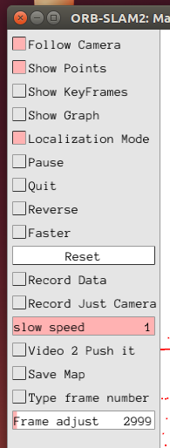

Picture of the control panel for the Map Viewer in ORB_SLAM2

## **An Illustrated example for PATMOS running ORB_SLAM2**

### **Preliminary set up with ProjectMain.xlsx**

First, go to the main page and select the ORB_Project:

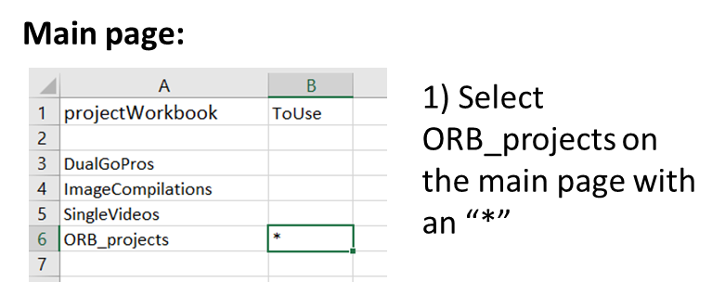

Next, go to the DualGoPro page and create a project, by entering a name, creating a Path name and placing it in the path column, and putting the file names for cameras 1 and 2 in the FileName and FileName2 column.

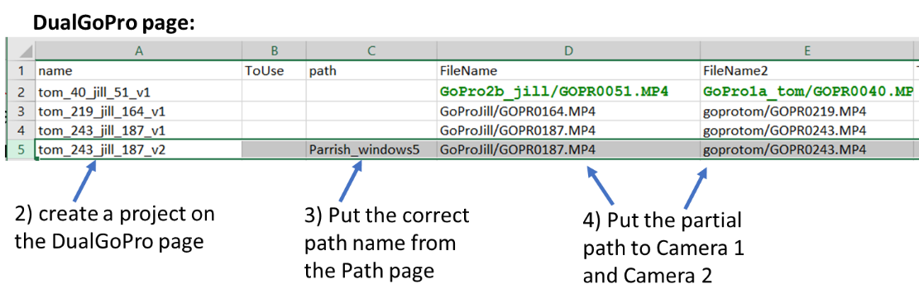

Then put a name for the ORB_Project in the ORB_Name column.

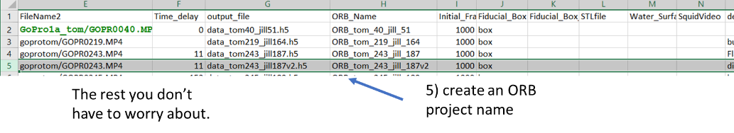

Then go to the **ORB_projects** page and put that same **ORB_project** name in the **name** column. Then select the project with an **“*”** and put the path group name in the path folder. Put the DualGoPro name that you created above in the link_to_video column.

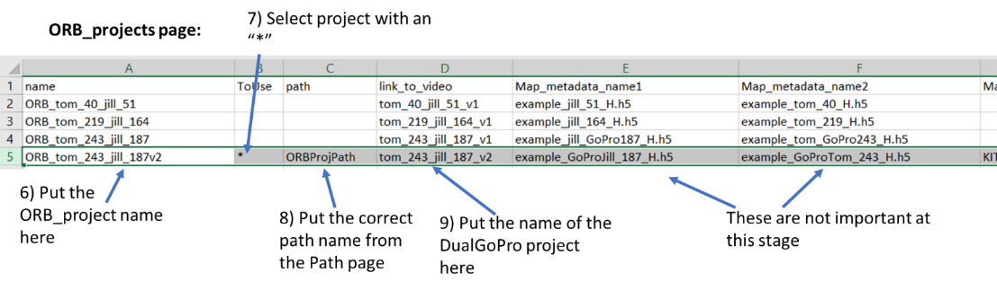

Put the **Yaml** reference in the **MakeYaml** column.

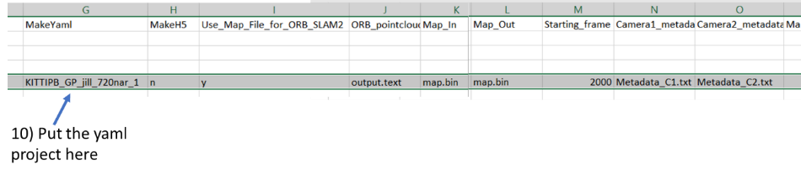

### **Working with the Yaml page:**

The camera parameters are those that are discussed in the camera calibration section. The fps (frame per second) feature has been disabled in my ORB_SLAM2 version. Ignore the camera.rgb parameter. Just put a 0 in the column.

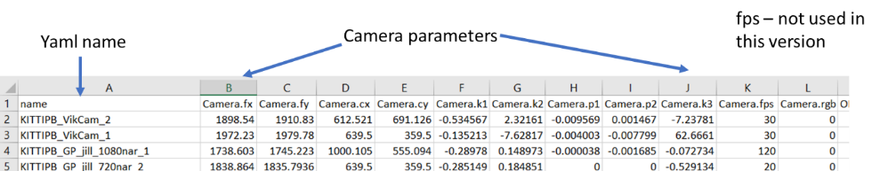

The mapping parameters have to do with the ORB_SLAM2 machinery. More can be found at <https://github.com/raulmur/ORB_SLAM2>

These parameters can be adjusted to make the mapping process better. I have found that the default values have met my needs with the exception of the .nFreaures column. This is the number of Map points that the program tries to maintain. The more you use the denser your map will be, but it also increases the computing power needed to run the program. There seem to be different numbers that enable the map to be made quicker. Some values the program will not make a map at all. It depends on the video.

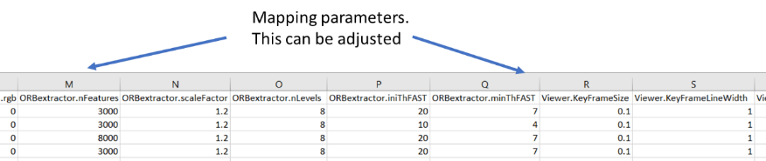

I use the defaults for the map viewer parameters. This just has to do with how the map is viewed in the Map Viewer of the program.

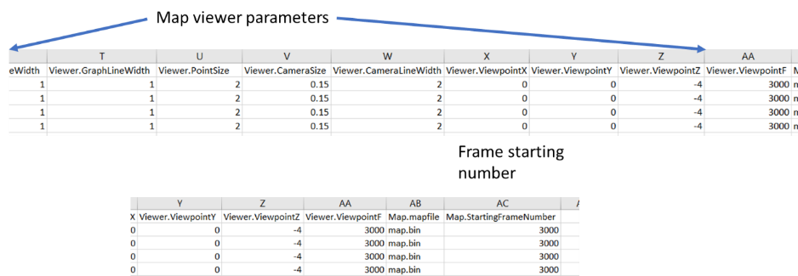

The Map.mapfile is not functional here. The map can be named in the **ORB_project** page. The Frame starting number can also be inputted in the ORB_project page.

**Back to the ORB_projects page:**

Put an “n” in the MakeH5 column. Put a “y” in the **Use_Map_File_for_ORB_SLAM2** unless you don’t want the map saved. You then put a text file name in the **ORB_pointcloud** column. This will save a space-delimited list of all the map points. This is not something the program can use to reload the map. That is the binary files that are listed in the Map_In and Map_Out column. The .bin file in the Map_In column is what the program reads in when it starts and Map_Out is the .bin file that the program will save the map when it exits. These files need to have a .bin ending in these cells. Put the starting frame in the Starting_frame column. This needs to be greater than 233 because of a glitch in OpenCV. Put the names of text files (.txt) in the Camera1_metadata and Camera2_metadata column for the output of the camera metadata from the program.

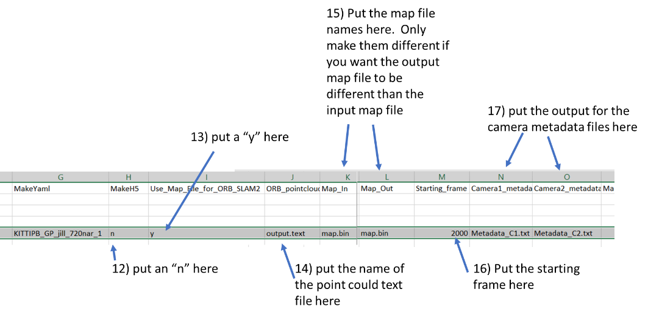

### **Starting the program.**

The coincident files are inputted into the ORB_SLAM2 program and ORB_SLAM2 creates a map of the environment. The Program should start mapping from the videos when they are ready to map the environment, and the time sync protocol etc. Then the program should run for a long time and occasionally watch the map for errors. If there are no errors, I keep the map going and the map will get very established. Then go to camera 2 and go back to the beginning and find a place where it pics up in localization mode. I find the latest part in the video where it picks up. Then take it out of localization mode and again let it run. After a while I save the map by pressing quit and exiting the program. Start the program again and look for the areas where the map picks up in the video files. Find big areas where it the map won’t pick up and go to the earliest time the map will pick up and let it run again. The user alternates between both cameras feed during the initial scanning period of the cameras to build the map and the map-making process is complete when ORB_SLAM2 localizes during the rest of the measurement footage. During this process, the user should watch for errors that can occur during the generation of the map. The program may alter the scale of the map being generated if the camera moves in a way not advantageous to map-making such as purely radial movements or quick movements through areas that are not co-visible. These errors are evident from a dense accumulation of points near the camera origin or when double features appear on the map. In which case, one can load back a version of the map file that was previously saved and run the program again slower, with different parameters, or avoiding the problematic part of the video entirely. Once the entire map is made, the user runs the entire video in localization mode (where the map is not being modified) for both cameras separately and sets the program to output the camera and map metadata into a text file. Now we will go over this again in greater detail:

The program will begin and two windows will show up… one for the maps and the other for the video feed.

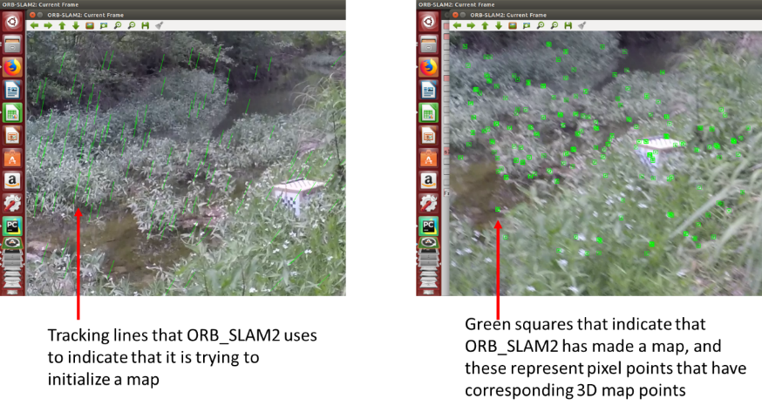

The program initializes the setup and you will see green lines on the video feed. Once these green lines turn into green boxes the mapping has begun.

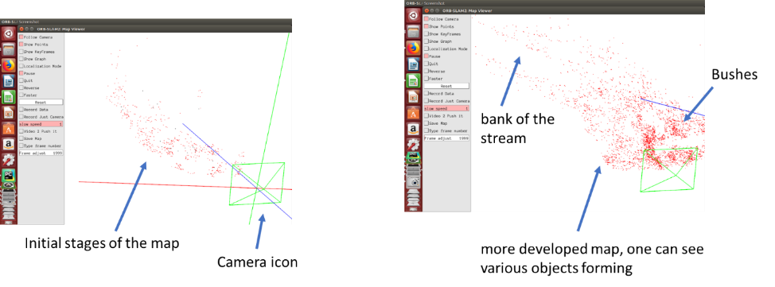

Several map points appear in the Map viewer and, in the initial stages of the map-making process, you will see clusters of points shift around a lot as the map is being developed. When the camera moves a sufficient distance away from the map new map points will appear and they will pulse and shift until they have converged to a solution. The map changes as new keyframes are introduced or taken away from the map point collection. As the map progresses you will begin to see recognizable features from the environment in the map.

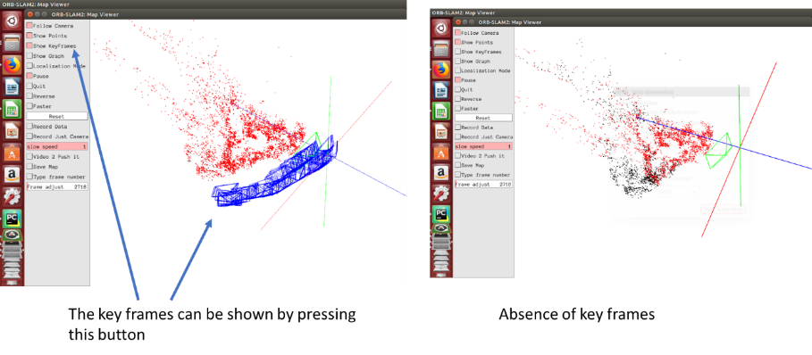

You can see the current frame number on the output either on the Linux terminal or for the output of the PATMOS.

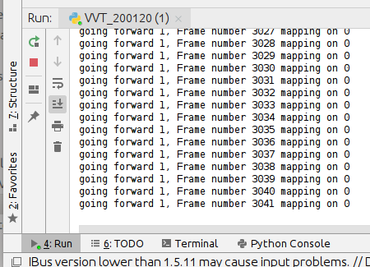

This output informs you whether the video is going forward, the frame number, and whether the mapping is on.

### **Co-visibility:**

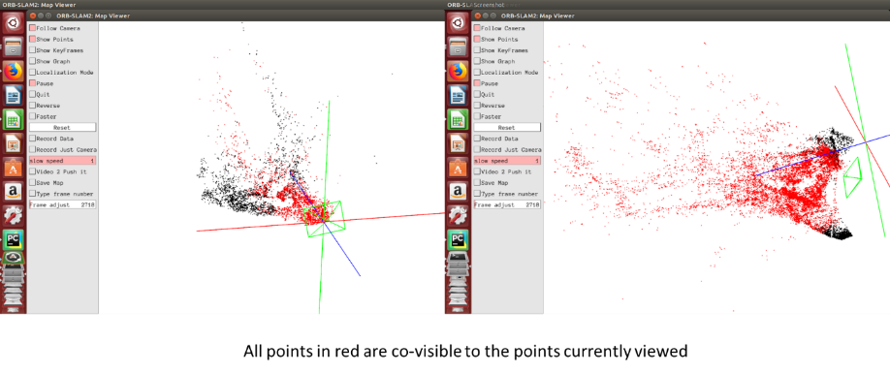

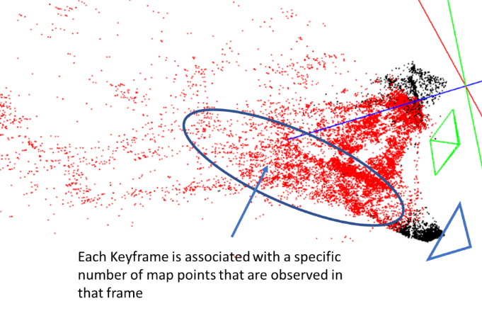

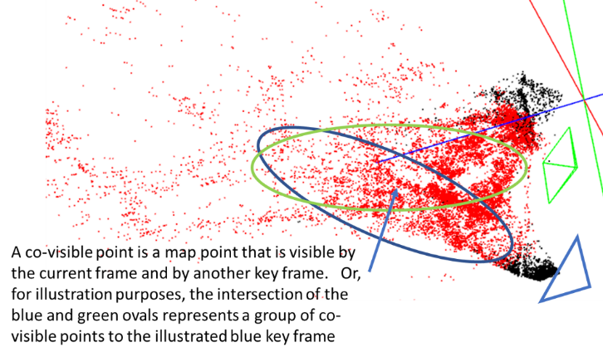

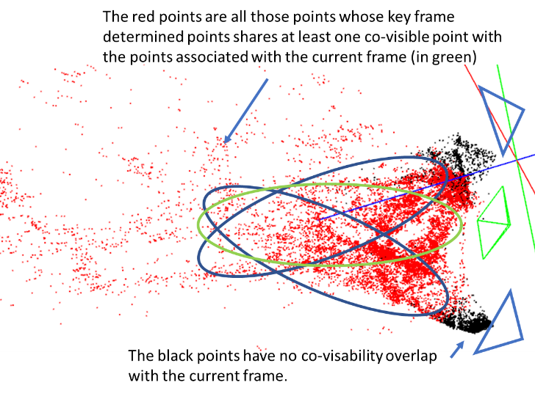

### **Map errors and problems:**

1. The map has failed when the map points clump up next to the camera origin with a radial pattern extending from the camera origin.
2. The map has failed when there is a double image of a known object, or where there is a double image of the ground or a flat surface. Or where there are two surfaces of the ground that should be co-planer but are not.
3. If the camera moves away from the focal area quickly it may cause one of these errors when it comes back. In that case, skip that part in the video sequence while the map is being made.
4. A good map is a map where the points are not changing significantly while they are being updated.

Here is a map of a wooden walkway within the woods.

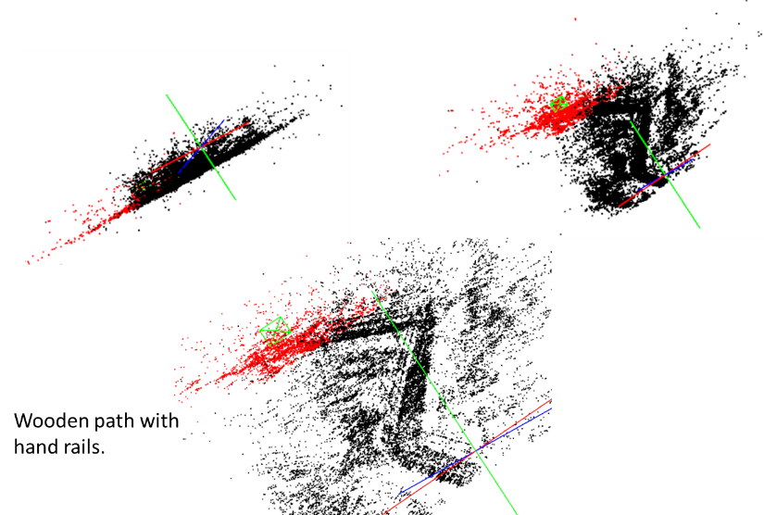

The camera follows the path in making a long map. The beginning of the map is very distant from the end of the map in terms of co-visibility. This means that there are no redundant checks or calculation comparisons within ORB_SLAM2 of the beginning of the environment to the end of the environment. Relative errors accumulate the farther you go from a co-visibility checked region. If this happened to be a circular path, when the camera comes back to the original part of the path, there will be so many accumulated errors in the path that the path will not meet up with the original path in the environment. Thus for making measurements with this method, the map should be created in a semicircular manner so that all elements are co-visible with each other.

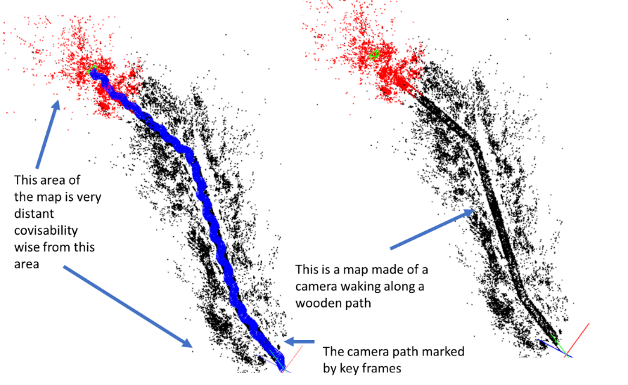

One map error happens when the camera moves away from the co-visibility of the rest of the map and then comes back to the same area but does not recognize the points and starts creating new map points where it should have recognized the other points. This is manifest by double representations of the same object, such as the ground in the following examples.

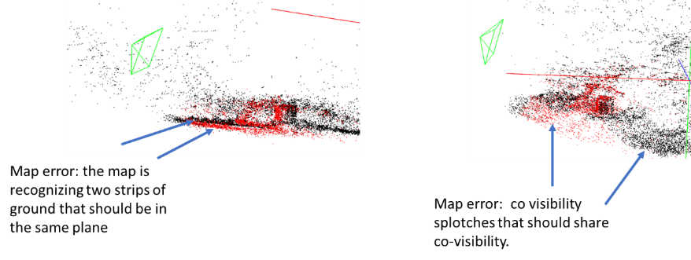

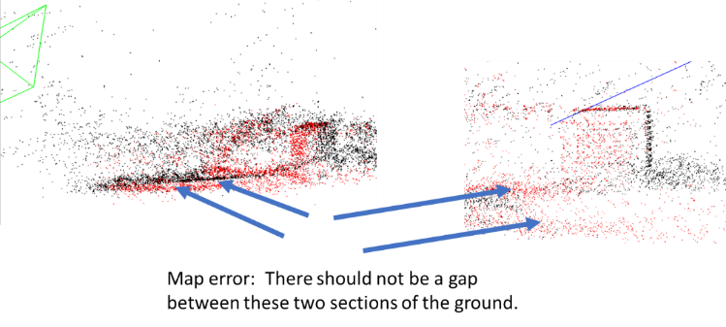

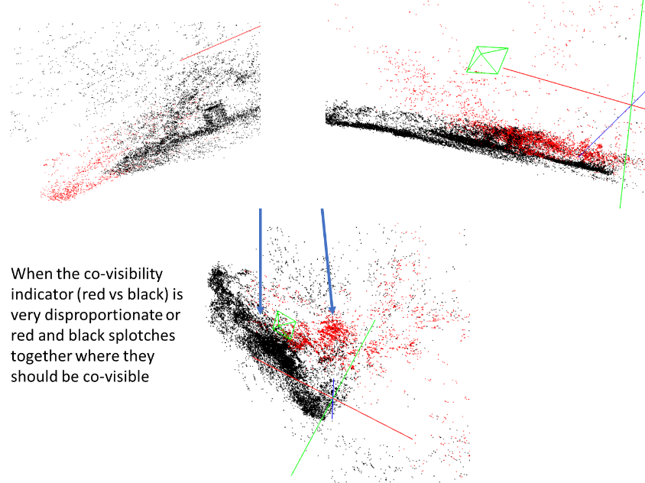

When a central point is monitored by the camera in a semicircular orbit then many points remain co-visible.

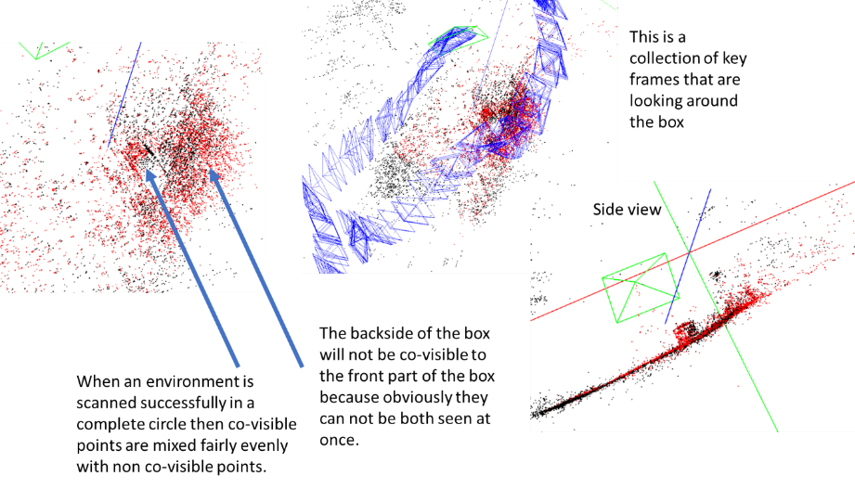

When ORB_SLAM2 is having difficulty adding on new points because of a sudden change of non-co-visible points the scale can change drastically as in the example below.

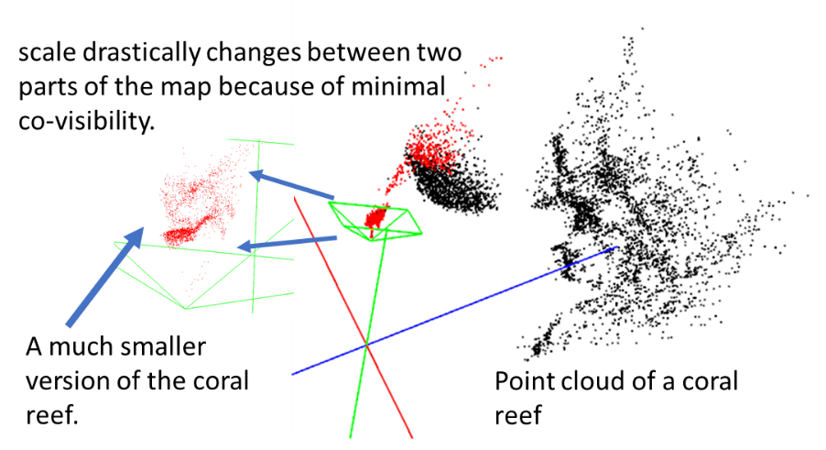

When the program struggles to assign new map points to the map the points get clumped up in a dense conical distribution emanating from the camera that, obviously, has no basis on the physical layout of the environment. Here are some examples:

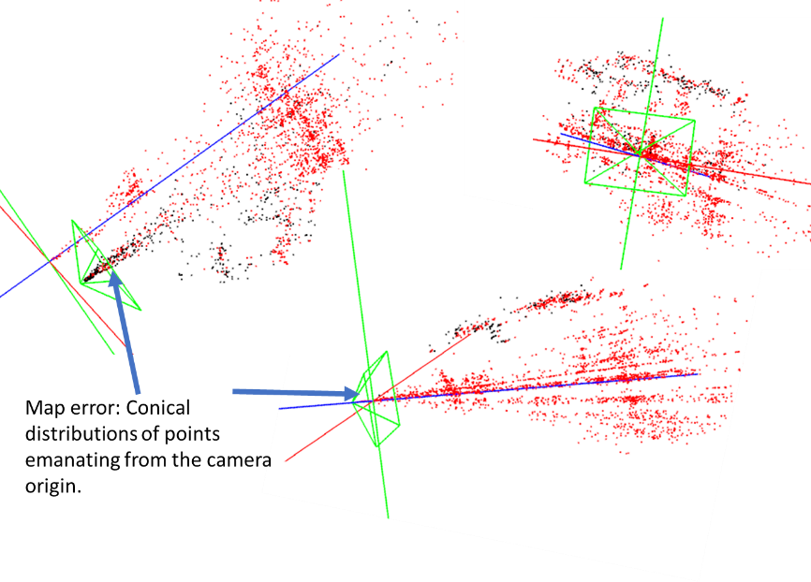

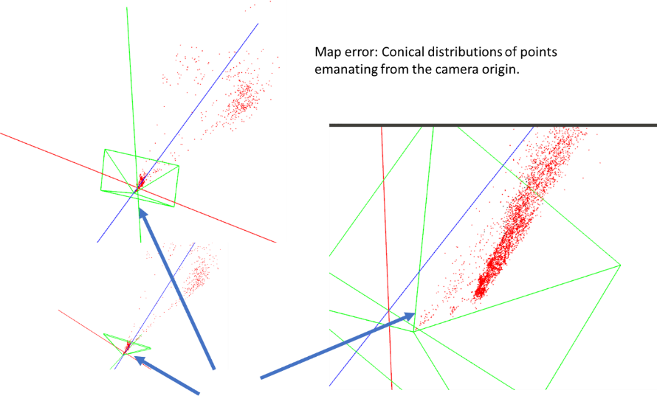

When the camera is not calibrated correctly many map features will appear warped such as this example of a path that is warped into a wave-like structure in the map:

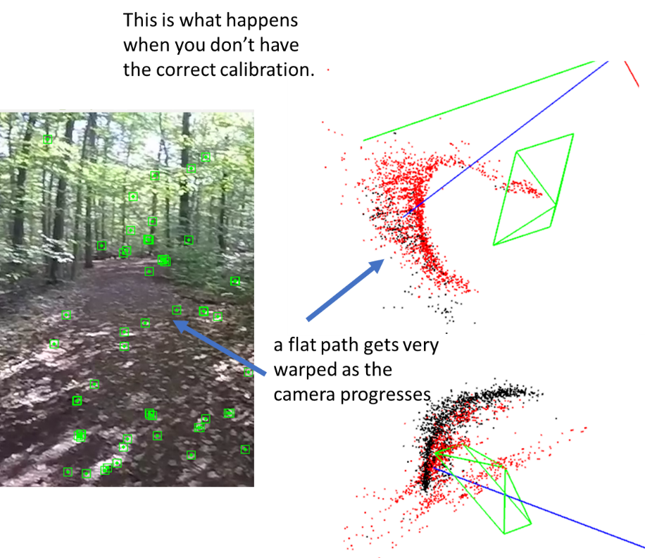

### **This is an illustration of a quality and correct map suitable for tracking:**

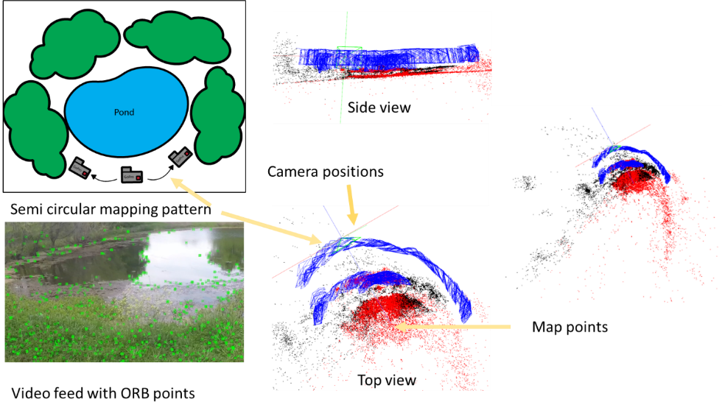

The camera mapping paths were made is a semicircular manner, most of the central points are co-visible, there are no doubling features seen on the surface of the pond.

### **Tips for avoiding map errors**.

If there are double features or drastically changed scale you will have to start the map over or start with a previously saved version of the map.

Save the map often by quitting the program:

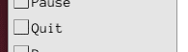

The save button will work but there is an error with this process that can corrupt the map file. Saving the map by quitting is the safest option.

If the map is producing dense conical points from the camera origin, slow it down by sliding the slow speed slider,

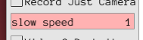

Or reverse if need be.

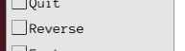

Sometimes those points eventually get calculated correctly and become a part of the map. A few floating phantom points are not to be worried about, because the whole PnP calculation comprises more than 500 points. If you think the map is going to mess up then turn the localization mode on

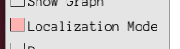

and the map will be preserved.

If the map shakes a lot (in camera view) in localization mode then the map is not very good and will contribute to errors in the tracking process. More calculations in the non-localization mode will be needed.

**Moving between cameras.**

For ORB_SLAM2 to register the other camera on the map of the current camera both cameras need to have times when they are both scanning the same thing in the same position. That is why I recommend filming the scanning footage for the map with both cameras held physically together or in very close proximity and in the same orientation. Once the cameras become separated for tracking purposes the cameras will independently be mapping different parts of the environment. Thus, the cameras need to be run in the program in terms of mapping even after the cameras are separated and are being used for tracking. ORB_SLAM2 needs to adjust the map for every new orientation and position in the environment the camera encounters. To switch between cameras press

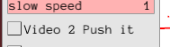

When the button is pressed then Camera 2 is invoked.

For moving to other frames within the video file use the slider:

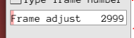

The frame adjust slider is very coarse so if you want to get a specific frame number then use this button:

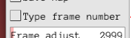

Then you will be prompted in the python terminal or whichever program you are using to run the program with this statement:

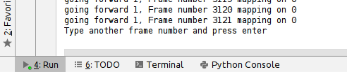

Then type the frame number and press enter.

### **Collecting the metadata for the camera:**

Once the map will pick up on every part of the camera for both cameras at random selection across the video that is important for data taking then the system is ready to save the camera data.

* Quit the program so that the map is saved.
* Start the program again with **camera 1** (default) selected
* The program will start in **localization mode**.
* Go to the frame where the data collection is needed.
* Then press **Record Data**

There are two buttons for this. One button just records the camera metadata (Record Just Camera) and the other records both the camera and map metadata (a significantly larger file)

. 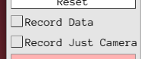

* Let the program run in **localization mode** until the end of the data collecting period.
* Repeat and do the process again with **Camera 2**

### **Going from metadata to h5**

This process changes the Text file from outputted with ORB_SLAM2 and converts it to an H5 file that can be used in **PATMOS.**

* Close **PATMOS** and select **“y”** in the **MakeH5** column in the **Orb_Projects** sheet.
* Have h5 file names written in the **Map_metadata_name1** and **Map_metadata_name2** columns. The file extension should be “**.h5**”, and these will be saved in the Paths_to_H5 column in the “**Paths**” sheet.
* This will only write the camera information into the h5. If you are wanting to do more analysis on the map data then go to the “**From ORB_SLAM2 to analysis preparation:**” section to see more.
* Run PATMOS and the program will make both files. This process takes some time.

# **From ORB_SLAM2 to analysis preparation:**

## **Converting the text output from ORB_SLAM2 into an H5 file, and further manipulations of the file:**

This uses various subprograms to reorganize the metadata output from ORB_SLAM2. There is an essential part of this functionality in the PATMOS program. See “ORB_projects” discussion below under “**MakeH5”.**

**ConvertMapDataintoH5_2_190613.py:**

This program takes the ORB text output data and reorganizes it into an h5 file.  
For various uses of this program, if you want the full map and camera metadata, use Moredata=True. This stores the data with the name “filename”_H.h5 . This file will be very large. If you want the camera metadata only, use Moredata=False. This stores the data with the name “filename”_HCO.h5.  
  
Next, if you want to convert the full H5 file (_H) to a file that is organized from the map points perspective use the program “**OrganizeandInvestigateOrbMap.py”.**

**OrganizeandInvestigateOrbMap.py:**

This program takes an ORB_SLAM2 full metadata h5 file (from ConvertMapDataintoH5_2_190613.py) and reorganizes it into an h5 that is organized in reference to the map point indexes. This program has some memory problems so consider doing this in stages by bounding frame numbers.  
  
If you want to extract a colored point cloud (from the ORB_SLAM2 video pixel data) for MeshLab use “**ReadOrganizedMapFile_2.py**.”

**ReadOrganizedMapFile_2.py:**Use this program after you use “**OrganizeandInvestigateOrbMap.py**.” This program reduces the map data to averages and associates with each map point certain average values.

After you use this program use the program “**readFilteredMapData180602.py**” to filter the data for MeshLab to view.

**readFilteredMapData180602.py:**  
Use this program after you use “**ReadOrganizedMapFile_2.py**”.  
This filters the data according to inputs in the program and writes the output as a comma-separated text file to be imported into MeshLab.

# **PATMOS and MIDOM analysis program:**

**PATMOS**

PATMOS of Path and Tessellated Meshes from ORB_SLAM2 enables the user to annotate positions of animals in both synchronous videos simultaneously. The synchronization delay is measured by annotating the frames in the video feeds that correspond in time to a fast-well-defined motion, such as a snap. A subframe delay is made interpolating the path of one camera between frames and minimizing the triangulation error along an object’s path. All visible points on the fiducial marker are annotated coincidently (minimum ten times each) and then fit using an affine transformation from the triangulated value of the points to the points measured physically on the fiducial object. The program aids in animal measurement by casting a line on the coincident frame of triangulated point possibilities to the point selected on the other frame. This aids in finding the animal in the coincident frame, to distinguish between multiple animals, or to qualitatively determine the quality of the camera data used in triangulation. To measure the quality of the triangulation throughout the measurement a fixed point that reoccurs in the environment (such as a point on the fiducial marker) is measured to get a distribution of the triangulation errors.

The modified version of ORB_SLAM2 used for this work records metadata associated with the generated map which includes information about the virtual camera positions, indexed map points, and the time of observation of each frame. The map point and pixel correspondence facilitate a three-dimensional camera placement facing the map points with the perspective of the camera’s plane image. The computer vision technique called perspective from n points or PnP selects a camera position that minimizes the reprojection error to the original pixels (Bradski and Kaehler,2008).

When two synchronous points are found on the coincident camera frames the points are undistorted with OpenCV. I calculate the ray passing from the camera to infinity through these points to be $\vec{J}=\vec{CO}+t\vec{w}$, where $\vec{CO}$ is the camera origin, and $\vec{w}$ is the ray propagating out of the camera origin into space associated with the pixel point. I find the points of closest approach, $\vec{{CP}_{1}}$ and $\vec{{CP}_{2}}$, of the two rays associated with the coincident cameras to find the three-dimensional position of the object. I calculate from vector geometry $\vec{{CP}_{1}}=\vec{{CO}_{1}}+c_{1}\vec{w_{1}}$ and $\vec{{CP}_{2}}=\vec{{CO}_{2}}+c_{2}\vec{w_{2}}$, where $c_{1}=\left(\vec{{CO}_{2}}-\vec{{CO}_{1}}\right)∙\vec{n_{2}}/{(\vec{w}}_{1}∙\vec{n_{2}}), c_{2}=\left(\vec{{CO}_{1}}-\vec{{CO}_{2}}\right)∙\vec{n_{1}}/{(\vec{w}}_{2}∙\vec{n_{1}})$, and $\vec{n_{1}}=\vec{w_{1}}×\left(\vec{w_{2}}×\vec{w_{1}}\right)$, and $\vec{n_{2}}=\vec{w_{2}}×\left(\vec{w_{1}}×\vec{w_{2}}\right)$ (see Fig 1a). The three-dimensional object position is the average of $\vec{{CP}_{1}}$ and $\vec{{CP}_{2}}$.

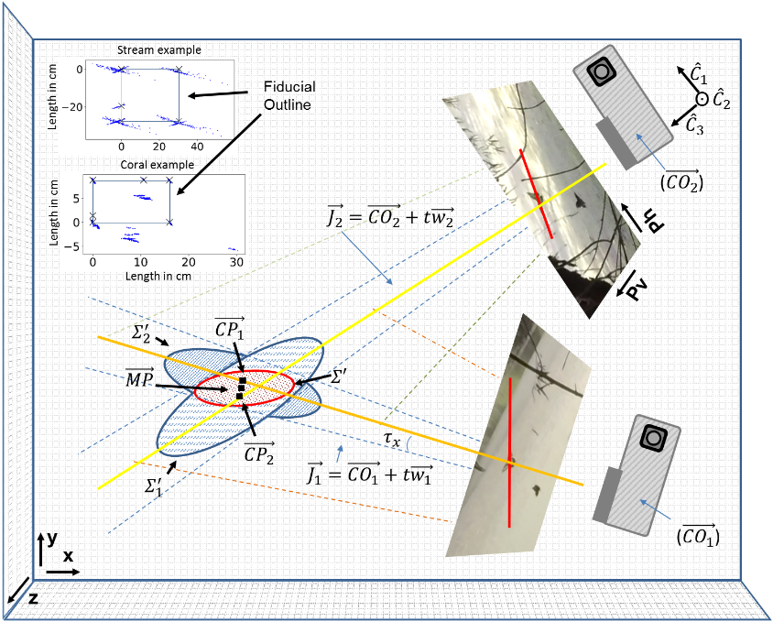

**Figure:** The pixel measurements from the GoPro video can be triangulated in three-dimensional space. ${\hat{C}}_{1}$, ${\hat{C}}_{2}$, and ${\hat{C}}_{3}$ are the unit vectors representing the camera axis in the virtual world. The $\vec{J}$ vectors are lines emanating from the camera through the pixels. The points $\vec{{CP}_{1}}$ and $\vec{{CP}_{2}}$ are the points of closest approach to the skew rays, and the object location, $\vec{MP}$, is the average of these points. The error distributions ($Σ$) are sigmoids displayed. A guiding line of triangulated solutions from a selected point on one camera is mapped onto the other camera (shown in red on the image frames). The distributions of measurements for the corners of the fiducial marker are shown in the upper left corner.

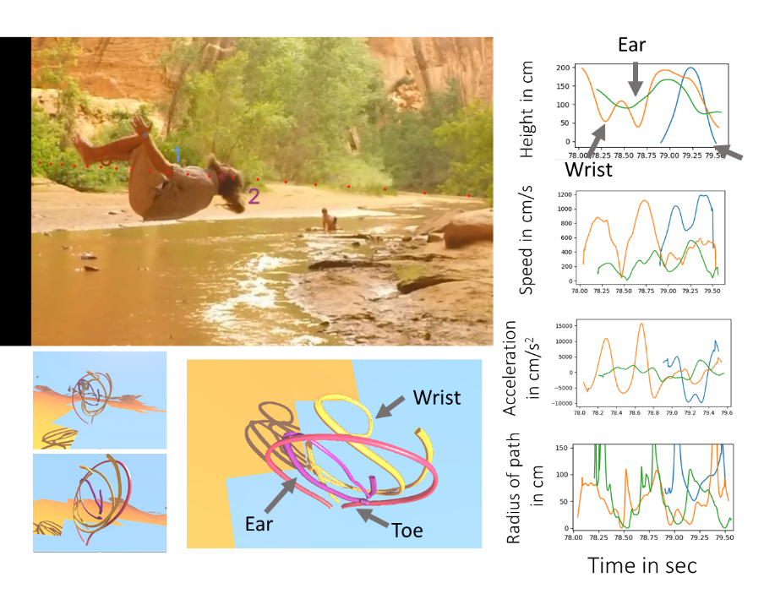

**qwq**

## **Installing the python analysis program PATMOS and MIDOM:**

1. For windows, install anaconda and PyCharm for python 2.7. Please make sure anaconda is installed for python 2.7 and not above python 3.X
2. Put the latest version of PATMOS and MIDOM (currently **PATMOS_MIDOM_200312.py**), ProjectMain.xlsx in the same folder.
3. You will have to put your corresponding to the video files etc. in ProjectMain.xlsx

**Here is an example installation on windows 8.1.**

Done on 9/7/2018 2:10:52 PM

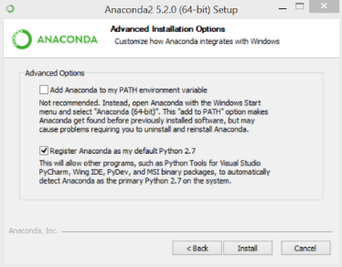

I use PyCharm community edition to work on my programs.

<https://www.jetbrains.com/pycharm/download/#section=windows>

After installing PyCharm you will then need to set the python interpreter in PyCharm to the anaconda interpreter.

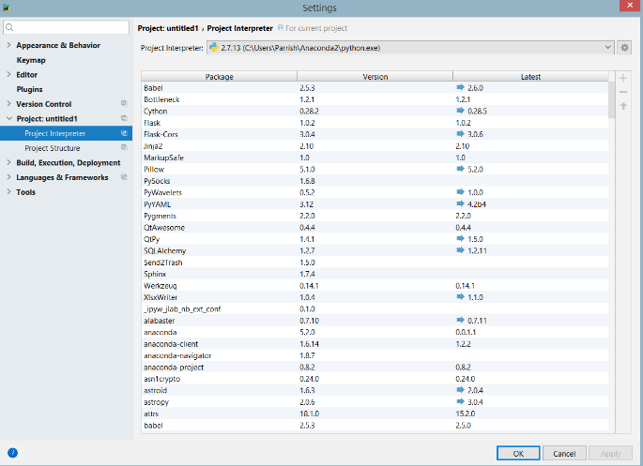

**Here is a list of dependencies for PATMOS_MIDOM_200312.py**

**import** numpy  
**from** datetime **import** datetime  
**import** matplotlib  
matplotlib.use(**"TKAgg"**)  
**import** matplotlib.pyplot **as** plt  
**from** matplotlib.mlab **import** PCA **as** mlabPCA  
**import** shutil  
**import** os  
**import** cv2  
**print** cv2.__version__  
**import** h5py  
**from** mpl_toolkits.mplot3d **import** Axes3D  
**from** mpl_toolkits **import** mplot3d  
**import** xlrd  
**from** xlwt **import** Workbook  
**from** xlutils.copy **import** copy  
**from** scipy.optimize **import** minimize *# pip install scipi after removing it from anaconda***from** stl **import** mesh *#conda install -c conda-forge numpy-stl***from** mpl_toolkits.mplot3d.art3d **import** Poly3DCollection  
**import** glob  
**import** vtk  
**from** scipy.signal **import** savgol_filter  
**if** 1:*#MIDOM only* **from** shapely.geometry **import** Polygon  
 **from** PIL **import** Image  
 **import** pytesseract  
 pytesseract.pytesseract.tesseract_cmd = **r'C:\\Program Files\\Tesseract-OCR\\tesseract.exe'**

**Conda installation routine:**

Installation as of 11/23/2019 8:12:33 PM… The more recent version of conda is having problems installing some of these packages so I have needed to downgrade anaconda.

If the new conda isn’t installing use these:

conda config --set allow_conda_downgrades true

conda install conda=4.6.14

Regular install commands in anaconda

conda install -c conda-forge opencv=3.2.0

If that opencv doesn’t work use:

From https://anaconda.org/conda-forge/opencv

conda install -c conda-forge opencv

<https://anaconda.org/anaconda/xlutils>

conda install -c anaconda xlutils

https://anaconda.org/anaconda/vtk

conda install -c anaconda vtk

conda install -c conda-forge numpy-stl

**for MIDOM only:**

conda install -c conda-forge shapely

<https://stackoverflow.com/questions/14697442/faster-way-of-polygon-intersection-with-shapely>

conda install -c conda-forge pytesseract

If you run the program at this point and you don’t get any **import** errors you are ready to go to the next step.

Run the program by pressing the run button in Pycharm or in your python IDE of your choice.

## **Making the executable:**

I use pyinstaller in windows 10 as administrator through the anaconda prompt to make the python executable. Pyinstaller stores the program in a folder called dist. The process takes a while. After it has compiled you will have to manually copy and paste opencv_ffmpeg310_64.dll into the folder and it is good to go.

This is the command to use pyinstaller in the same folder where PATMOS_MIDOM.py is found.

pyinstaller PATMOS_MIDOM.py

## **Running the premade executable:**

* Extract the zipped files
* Open the folder and get to the folder with all the files.
* Find ProjectMain.xlsx among all the files and open it.
* Make the necessary changes to ProjectMain.xlsx as outlined in this Manual to get it to work.
* Then find the file PATMOS_MIDOM_200324.exe, double click on this file and the program will run.

This is only tested on windows 8.1 and windows 10. It has not been implemented for Macintosh yet.

## **Keyboard key reference:**

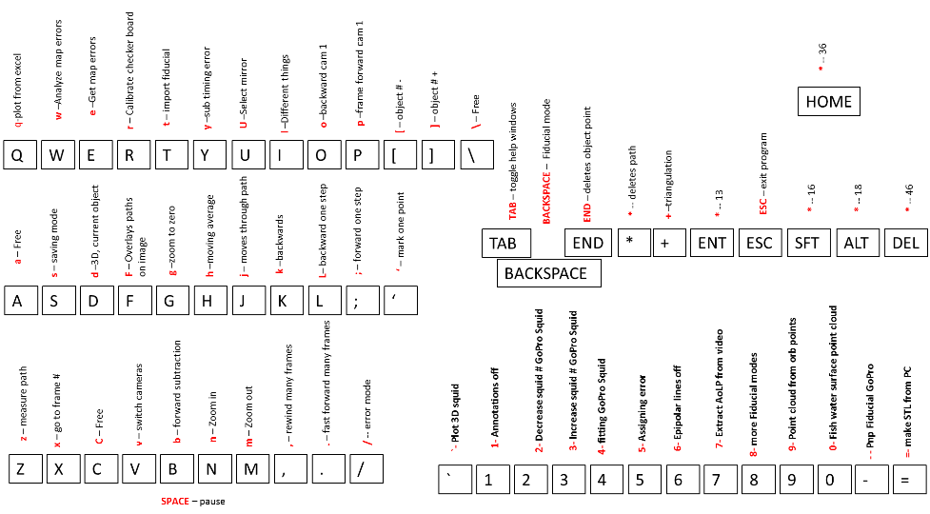

## **Hand Tracking workflow for tracking insects or other animals:**

1. Input the camera names, paths, H5 file names to the ProjectMain.xlsx excel file. You must link the video files with the H5 files in the excel file by putting the mutual file grouping names in the appropriate places.
   1. Select DualGoPros on the “**Main**” sheet in project main by putting an “**\***” to the right of DualGoPros in the “**ToUse**” column in **ProjectMain.xlsx**
   2. The “**Paths**” sheet in **ProjectMain.xlsx** list five columns for paths. The paths important to PATMOS are Paths_to_videos, Paths_to_H5, and Paths_to_ImageFolder. For **DualGoPros** you will only need to supply paths for **Paths_to_videos** and **Paths_to_H5**. The Paths_to_videos is the path to the subfolders containing each GoPro camera’s file list. The GoPro files must be put in a folder specifying the camera used, and those to folders put in a folder to where this path is pointed to. All the H5 files should be kept in one folder for which the path will be put as Path_to_H5. The Paths need to have the folder separator set to “/”. Copying and pasting from windows give “\” which must be changed. The path “name” imputed into the project you are working with will supply the project with the correct paths.
   3. You will need to name the H5 data output for the project which will be created and stored in Path_to_H5. And you will need to input a name for the **ORBprojects** page under the heading of ORB_Name.
   4. The ORB projects sheet lists where you have placed the files from the ORB_SLAM output. This includes
   5. Put **0** in the **frame delay** column until it is measured using the instructions below.
2. Set up the **fiducial object**.
   1. Measure specific points on the fiducial object in three dimensions choosing a point of origin on the fiducial object and measuring the other points in a standard x-y-z cartesian coordinates system.
   2. Label these points by number on some reference sheet that can be referred too and input the points on the sheet “PointsOnObjects” naming the fiducial object in the first row and the second-row labeling x-y-z and the subsequent rows labeling the coordinates under their specific headings. The first column will be a list of integers that read starting from 1 on the same row that the position data begins. These numbers should correspond to the numbers labeled in the reference sheet.
3. Get the mutual frame delay
   1. To time synch the videos using snapping go to the frames around the snapping point (Fastforward 500 frames – “.” Rewind 500 frames – “,” Rewind one frame – “l”, Fastforward one frame – “;” ). Find where the finger is moving. Toggle between cameras (to toggle use “**v**”). Mark the frame point of the snapping finger moving and log the difference in ProjectMain.xlsx and save ProjectMain.xlsx. **frame delay** = frame# **camera1**-frame# **camera2**
   2. Restart the program
4. Find an insect to track
   1. Select which object number you want to track using “[“ to decrease the insect number or “]” to increase the insect number. Here insect referrers to any object to track.
   2. **Double click** on the object to center the object.
   3. **Zoom** in (“n”) and out (“m”) to get to a scale where you can see the insect better.
   4. You can input the insect individually by clicking on “ ’ ” after double-clicking the point that you want to select.
   5. **z-mode tracking**
      1. Press on “**z**” to start the z-mode tracking procedure. This procedure will reduce the size of the window just around the object.
      2. Place the mouse on the object and keep it there and the point will be saved and will move to the next frame.
      3. The program will play 4 previous frames of the video before the next video so that the object may be easier to see. The program will also predict where your next spot will be and have that prediction centered on the frame.
      4. Once you move the mouse the program will be waiting for the mouse to stop for a specific amount of time and then will record the point where the mouse stopped. Thus, you will move the mouse to the new object position and leave it there and the point will be saved.
   6. **Mirroring:**
      1. **Mirroring,** If an object is not in the other frame but is reflected off of a water surface and you have measured the water surface (see “**Getting the surface of water**”) then you can measure the 3D position by measuring the pixel position of the above water object and using another object measuring the reflection in the water.
   7. Use “**j**” to scroll through various places of the track. The recorded point will have a circle around it with the number of the insect.
   8. Then toggle to another insect and repeat.
   9. When toggling between cameras (“**v**”) try to match up the same insect flight with the same insect name on both cameras.
   10. The red dotted line is the epipolar line (or the line of all possible coincident points from the marked object on the other camera) from the same-named object on the other camera. This can help you determine which object is which.
5. **Annotation options:**
   1. To turn off the display of all image **annotations** press “**1**”
   2. To turn on and of the **epipolar** lines press “**6**”
6. When you are all **finished with the tracks** push (“**+**”) and this will calculate the 3D trajectory
   1. The insect number must be the same object for both cameras.
   2. Then press **“h**” to calculate the moving average of the paths.
7. Mark the edges of the fiducial marker in your video file, if this is a box, find a frame that has over three or more points visible with both coincident camera frames.
   1. Select the points for finding the fiducial object using “Backspace”. This will change it to inputting the fiducial markers instead. Fiducial instead of insect should show up on the frame header
   2. Have the 3D real-world inputs of the box inputted into the program. Right now this is imputed directly to the program. This will eventually change to an excel file
   3. Press “**+**” while in fiducial mode to calibrate the spatial quality of the project
   4. If the fiducial object is in another project working with the same map scale, put that project in the Fiducial_Box_Information_from_Other_Project in the DualGoPros sheet. Then press “**t**”.
8. **Creating an STL** fit of a point cloud. “**=**”
   1. The scale must be manually optimized
   2. This takes the point cloud from the ORB_SLAM2 and rotates it to the fiducial frame
   3. The point cloud file needs to be .txt and they need to be separated by one space (ie, if coming from Meshlab xyz mode… the .xyz can be manually changed to .txt) or by “;” which is what comes from ORB_SLAM2.
   4. Uses Map_pointcloud_name column in Orb_Projects as the file name and it saves the file with the same name except with ending “.stl”.
9. **Fitting a water surface** measurement to a plane see “**Getting the surface of water**:” below.
10. **Displaying data** 
    1. Press “q” after everything is set up in ProjectMain.xlsx, see the discussion below for more details.
    2. To **overlay** measured lines on the video image press “f” but only after you have pressed “q” for plotting. It will overlay the paths selected for plotting.

## **An example of hand tracking workflow for tracking insects or other objects:**

To start a new project first open the ProjectMain.xlsx excel file.

On the “**Main**” sheet select “**DualGoPros**” in the “**ToUse**” column by using an “**\***” as shown here:

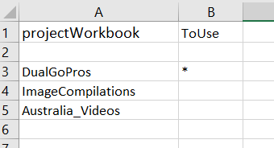

Next go to the “**paths**” sheet as shown here:

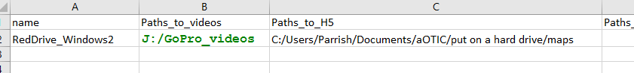

Two paths must be inputted for the Multi-camera tracking procedure labeled “**Paths_to_videos**” and “**Paths_to_H5**”. The paths must be inputted with a forward slash folder separator. For example: **C:/Users/Parrish/Documents/aOTIC/put on a hard drive/maps** and not **C:\Users\Parrish\Documents\aOTIC\put on a hard drive\maps**.

The path “name” imputed into the project you are working with will supply the project with the correct paths.

The video files should be organized by camera name and then into one large video folder, such as: **goprotom/GOPR0243.MP4** and **GoProJill/GOPR0187.MP4**, where “**goprotom”** and “**GoProJill”** are the names of both cameras and both folders are placed in a main folder (“**J:/GoPro_videos”** for example). Write the path to this folder in the “**Paths_to_videos”** column. Place the path to all the files that came from ORB_SLAM2 in the “**Paths_to_H5”** folder. The “**Paths_to_Images”** is for a different type of analysis project. Name this path combination in the “**name**” column with a unique name.

Go to the “**DualGoPro**“sheet:

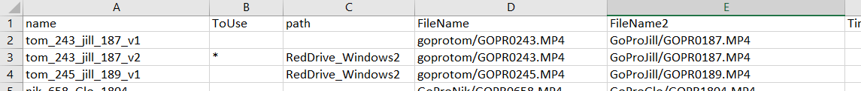

Name the project in the “**name**” column. Put an “**\***” in the “**ToUse**” column next to the project name you are going to use. Put the name of the path combination in the path column. Put the camera folder and file path combination for both videos in the “**FileName”** and “**FileName2”** columns.

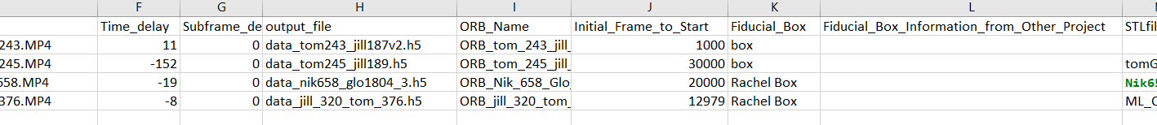

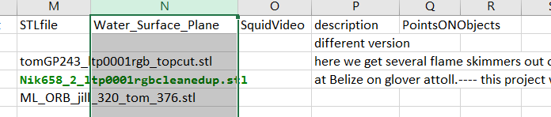

Put a 0 in the “**Time_delay**” and “**Subframe_delay**” column to start with until you have measured the time delay. Name an output file for all the data that will be measured in the “**output_file”** column. This will be an h5 file so put a “.h5” extension on the name. This will be saved in the “**Paths_to_h5”** folder. Put a name in the “**ORB_Name”** column … this will be on another sheet and will have more information about the ORB outputs. Put a number in the “**initial_frame_to_start”** column. For some reason, in my experience, OpenCV does not like to run an MP4 file past frame 233 if it started before 233 so put in a number after 233. Put the name of the fiducial object in the “**Fiducial_Box”** column. This will be discussed later, but the fiducial object names and points will be in the “**PointsOnObjects”** sheet in “**ProjectMain**”. If you have an STL file for the environmental background for the project from ORB_SLAM2 put the name including the extension in the “**Background_STL”** column. The “**description”** column is for a short description of the project.

Go to the **ORB_projects** page:

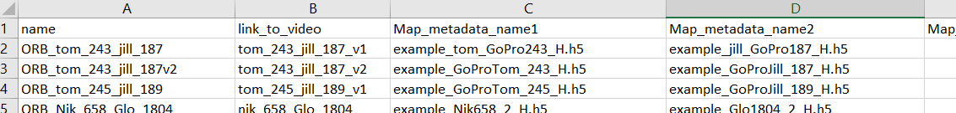

Put the name that you named in the “**ORB_Name”** column in the “**DualGoPro**” sheet in the “**name**” column in the “**ORB_projects**” page. You can put the name of the “**DualGoPro**” project in the “**link_to_video**” column but this is not used in the program. Put the h5 metadata file for each camera in the appropriate column. Make sure that they correspond to the cameras in “**Filename**” and “**Filename2**” in the “**DualGoPro**” sheet or, in other words, make sure they have the same column order. The other columns are for information about the “**ORB_files**”. Where they come from etc.

Go to the “**PointsOnObjects**” page:

The fiducial object should be large enough to be seen in the measurement arena. It should have distinguishable points in all three dimensions. There should be at least 3 points used for an accurate position measurement in multiple dimensions… i.e. all points shouldn’t just be on a plane or a line. An origin should be chosen for the object and district points should be chosen. The points should be measured from the origin and should be in a standard cartesian coordinate system. make sure you choose the x,y,z, directions below with the arrows point in positive directions.



These numbered points should be listed in the “**PointsOnObjects**” page. The numerical list should be in the first column and should start on row number 3. The name for the fiducial object should be in the first row and the x,y,z coordinates should be just below the name and occupy the next two columns. The name can be placed in any column except the first one and provided it doesn’t interfere with another group. The values should be placed in the x,y,z columns as shown below:



To find the frame delay of the project:

First, run the program. Help windows will show up. Toggle different help windows using Tab.

Help windows 1,2,3, and 4:

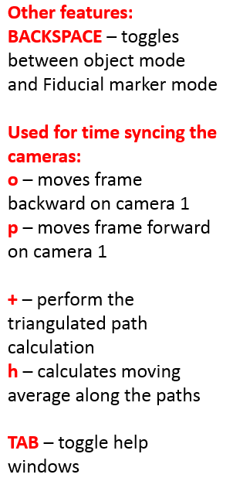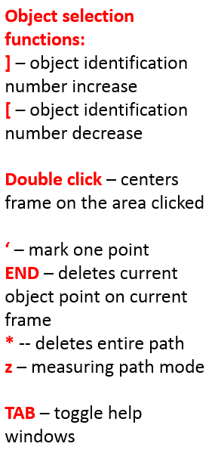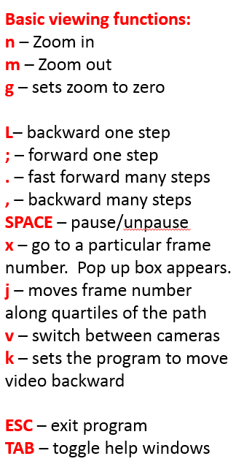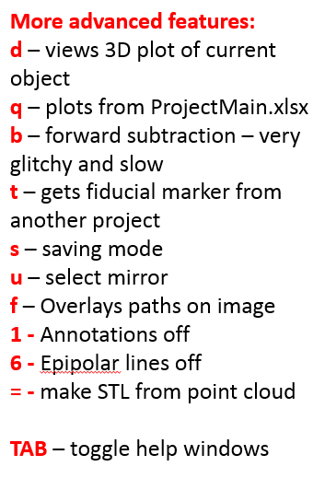

This is the header for the image. Showing the insect number (**insect0**) the camera number (**camera1** vs **camera2**) the frame number (32862) and an indicator as to whether the camera metadata is present for this frame with “h5good”.



Get to the place in the video file where you have the time synchronizing snap using these controls:



Switch to **camera2** using the “**v**” function and find the place where the finger in a discernable motion state. Switch back to **camera1** and search for the frame that has the finger in the same state using the “**o**” (backward) and “**p**” (forward) keys for just **camera1**. Toggle back and forth between the cameras to make sure you are satisfied with the synchronization. Then put the difference of frame of **camera1** from the frame in **camera2** (frame delay = frame# **camera1**-frame# **camera2**) and put it in the “**Time_delay**” column in “**ProjectMain**” and restart the program by exiting with **ESC**.

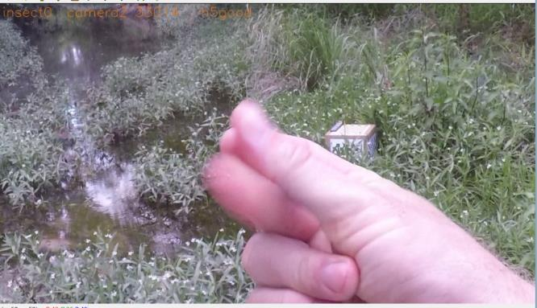

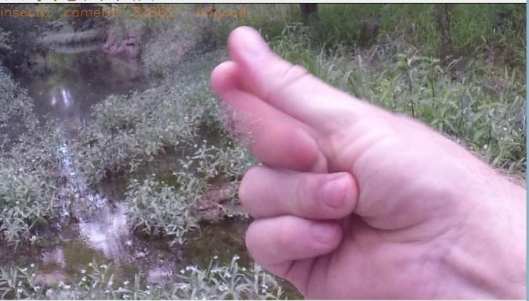

**Start tracking**:

Find an insect or object etc.

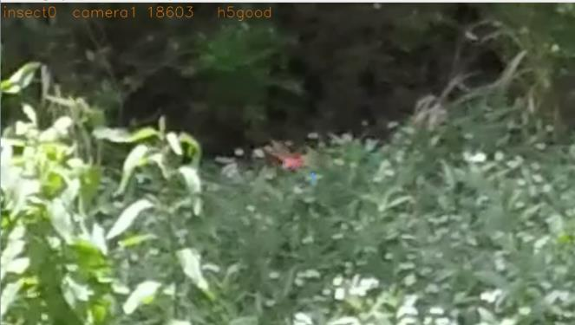

Then double click on that object and zoom in.

Click on “**z**” to start the special tracking procedure. This procedure will reduce the size of the window just around the object. Place the mouse on the object and keep it there and the point will be saved and will move to the next frame. The program will play 4 frames of the video before the next video so that the object may be easier to see. The program will also predict where your next spot will be and have that prediction centered on the frame. Once you move the mouse the program will be waiting for the mouse to stop for a specific amount of time and then will record the point where the mouse stopped. Thus, you will move the mouse to the new object position and leave it there and the point will be saved.

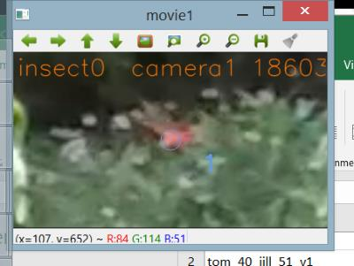

Here is an example of the smaller window after pressing “**z**”.

Pressing “**v**” toggles back and forth between the two camera feeds at coincident frames. The epipolar line from the other frame will show up on this frame as a line of red dots. This is the line of all points in this frame that will be triangulated with the other frame.

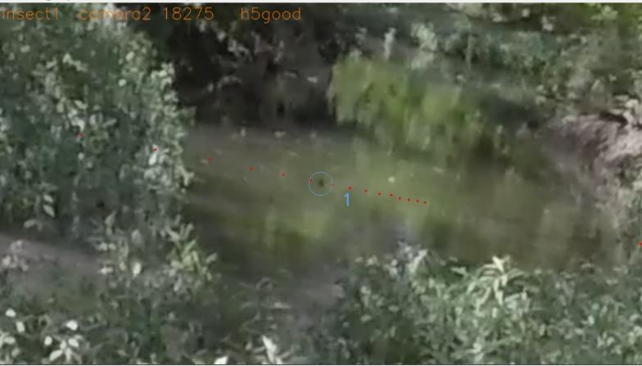

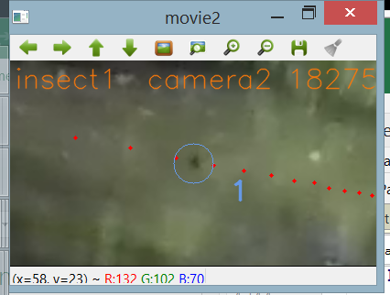

### **Measuring the fiducial object:**

It is much the same for tracking an object. You press “**BACKSPACE”** to get to the fiducial object measuring mode.

Instead of insect# you have fiducial0_#. You look for points on the fiducial marker that are visible in both camera frames and you change the fiducial point number just as you would insect number.

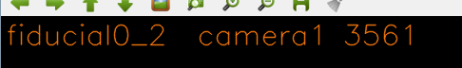

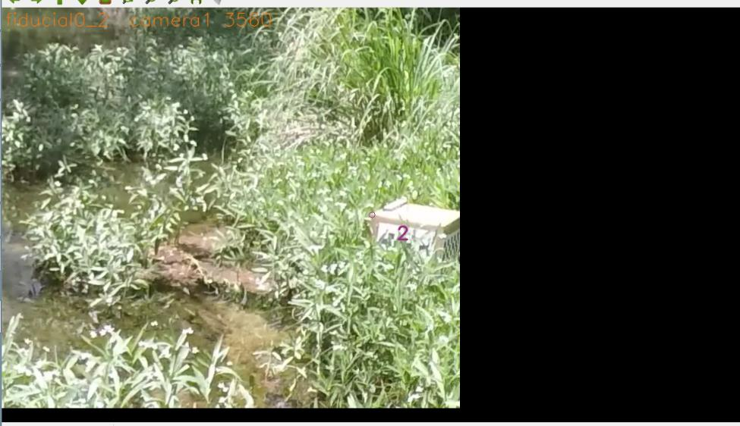

### **Mirroring:**

With this program, it is possible to measure the path of an object using just one camera if the object and the reflection of the object can be seen. If the water surface has been measured from the ORB_SLAM2 point cloud (see “**Getting the surface of water**” below) then the 3D position of the object can be measured from the pixel position of the above water object and measuring the reflection of the object in the water. Both the object and the reflections of the objects need to have a different “insect number.”

The object and the reflection need to be connected by using the “u” key….

You go to the object number which represents the reflection of another object.

You press the “u”. you will be prompted by the statement “Type the object number you wish Mirror to and press enter:”

Type in the integer number that represents the object number of the object that is the real object of the reflection and press enter. The program stores that number and displays it in the display image header

In this example, insect5 is the real object and 85 is the reflected object. The header indicates “Mir. From insect85”

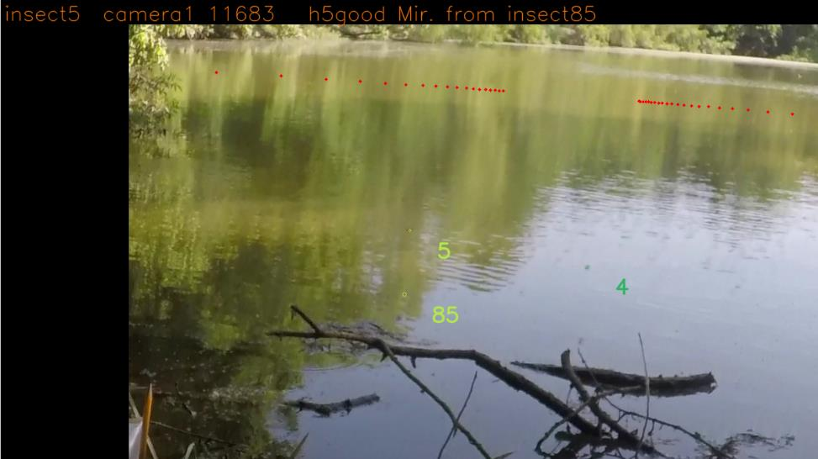

And when selected to insect85 the header states “Mir. to insect5”

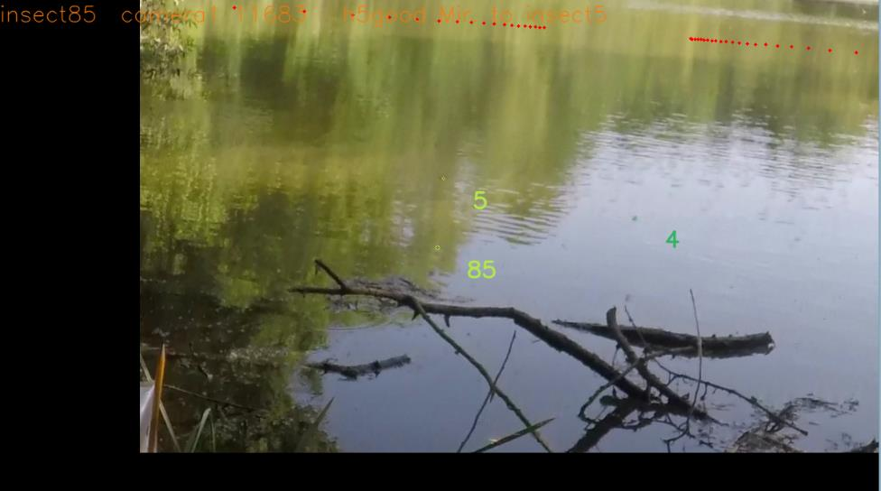

### **Computing the paths**:

In the fiducial mode, press **“+”** to calculate the fiducial calculation and points.

In the normal mode, press **“+”** to calculate the tracks.

Then press **“h”** to calculate the smoothed averages of the tracks.

## **Importing a Fiducial Marker from another project:**

* To import the fiducial information from another project that uses the same map, place the name of the project you want to import the fiducial information from in the “Fiducial_Box_Information_from_Other_Project” column in the DualGoPros sheet in ProjectMain.xlsx
* Run the program.
* Then press **“t”**.

## **Measuring and using a subframe delay offset for improved accuracy:**

Here we measure the subframe rate error to get a delay lower than the frame rate. Pressing “y” will measure the average error for the current path with subframe rate delays added to the overall delay. The results are outputted in the program terminal output and you must manually measure the delay with the lowest error value. Values may not be the same for various paths, and so one would have to take an average of various paths. When a subframe delay is found close the program and put the subframe delay in the Subframe_delay column of the DualGoPros sheet.

## **Measuring the minimum error limit of the camera measurements in reference to the map:**

One can use the map data from ORB_SLAM2 to automatically measure coincident ORB points on two cameras and the 3D point measurement to get the spread of the camera error. You will need the full map data from ORB_SLAM2, not the camera only file. This will serve as a minimum error value for the measurement. The path errors will be larger, due the inaccuracies of measuring the correct pixel of the object. If the map making has made any obvious errors this will also be inaccurate.

This takes the ORB points that ORB_SLAM2 uses, (which are recorded with the map data) and finds which points are shared by both coincident cameras. The map points are associated with a unique ID. This program looks for points in each coincident camera that share the same ID. The program then measures the calculated 3D map points based off of the camera information and the pixel value of the map points. The program gathers a distribution of map points from several frames of the camera (measure thousands of frames for this). The program measures standard deviations of this distribution. One standard deviation is the difference of the map point to the average map point dotted with the unit vector of the vector comprising of the difference of the average map point and the average position of the camera. This gives an axial distribution of error, where the error is likely to be the largest. The second distribution dots the vector with the vector that is perpendicular to the difference of the average map point and the average position of the camera and is also in the vertical plane. This servers as the vertical distribution which should have the least amount of error variation.

Press “**e**” and while the video is running it will measure the coincident points. You can let it run throughout the entire video or you can jump through the video measuring sections though the video. Then press “**w**” and the distance verses error graphs will be displayed. The data will be outputted in an excel file. The output name and path comes from the plottingSheet. If you have not inputted it there it will not show up. The distances are limited to 0.8 m to 10 m but can be changed in the program.

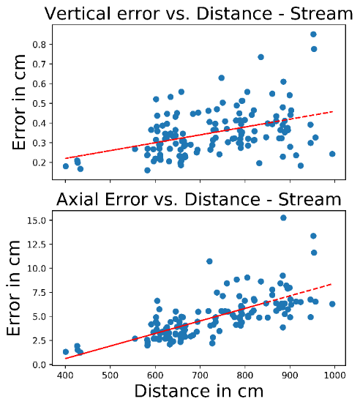

## **Getting the surface of water:**

When filming and mapping around a still, flat water surface the edges of an object touching the water at the surface of the water are often chosen by the program as an ORB_SLAM2 map point. As a result, there are often numerous points that can be seen at the water surface. This effect can be seen as a flat, high density, plane of points when the point cloud is rotated (see below). This plane can be cut out of the point cloud using a point cloud manipulation program (such as MeshLab) and can be fitted to an analytic plane.

### **Directions using MeshLab:**

Open mesh lab.

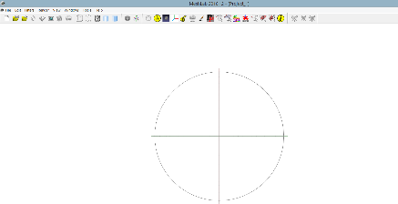

Import point cloud from ORB_SLAM2:

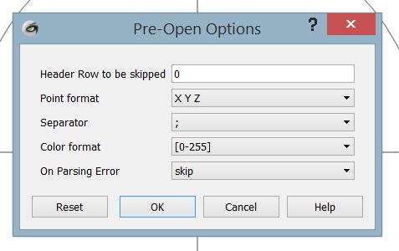

Use the appropriate separator in your file. The output of ORB_SLAM2 uses a single space “ “ as a separator.

Use General MeshLab commands from <http://www.cse.iitd.ac.in/~mcs112609/Meshlab%20Tutorial.pdf>

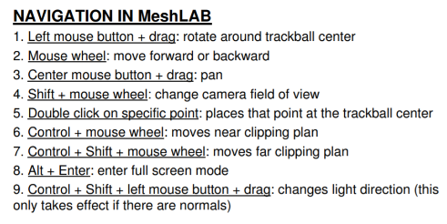

Spin the point cloud so that the water line is most distinct and either vertical or horizontal.

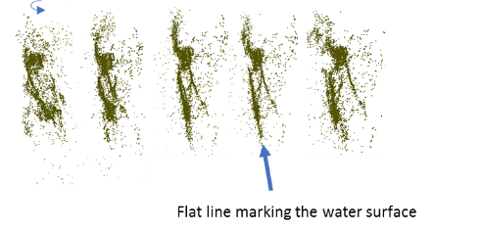

Select all points that are not part of this plane to delete.

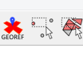

Ctrl+delete will delete selected points

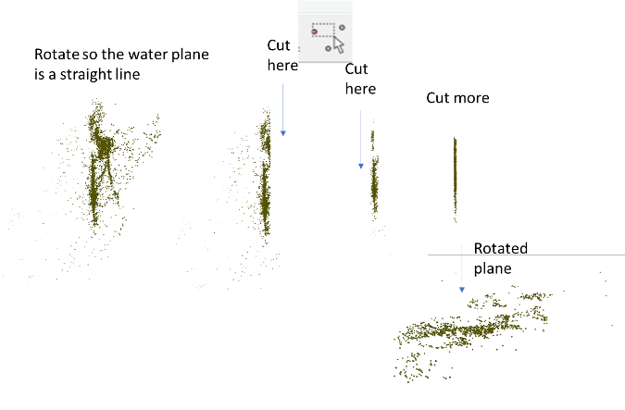

Export the water plane point cloud.

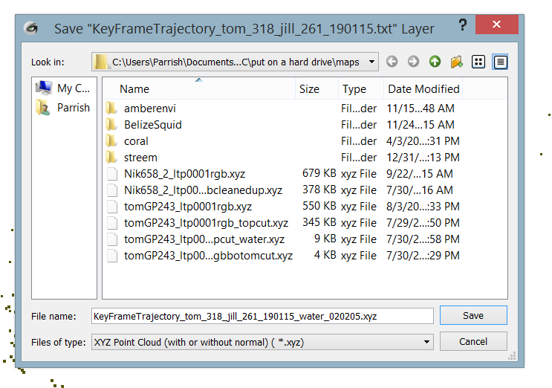

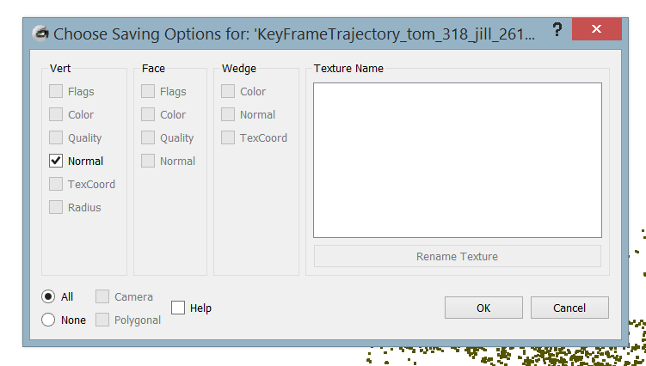

Replace the xyz extension with txt

Place the file name in the “**Water_Surface_Point_Cloud”** column in ProjectMain.xlsx and save ProjectMain.xlsx

When the program is running press **“0”** to calculate the fit.

Then copy and paste the text output into the **Water_Surface_Plane** column of the **DualGoPro** sheet in ProjectMain.xlsx and save ProjectMain.xlsx. This text output is the output of two water planes that fit the data. The first one is with the given raw point cloud data and the second one is the fiducial transformed data. Each one is a list of 4 comma-separated numbers, and both groups are separated with a “;”.

## **Discussion of mirroring:**

With this program, it is possible to measure the path of an object using just one camera if the object and the reflection of the object can be seen. If the water surface has been measured from the ORB_SLAM2 point cloud (see “**Getting the surface of water**” below) then the 3D position of the object can be measured from the pixel position of the above water object and measuring the reflection of the object in the water. This comes from geometry that is derived below:

The camera will intersect the water with a vertical plane that will contain both the object point and the virtual object point or the position of the reflected object if it were indeed underwater.

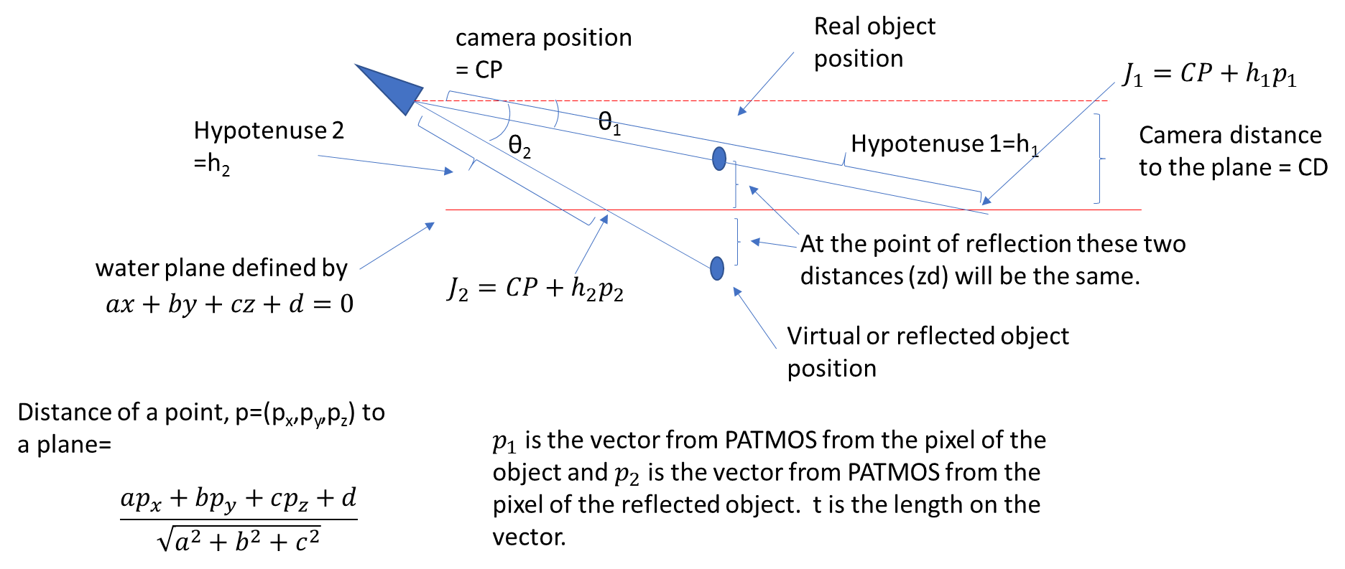

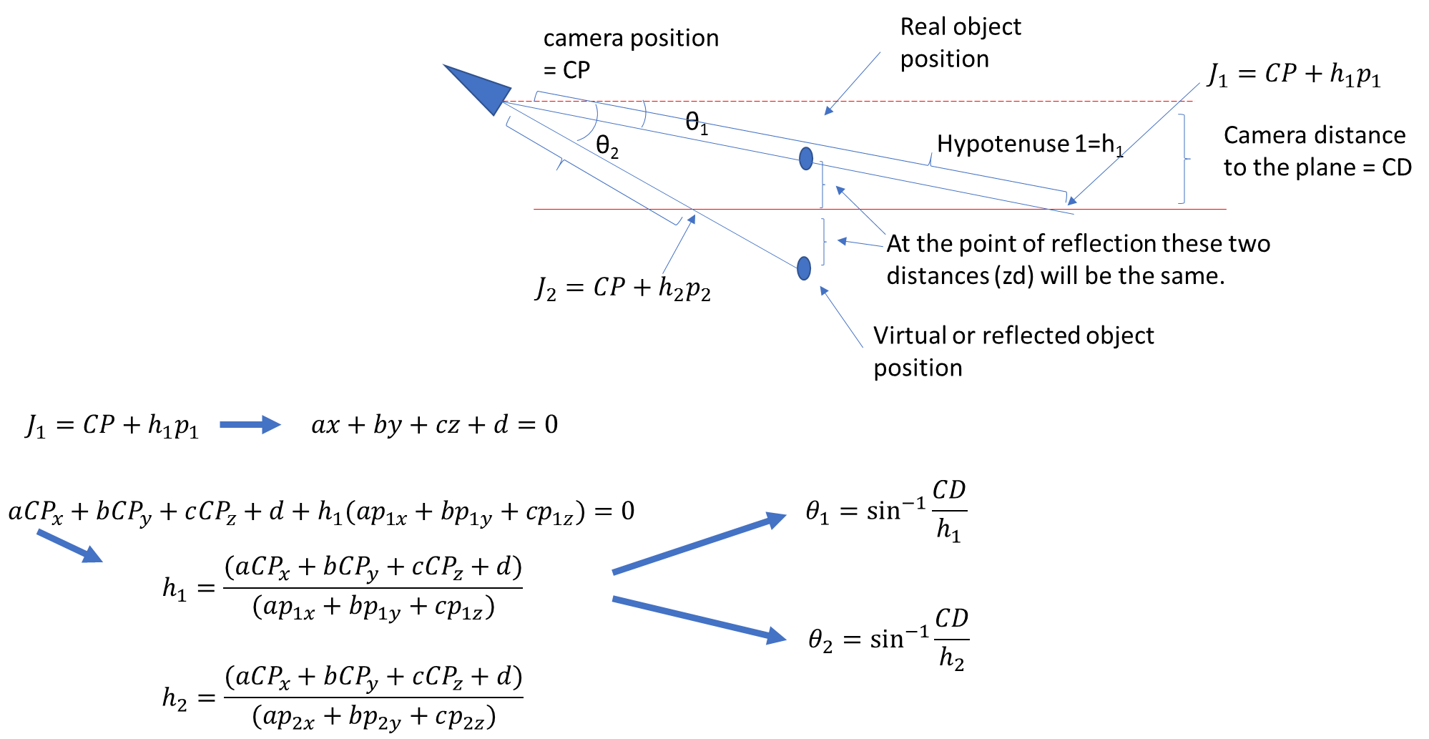

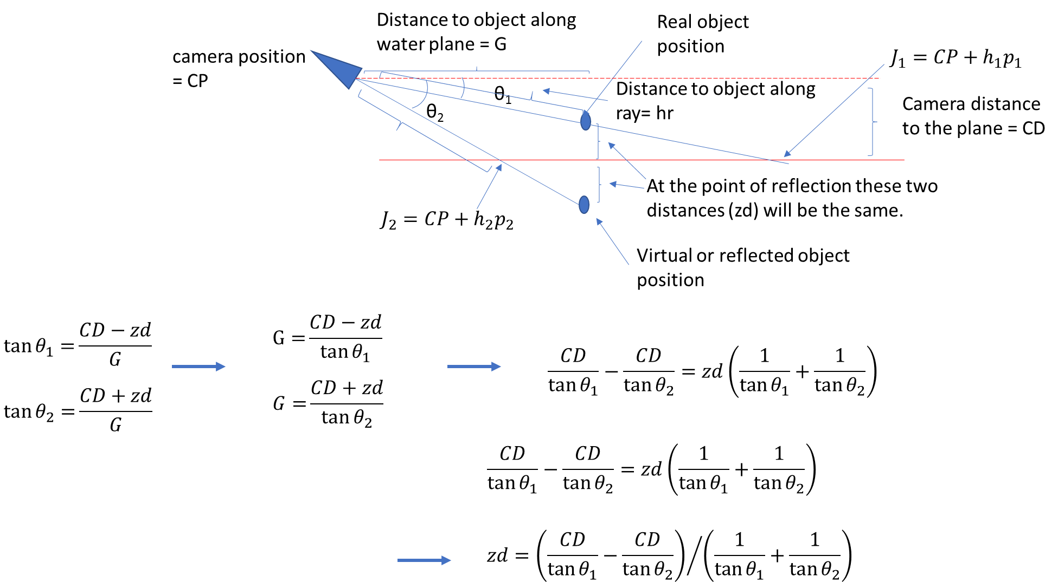

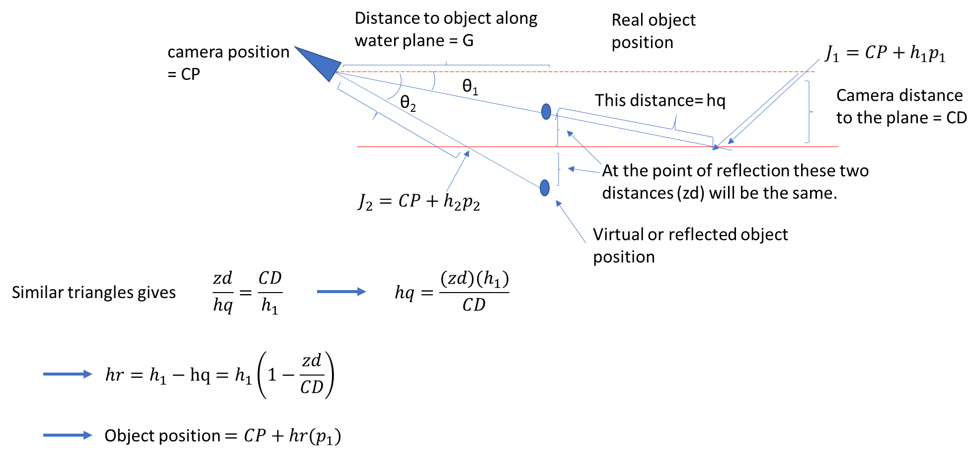

And thus we obtain the 3D object position.

## **Fitting an SLT to point cloud data:**

**Technical details --- Making fits to cloud points:**

A fitted Standard Tessellation Language (STL) surface to an ORB_SLAM2 point cloud map enables the quantification of animal proximity to the environment. I have developed an STL fitting algorithm (which I call the gridded average algorithm) such that the resulting surface values are an average of a subset of ORB_SLAM2 map points. This algorithm uniformly grids the horizontal plane of the environment and takes the vertical average of all the points within each grid unit. The point cloud map data is prepared for this algorithm in a point cloud manipulation program, such as MeshLab, by cleaning up spurious map points and deleting points or parts of the map that would interfere with the desired vertical average (such as a branch hanging over an environment or reflected virtual map points from the water’s surface). A map transformed with the fiducial transformations will have a horizontal plane perpendicular to gravity and resulting in a natural symmetry for which to take a vertical average. I use the python-based package numpy-stl to organize the resulting average values into a triangulated surface and save the result as an SLT. Small holes in the surface are given interpolated values when surrounded by a sufficient number of points.

Water surfaces measured with ORB_SLAM2 often have sharp boundaries with objects intersecting the water and are often chosen as ORB mapping points. These points form a distinct plane that can be fitted to an analytic plane. This water surface plane can be incorporated into the above STL algorithm by setting all voided areas in the map corresponding to the water’s surface to the values of this analytic plane. Distances between animals and the STL mesh can be measured using the visualization toolkit (VTK) python package which can locate the intersection of a line emanating from a point with an STL surface. To find the minimal distance between the path and the mesh I either use VTK to find minima in a known direction such as vertical. Or to find the minimal distance from a point to the VTK surface I find the closest vertex to the point and use three-dimensional vector geometry to find the closest distance to the mesh near this point.

**Procedure:**

The point cloud file needs to be .txt and they need to be separated by one space (ie, if coming from mesh lab xyz mode… the .xyz can be manually changed to .txt) or by a “**;**” which is what comes from ORB_SLAM2.

Put the text file of the point cloud you want an STL fit of in the **Map_pointcloud_name** column in **Orb_Projects.** This text file will need to be in the folder specified by the Paths_to_H5 column in the “Paths” sheet.  The STL will be saved with the same name in the same folder except with the file ending in “.stl”.

Then choose the scale for the SLT in the **Map_pointcloud_scale** column in the “**Orb_Projects**” sheet. Here are some examples of different scale numbers with a particular map. The larger the scale number the finer the sampler area of the mesh.

**Scale=0.1**

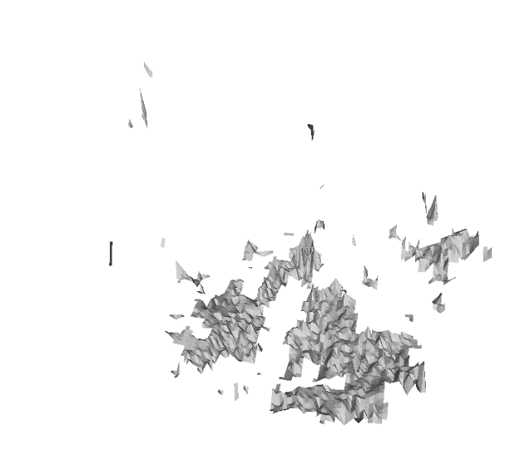

**Scale=0.05**

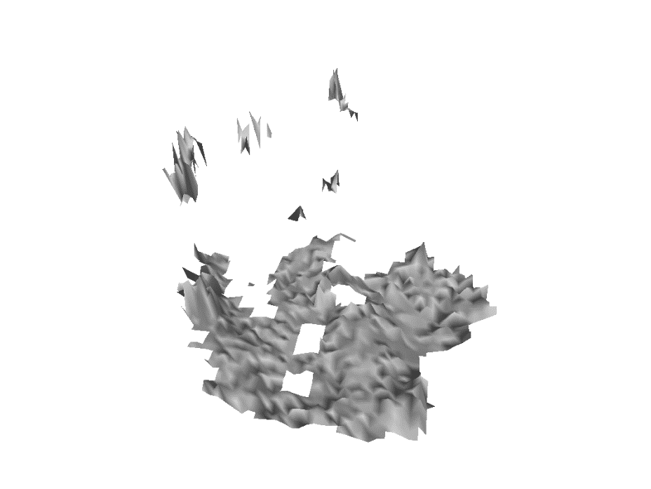

**And scale = 0.01**

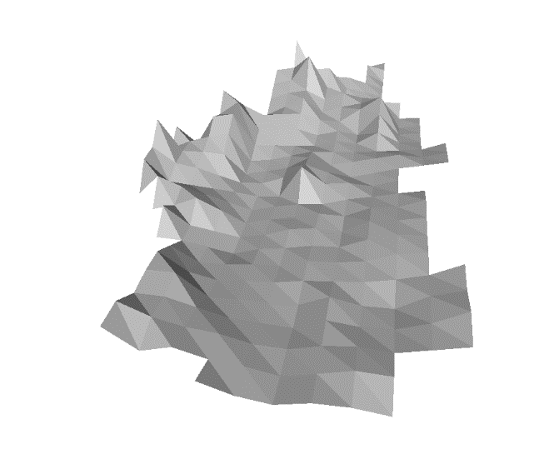

In this case I would choose scale of 0.05 as a scale that gives us the most information.

When you press **“=”** you will be given the following prompt:

“If you want an STL from just the point cloud enter 0

If you want an STL from the point cloud and the water plane enter 1

If you want an STL of the water plane without the point cloud enter 2”

You have the choice of using the water plane derived and talked about in section “Getting the surface of water” in the STL making process. You can merge the water plane with the rest of the STL, and you can get just the water plane as an STL if you want to put it in Blender as a separate object for illustration purposes.

For the water surfaces to work you need to have fit the water plane as in “Getting the surface of water” and then entering the values of the fit in the “**Water_Surface_Plane**” column of the **DualGoPros** sheet.

If you choose 1 you will get:

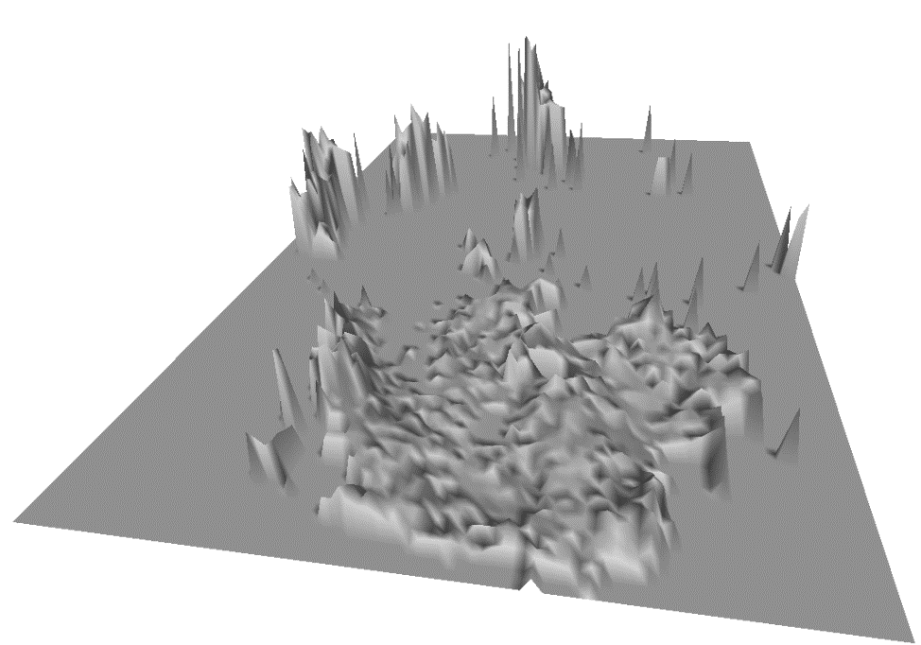

Or for various reasons if you just want the flat water you choose 2 which will give you:

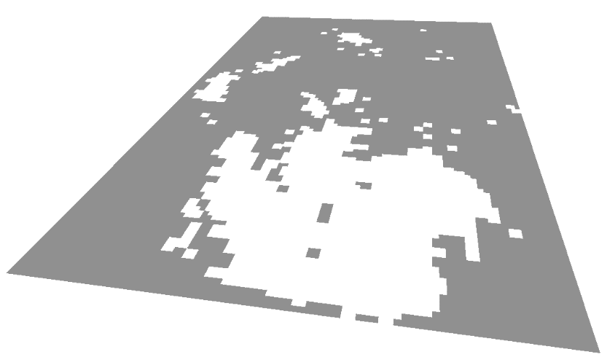

This SLT will be in the scale determined by the Fiducial Object.

## **Plotting and analyzing the data:**

**PlottingSheet**

The PlottingSheet is an excel worksheet used to organize and view data visualization and analysis. Here you can list various paths to be viewed, next to each other in single or multiple outputs. The kinematics for the paths are also calculated. The graphs can be plotted in 3D path view, kinematic view, polar plots, and box plots. Changes can be made to the spreadsheet in ProjectMain.xlsx and saved …. then “q” can be pressed in the program and the graphs will be plotted with new parameters.

**Press “q” to load the plot**

### **The PlottingSheet parameters and explanations are listed as follows:**

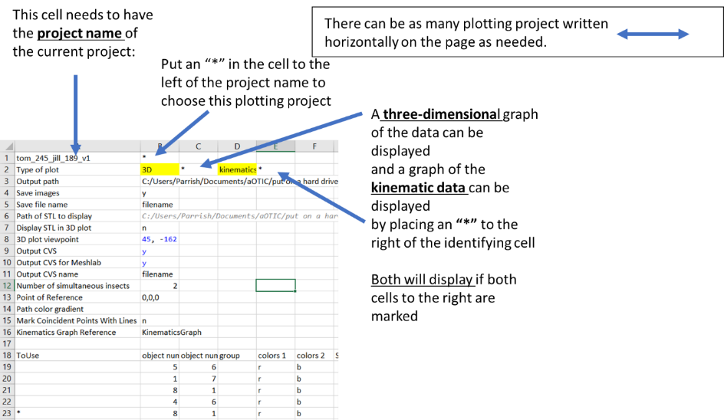

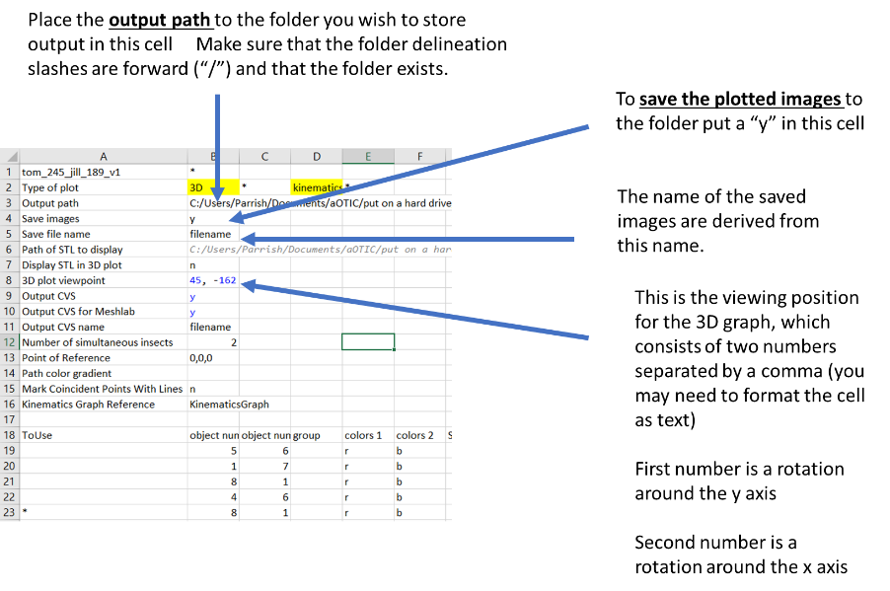

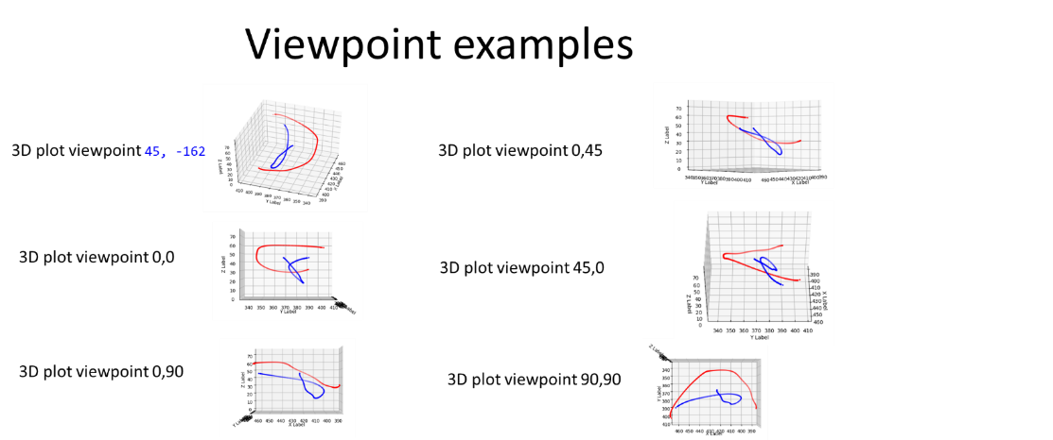

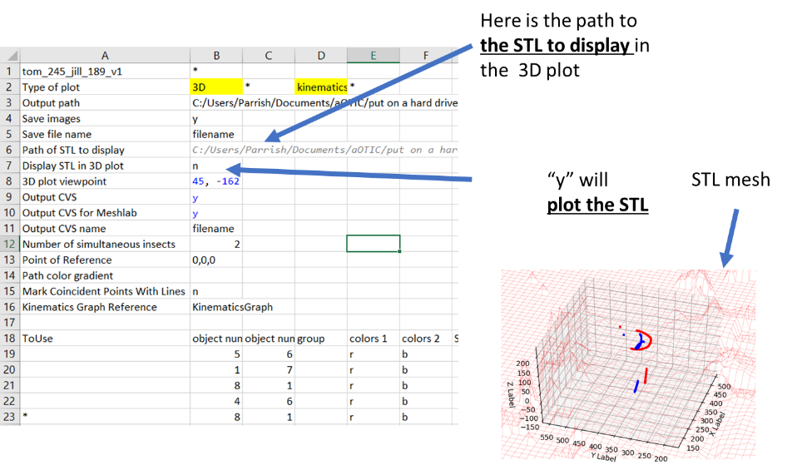

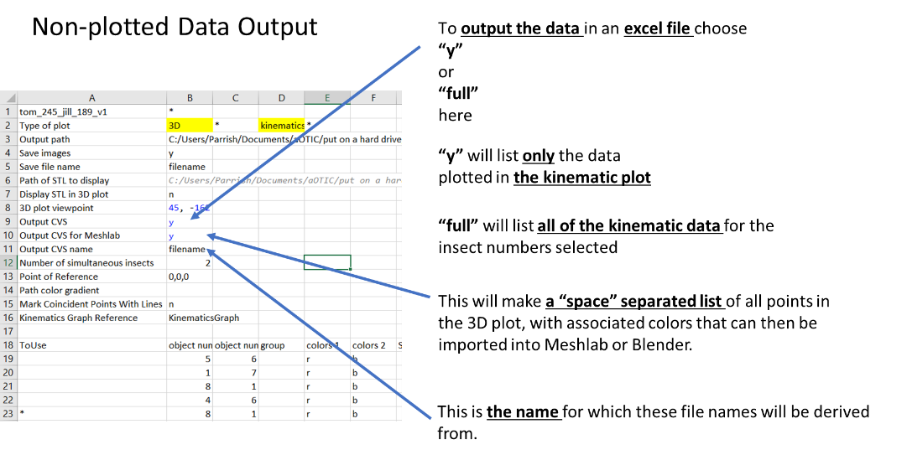

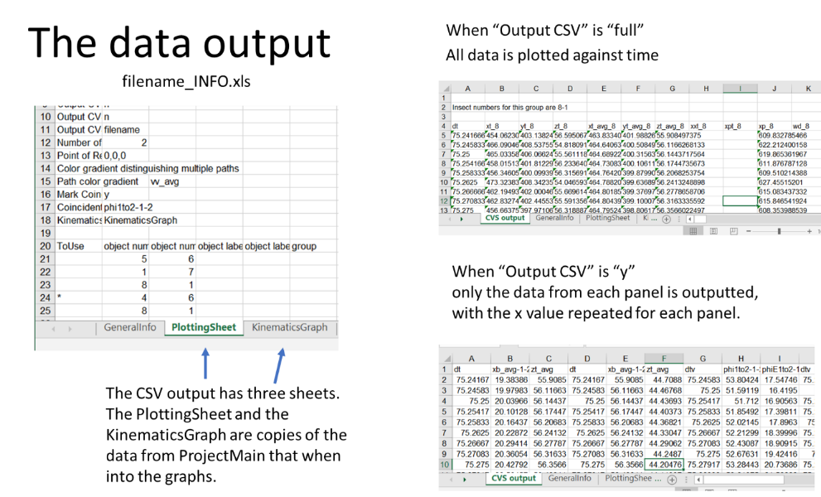

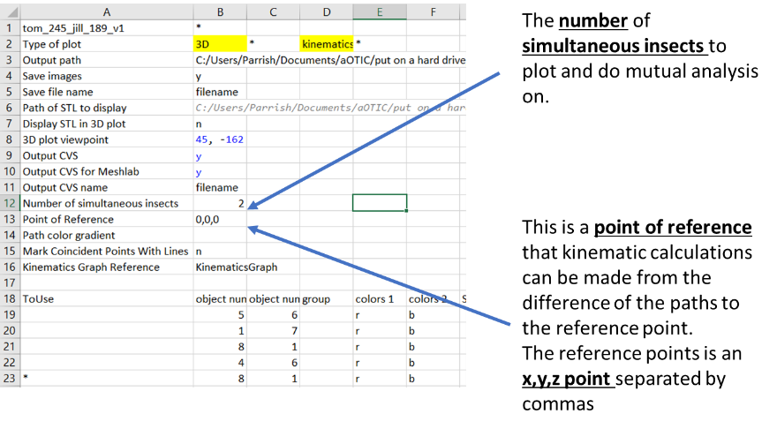

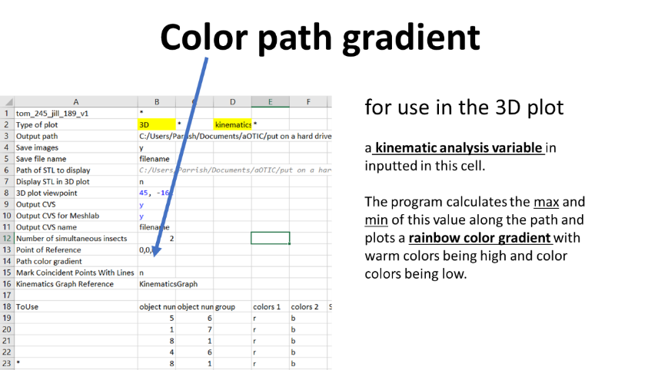

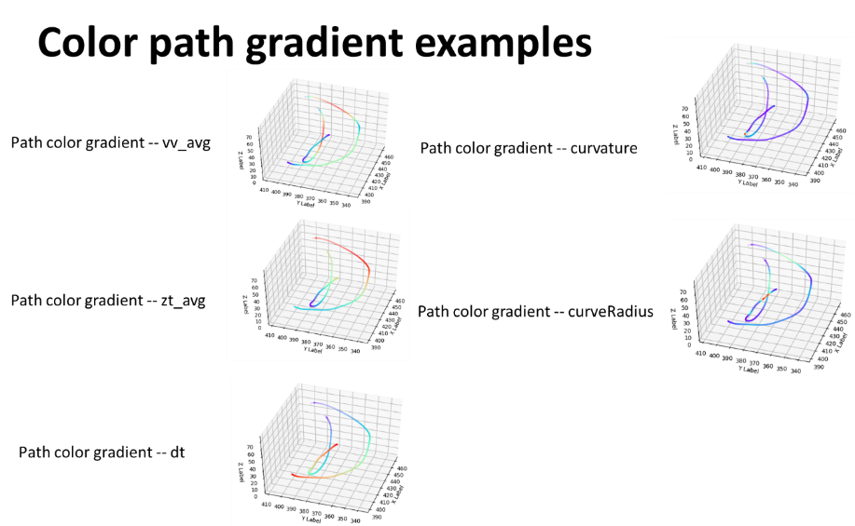

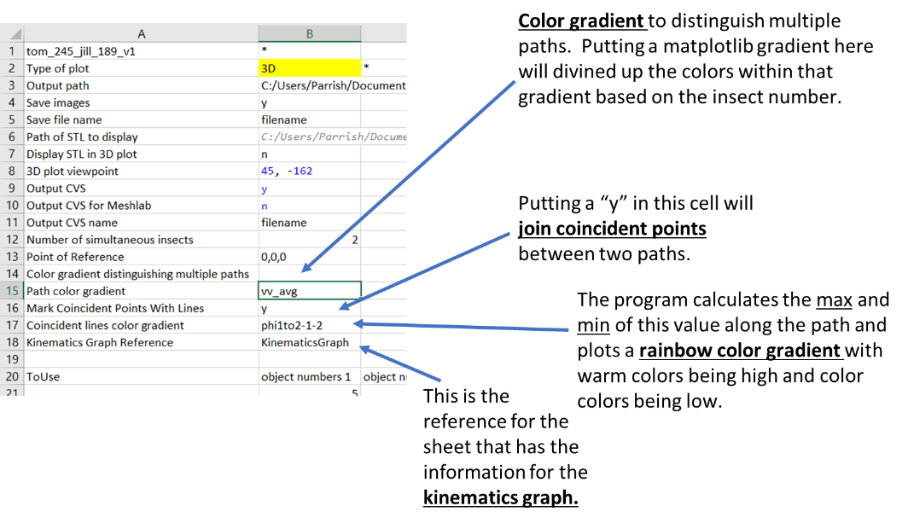

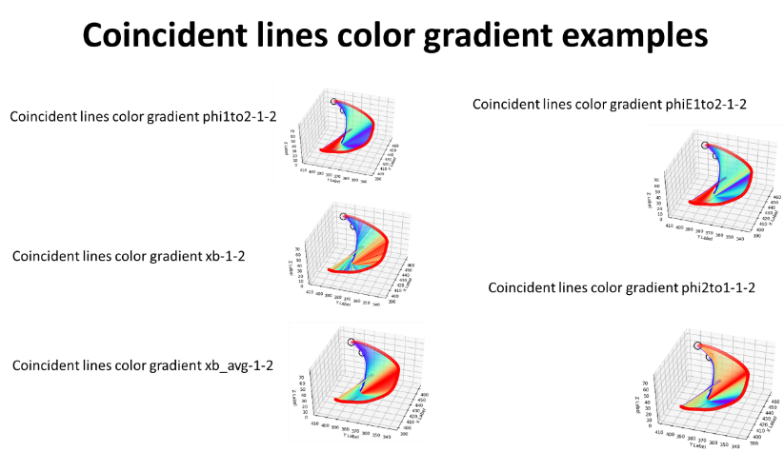

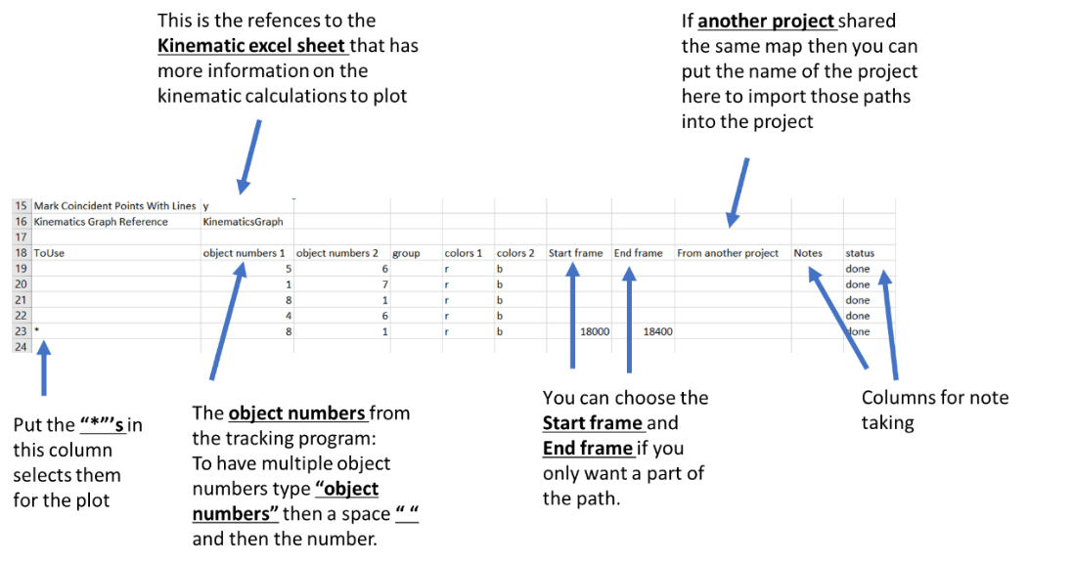

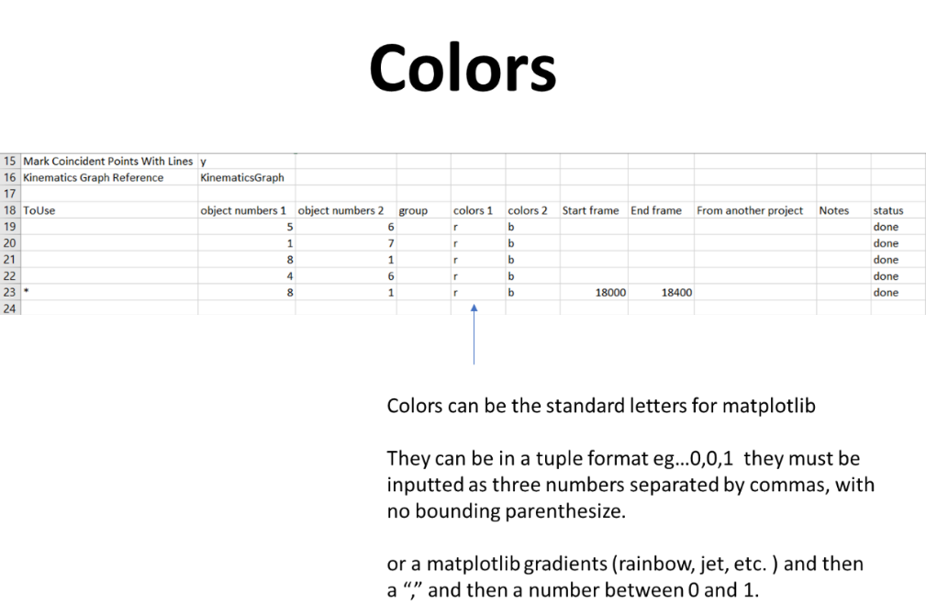

### **The KinematicsGraph parameters and explanations are listed as follows:**

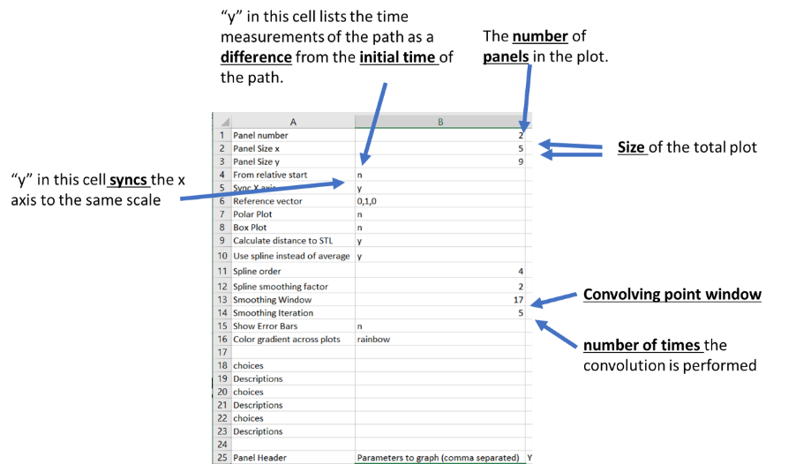

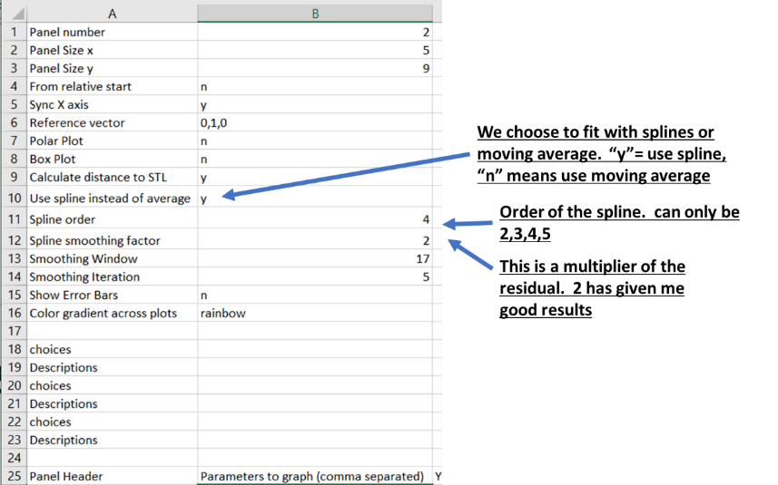

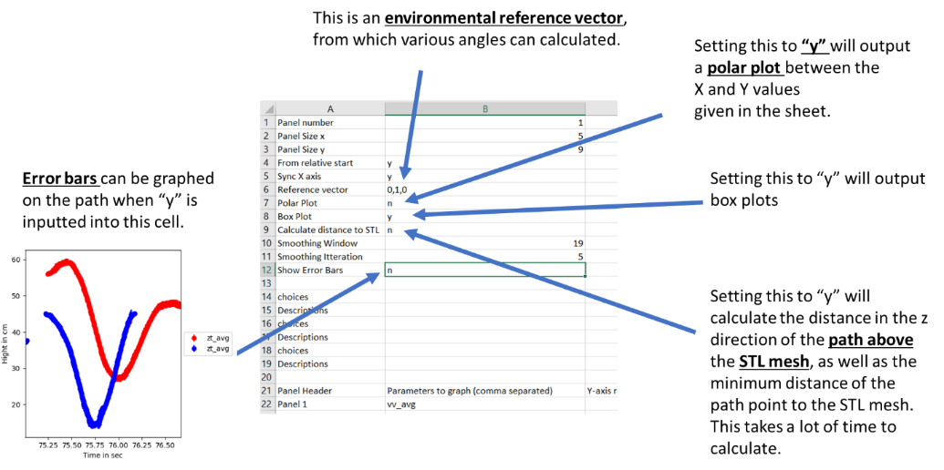

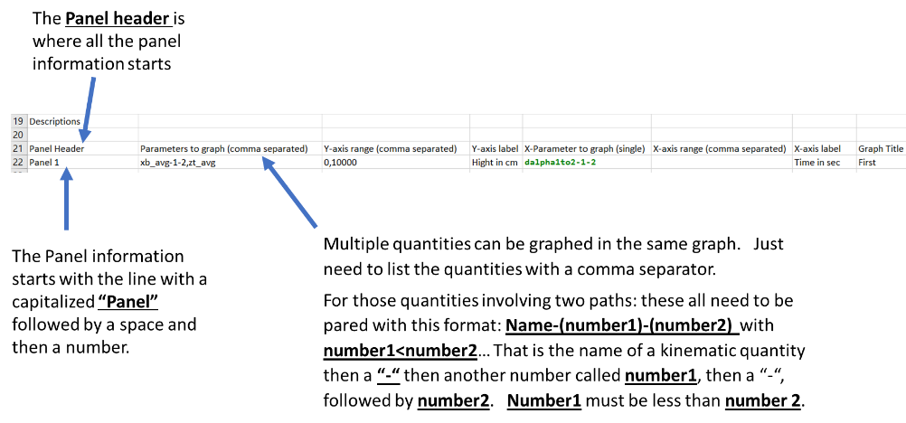

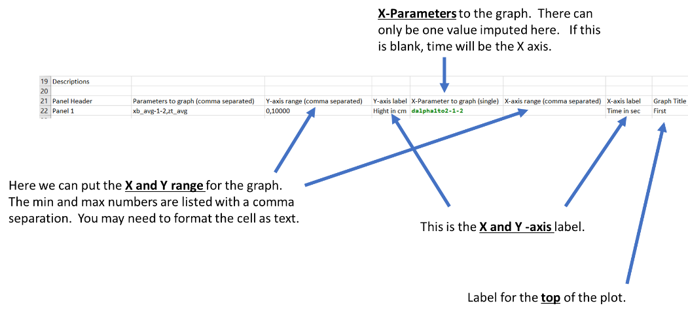

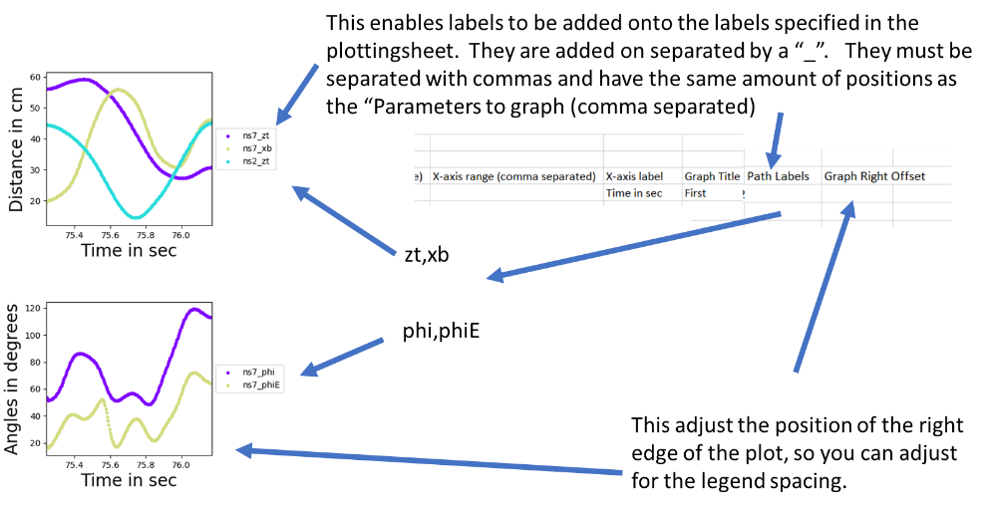

### **Assigning and analysis of Kinematic variable for visualization:**

PATMOS can calculate various Kinematic properties of the path and plot them with inputs made to ProjectMain.xlsx

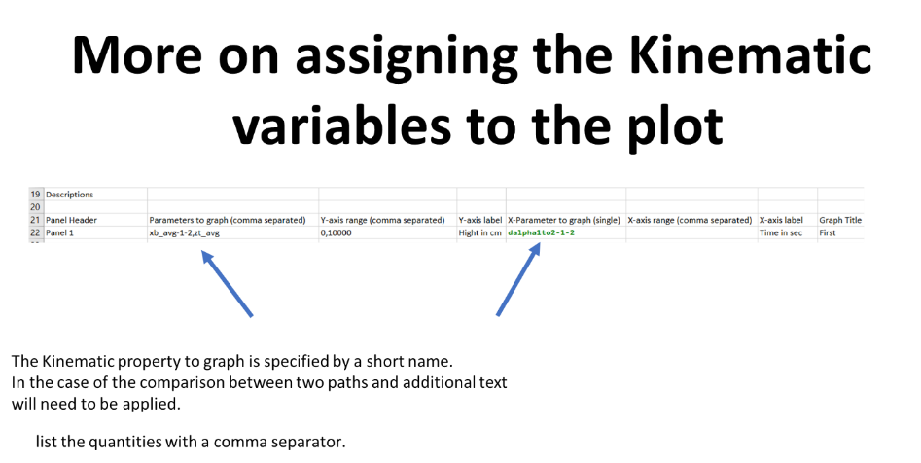

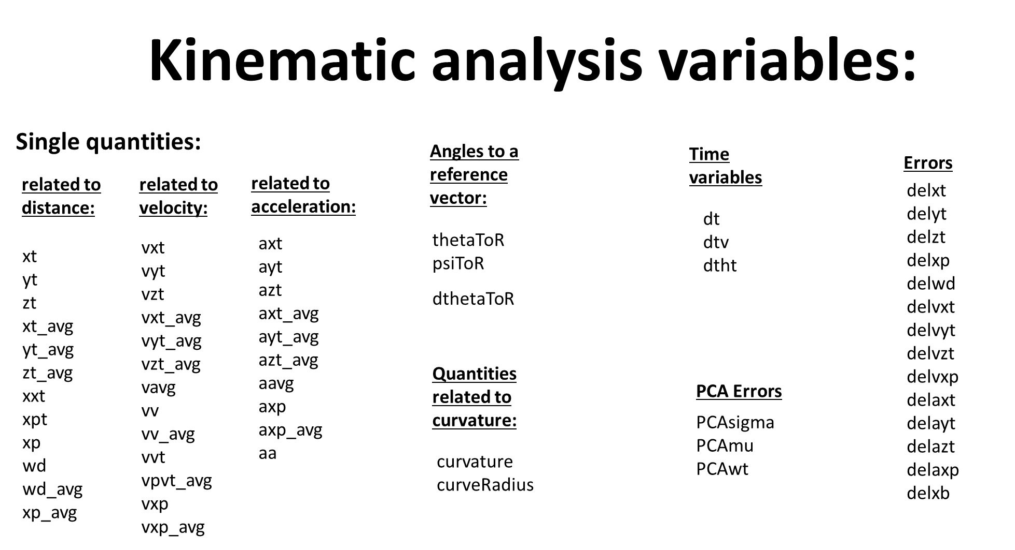

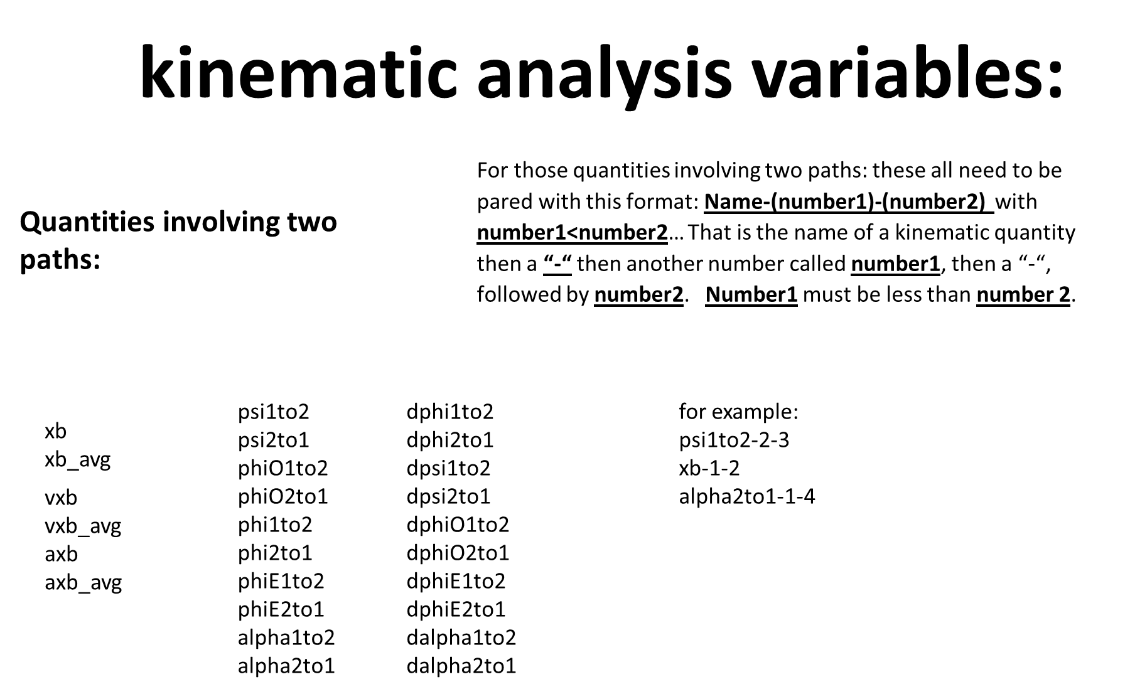

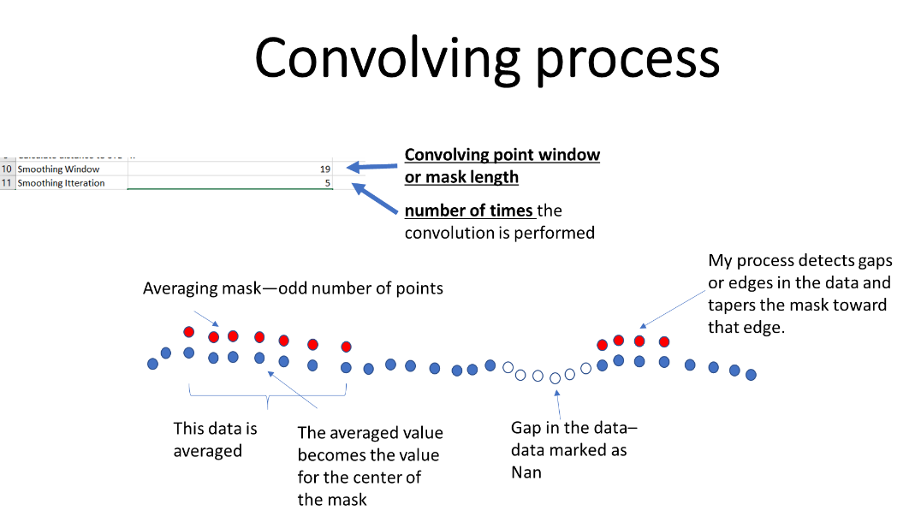

**Splines**

Use univariate spline fitting from scipy. You can input the spline order on the Kinematic sheet. It need to be greater than 1 and less than 5.

the Smoothing factor s=bfactor*(len(ztRawCP)-1)*delztavg**2

This is derived from the error standard deviations calculated below. The smoothing factor is the residual from all points in the spline fit, and that residual will be (N-1)*std^2. The bfactor can be inputted in the Kinematic sheet.

**Spatial calculations**

**xt** = raw position values for x

**yt** = raw position values for y

**zt** = raw position values for z

**xxt** = distance from the first point

**xpt** = Path length

**xp** = Distance from the insect to the reference point

**wd** = distance to water surface if the water surface of a pond has been measured.

for a water plane defined by

$$ax+by+cz+d=0$$

The distance of a point, p=(px,py,pz) to a plane (or wd)=

$$\frac{ap_{x}+bp_{y}+cp_{z}+d}{\sqrt{a^{2}+b^{2}+c^{2}}}$$

**distz** = distance to the STL surface in the z-direction

**dist** = closest distance to the STL surface

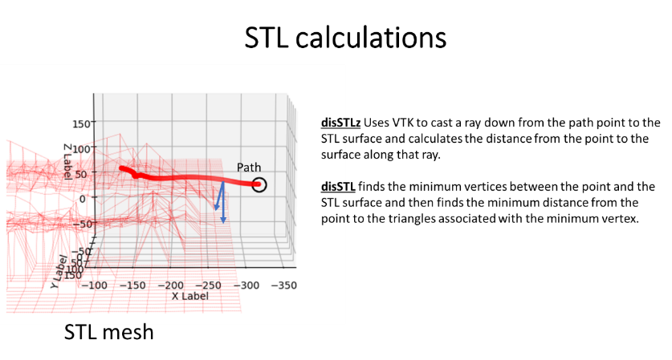

This is a list of paths that will be plotted.

The path will be plotted if there is an “*” in the “ToUse” column. Object numbers 2 and colors 2 are not used with the Number of simultaneous insects is 1 but is used if it is greater than 1.

**Error discussion:**

To get the error for position quantities, $σ_{x}$ for example, I take the standard deviation from the masked data in the convolving average for a point on the path.

The error for numerical differentiation of velocity is

$$\sqrt{2}σ_{x}/∆t$$

where $σ_{x}$ is the error for the position measurements. And for acceleration, the error will be

2 $σ_{x}/{∆t}^{2}$

The error does not propagate well for numerical differentiation, as the limit $∆t$ goes to zero the error becomes infinite. Therefore this error will not be very useful for analysis. Errors are not commonly propagated through differentiation for this purpose.

I also use **PCA anslysis to measure** the error sigmoid from the masked data used to make the average for a point on the path. This gives more geometry for the error distribution for the points. The PCA distribution can be viewed (see below) but the ability to do so is not included in ProjectMain.xlsx. In the program set PlotEllipsoid=True in the function “Plot3Dinsect2(self,PlotDesciptiveDic,DictA,DictErr):”

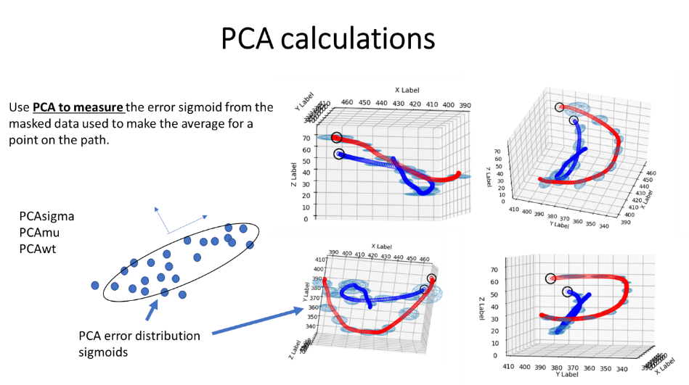

**Velocity calculations**

v = (xt_avg[i + 2] - xt_avg[i]) / ((dt[i + 2] - dt[i])))

$v=\frac{dx}{dt}$

**vxt** = derivative of xt_avg

**vyt** = derivative of yt_avg

**vzt** = derivative of zt_avg

**vv** = speed of velocity magnitude sqrt(vxt ** 2 + vyt ** 2 + vzt ** 2)

**vavg** = speed of velocity magnitude sqrt(vxt_avg ** 2 + vyt_avg ** 2 + vzt_avg ** 2)

**vvt** = derivative of xxt

**vxp** = derivative of the distance from the reference point

**vpvt** = derivative of the path length

**The derivative is thresholded in regards to the time difference**

**acceleration calculation**

a = (xt_avg[i + 2] - 2 * xt_avg[i + 1] + xt_avg[i]) / ((dt[i + 1] - dt[i]) ** 2))

$a=\frac{d^{2}x}{{dt}^{2}}$

**axt =** double derivative of xt_avg

**ayt** = double derivative of yt_avg

**azt** = double derivative of zt_avg

**aa** = speed of velocity magnitude sqrt(vxt ** 2 + vyt ** 2 + vzt ** 2)

**aavg** = speed of velocity magnitude sqrt(vxt_avg ** 2 + vyt_avg ** 2 + vzt_avg ** 2)

**vvt** = double derivative of xxt

**axp** = double derivative of the distance from the reference point

**vpvt** = double derivative of the path length

**Curvature**

curvature= $ℵ=\frac{\left\|\vec{v}×\vec{a}\right\|}{{\left\|\vec{v}\right\|}^{3}}$

curveRadius= $R=\frac{1}{ℵ}$

**Calculations involving the comparison of two coincident paths**

**Distance between two paths** and the corresponding velocity and acceleration

xb

xb_avg

vxb

vxb_avg

axb

axb_avg

For those quantities involving two paths: these all need to be pared with this format: **Name-(number1)-(number2)** with **number1<number2**… That is the name of a kinematic quantity then a **“-“** then another number called **number1**, then a “-“, followed by **number2**. **Number1** must be less than **number 2**.

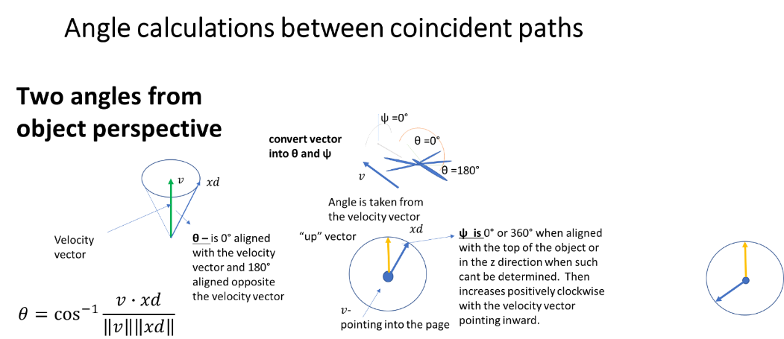

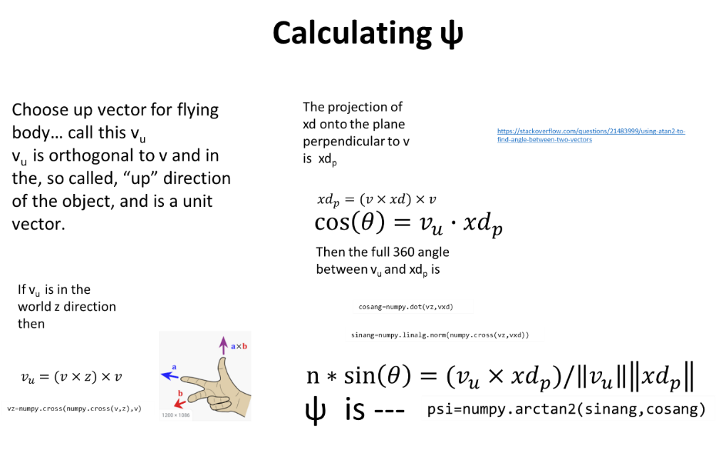

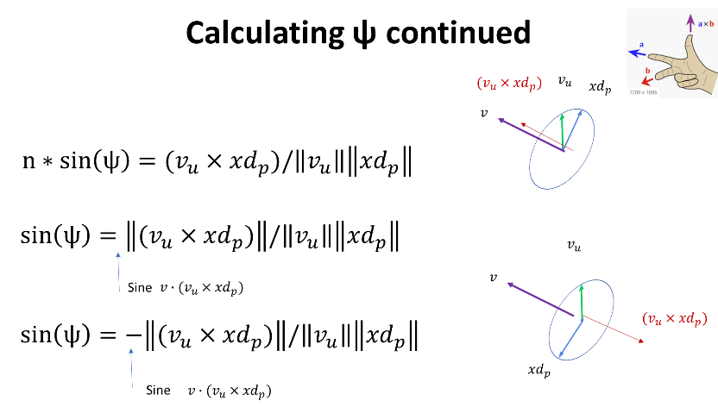

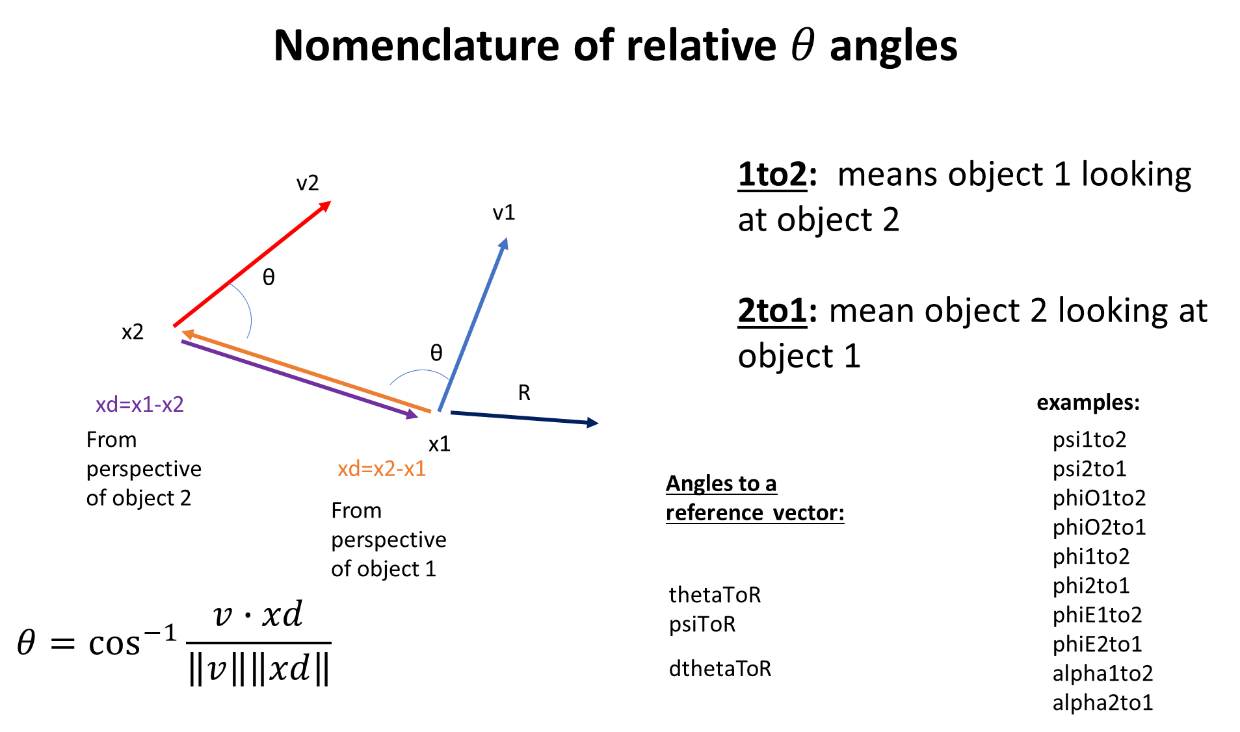

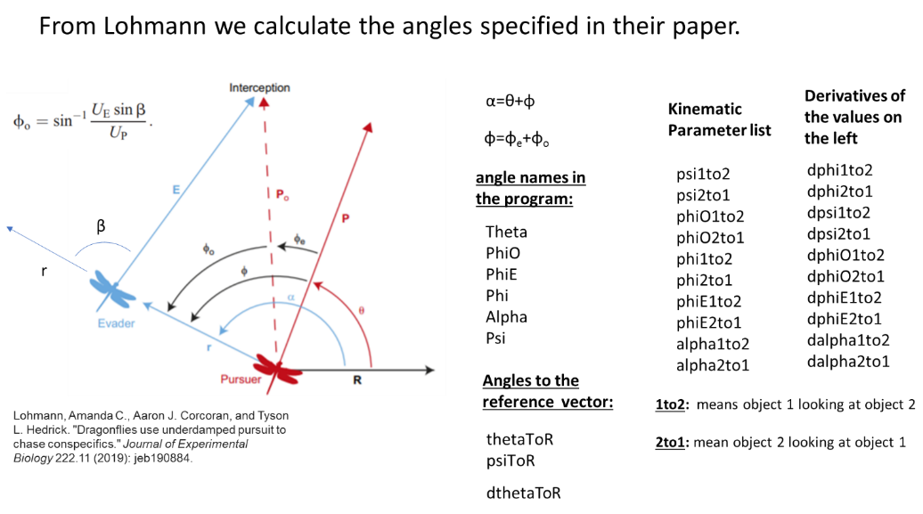

After the graphs are displayed they will need to be closed (or killed) before you can continue with the program.

### **Examples:**

Example 1: Making graphs and box plots of insect paths.

PlottingSheet:

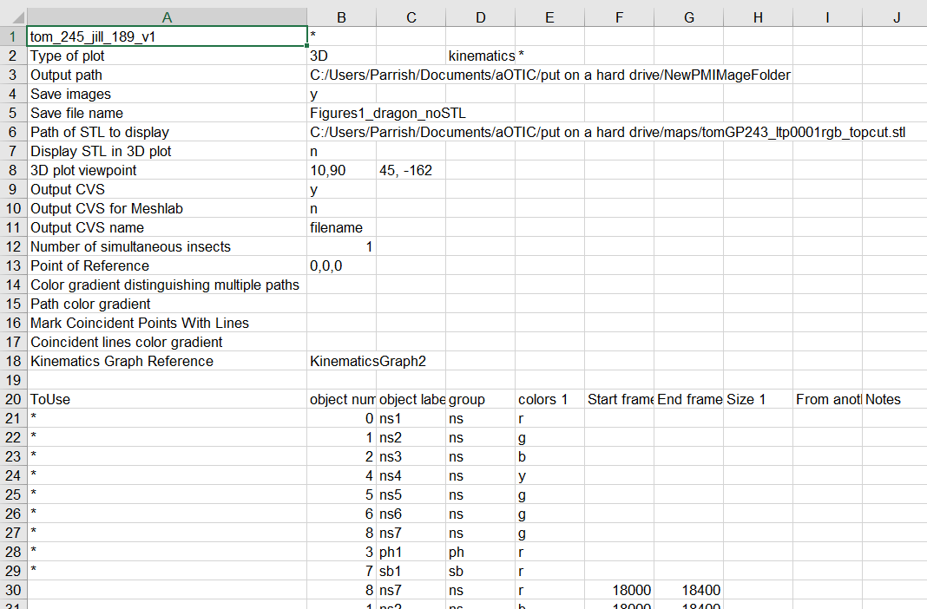

KinematicsGraph2 sheet:

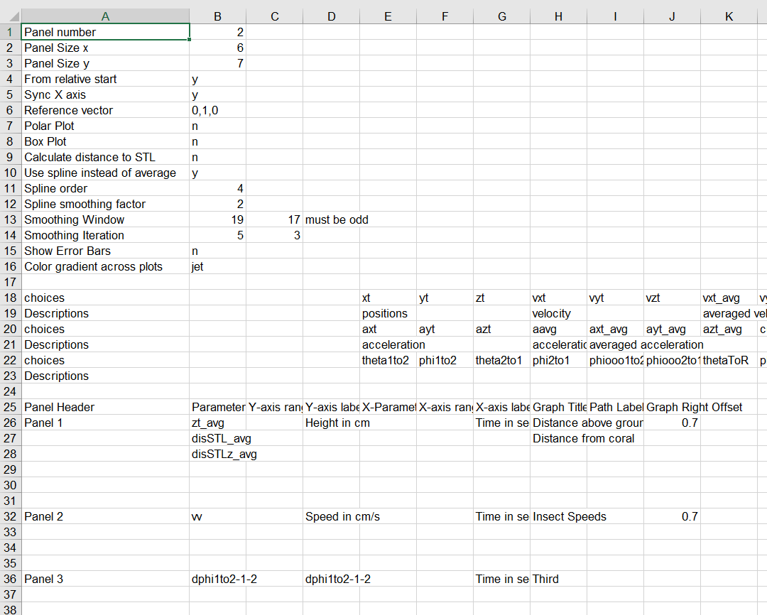

For the box plot change the Box Plot entry to “y”

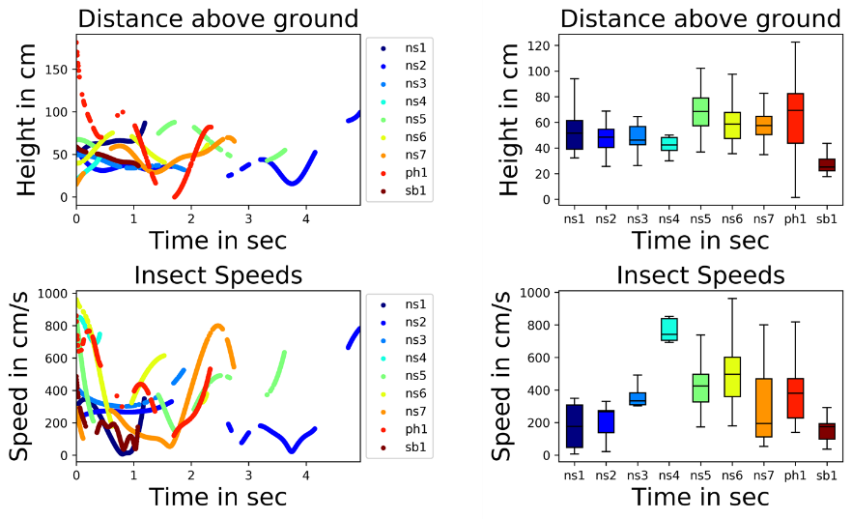

Example 2: Doing a comparison graph of two paths.

PlottingSheet:

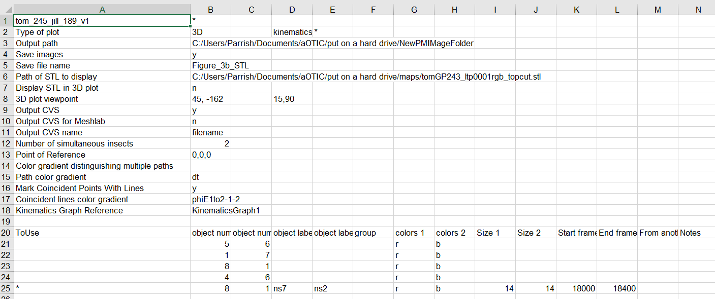

KinematicsGraph1 sheet:

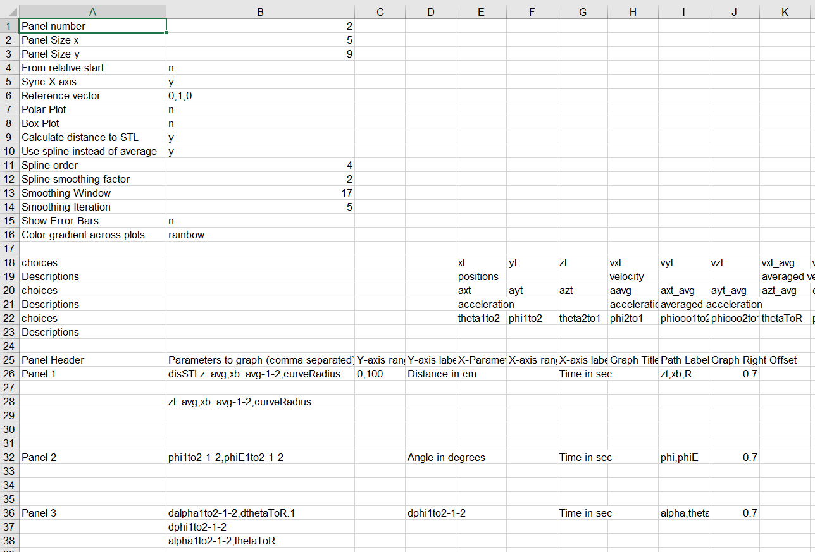

Output

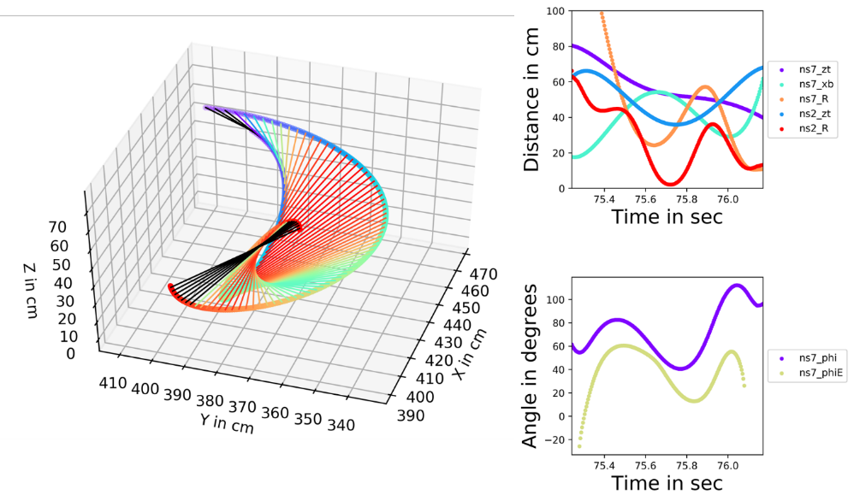

Example 3: Doing a polar plot for two coincident paths.

PlottingSheet:

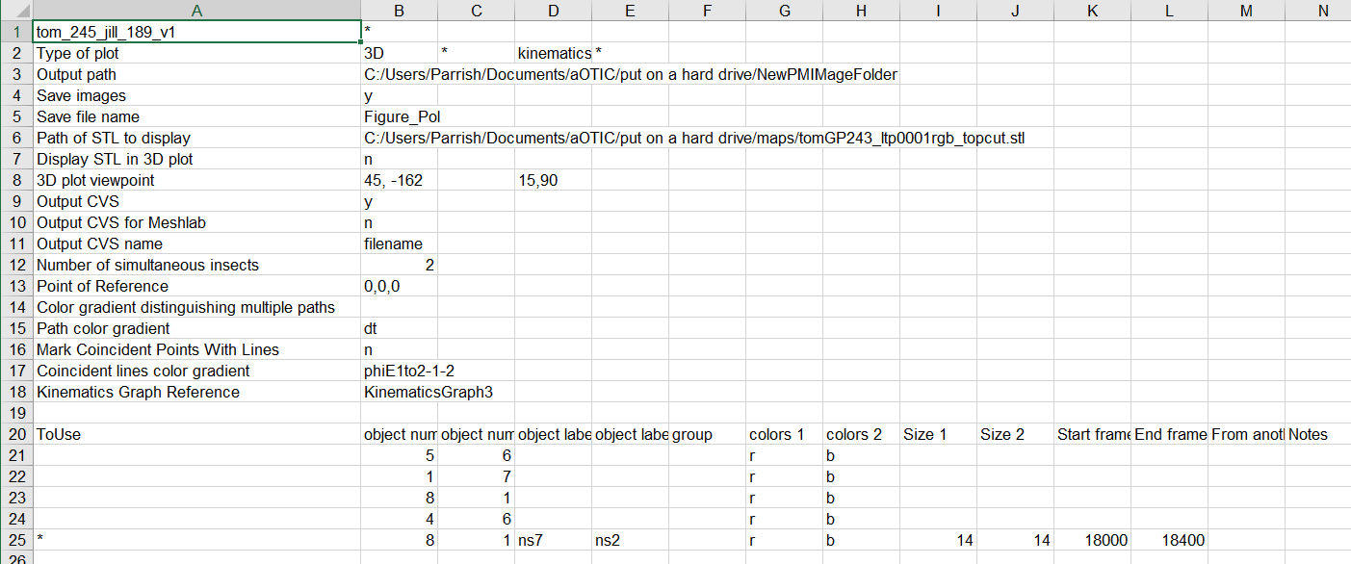

KinematicsGraph3 sheet:

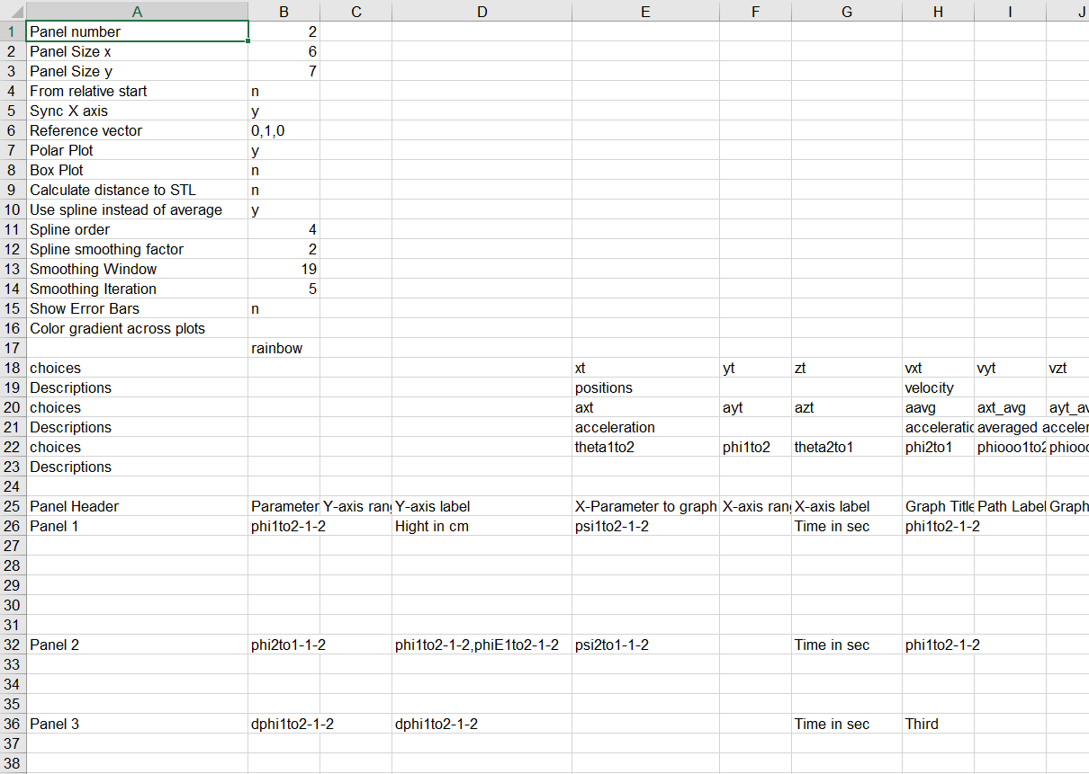

Output:

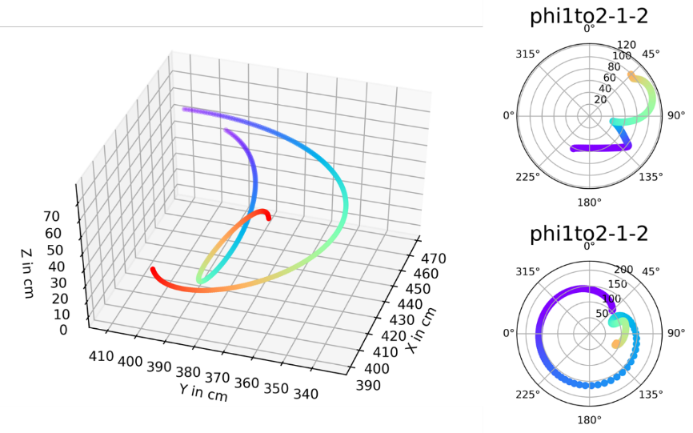

## **Importing and visualizing Paths in Blender:**

Sample of code used to import paths into Blender.

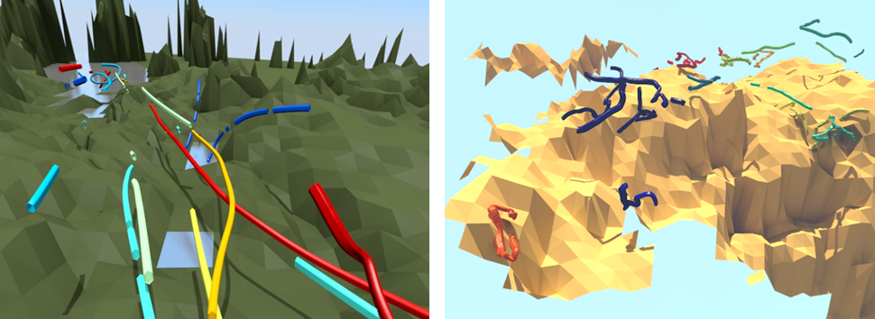

Selecting “Output CVS for Meshlab” on the PlotSheet will make **a “space” separated list** of all points in the 3D plot, with associated colors that can then be imported into Blender using the following script. Only use one path per run on the script. It will import the color also. The STL mesh of the background needs to be imported manually into the program.

import bpy

from mathutils import Euler, Matrix, Quaternion, Vector

from bpy import context, data, ops

import numpy

if 1:

saveFile = "C:/Users/Parrish/Documents/aOTIC/put on a hard drive/maps/"

crds=open(saveFile + "Neonnewpaths.txt")

coords=crds.readlines()

#print (coords)

# create the Curve Datablock

tracki=0

broke=0

while tracki<len(coords)-3:

coordssmall=[]

broke=0

for i in range(len(coords)-1):

if i>tracki:

x= float(coords[i].split(" ")[0])

y= float(coords[i].split(" ")[1])

z = float(coords[i].split(" ")[2])

x1= float(coords[i+1].split(" ")[0])

y1= float(coords[i+1].split(" ")[1])

z1 = float(coords[i+1].split(" ")[2])

diff=numpy.sqrt((x-x1)**2+(y-y1)**2+(z-z1)**2)

if diff<3:

coordssmall.append(coords[i])

#tracki=i

else:

tracki=i

broke=1

break

if broke==0:

tracki=len(coords)-1

curveData = bpy.data.curves.new('myCurve', type='CURVE')

curveData.dimensions = '3D'

curveData.resolution_u = 2

if 1: # map coords to spline

polyline = curveData.splines.new('BEZIER')

polyline.bezier_points.add(len(coordssmall)-1)

for i, coord in enumerate(coordssmall):

x= float(coord.split(" ")[0])

y= float(coord.split(" ")[1])

z = float(coord.split(" ")[2])

rr=float(coord.split(" ")[3])

gg=float(coord.split(" ")[4])

bb=float(coord.split(" ")[5])

polyline.bezier_points[i].co = (x, y, z)

polyline.bezier_points[i].handle_left = polyline.bezier_points[i].handle_right = polyline.bezier_points[i].co

# create Object

curveOB = bpy.data.objects.new('myCurve', curveData)

# attach to scene and validate context

scn = bpy.context.scene

scn.objects.link(curveOB)

scn.objects.active = curveOB

curveOB.select = True

ops.object.mode_set(mode='OBJECT')

if 1:

curve = context.active_object

ops.object.mode_set(mode='OBJECT')

curve_data = curve.data

material = data.materials.new(name=curve.name)

material.diffuse_color = (rr,gg,bb)

curve_data.materials.append(material)

# Store a shortcut to the curve object's data.

obj_data = context.active_object.data

# Which parts of the curve to extrude ['HALF', 'FRONT', 'BACK', 'FULL'].

obj_data.fill_mode = 'FULL'

# Breadth of extrusion.

obj_data.extrude = 1.5

# Depth of extrusion.

obj_data.bevel_depth = 1.5

# Smoothness of the segments on the curve.

obj_data.resolution_u = 20

obj_data.render_resolution_u = 32

## **Overlaying paths on video feed:**

After you press “**q**” you can kill the graphs and then press “**f**” and the paths that were rendered for the graphs will be plotted as an overlay on the video frame. The paths will be updated in position as the video updates, but that will cause the video stream to go very slow. If you want to save the image press “**s**”. It will continuously save the image when you change frames unless you press “**s**” again. It will save it to the path specified in “**Output path**” in the plotting sheet in a folder named “**AnnotatedImages**”

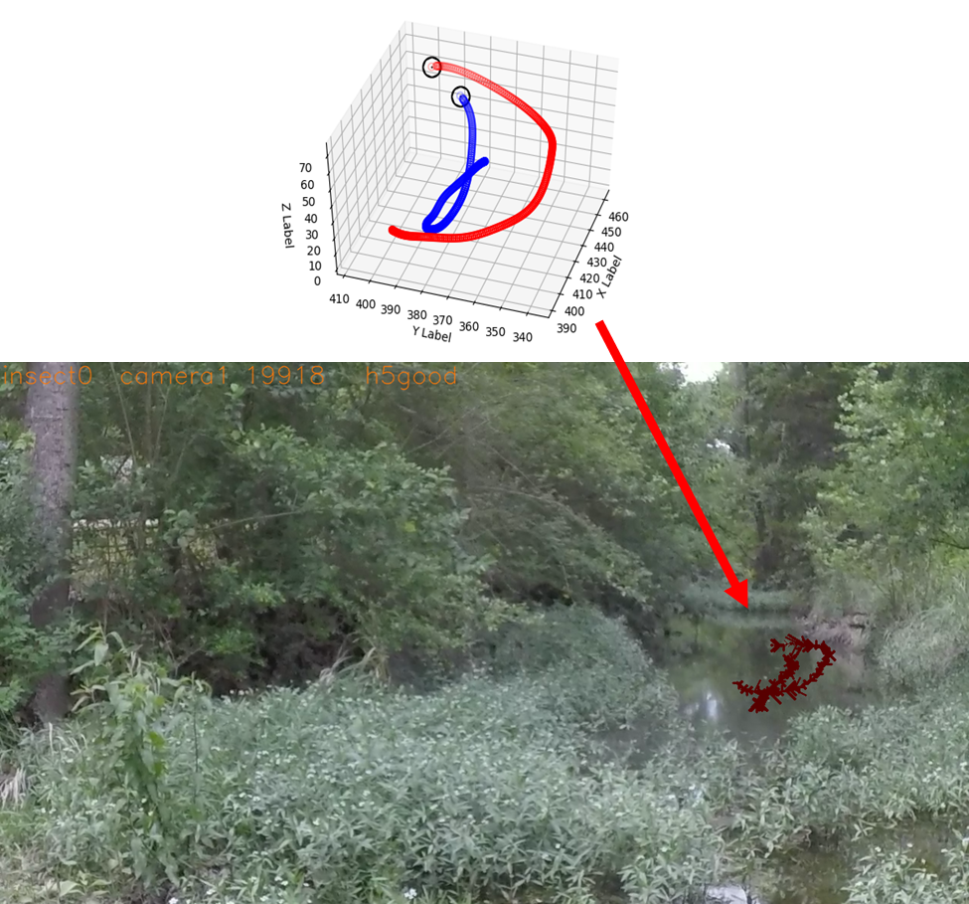

## **Other functionality available to the insect tracking part of the program:**

**Saving features using the key “s”:**

The user will have to specify the saving mode in the program

This functionality is turned on by pressing “s” when saveImagesAsIs is set for 2. This will save the rendered images of the analysis program with all the visible annotations to the folder specified in SingleFramesImages.

## **Hand tracking for GoPro measurements of Squid:**

* “2” and “3” increment squid numbers
* Point 0 is the tip of the squid, point 1 is the right eye (mantel tip forward), point 2 is the left eye (mantel tip forward)

## **Image compilations excel file for MIDOM:**

We use an excel file to organize the images that we use to overlay 3D meshed onto the image and to put polarization information onto the mesh. This is used with mapping image information onto meshes part of the program and not the Tracking from the ORB_SLAM2 program.

* **Name** --- this is a name for the file in case one image is used several times.
* **Video_File_Name** --- This is the main MP4 that these images comer from.
* **Frame_Number** --- the frame number within the large MP4 file.
* **PNG_Full_File_Path** --- this is the combination of the two items just below.
* **PNG_File_Name** --- this is the file name for the image file.
* **PNG_Path** --- this is the path to the PNG file.
* **Image Name** --- this is the H5 file that the polarization and IMU data is stored in.
* **Frame #** --- this is the frame number that the image corresponds to in the polarization H5 file.

## **Hand tracking for 3D overlays of squid, cuttlefish, and fish for MIDOM:**

1. This should be done in connection with another excel file that contains path links to the images that will be studied.
   1. To set up this excel file and the images us this procedure:
      1. The video to get images from needs to be put in a project in Project main in the sheet SingleVideos.
      2. For the button “s” use savefunction = 1. this savefunction is in association with object STL annotations. It saves the image and writes information down in an excel file.
2. There are often several squids on a frame and the frame is therefore repeated several times.
3. There is a powerpoint that lists the names of points that are associated with the eye etc. These points should be annotated onto the squid in the program. There is the nose, and a vent at the bottom of the body cone, there is the center of the eye, and the left, right, top, and bottom boundary of the eye as viewed with the squid being horizontal.
4. Then with the insect points placed between point 20 and 40 the outline of the squid should be made. This should exclude all of the fins and no tentacles. Just around the part of the body that has a smooth predictable shape.
5. You may have to guess on a few of these points. Like the nose when it is facing away from you. The outline part will make it more rigorous
6. Once these points are annotated press “f” to put in the solve PNP function
7. Once these points are annotated press “i” this will fit the outline of the squid and you will be able to tell.
8. An ROI should be made of the background water column (so where the surface of the water and the ocean floor cannot be seen) from ROI’s 40 to 43, and they should follow the solar rays where possible and should be close to the squid.
9. You can make fine adjustments to the mesh using the keyboard but using the following keys: XXXX.

Here is a picture of a squid

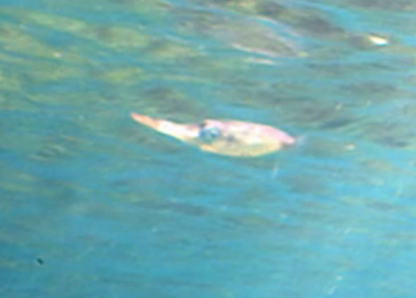

Here we have put on the body specific anotations.

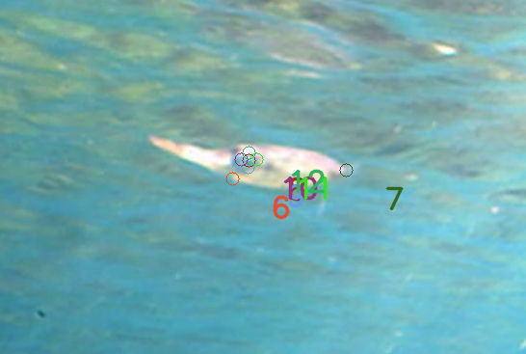

Here we have pressed “f” which performed a PnP calculation and then overlays a projection of the mesh over the squid. The boundary of the mesh is in blue.

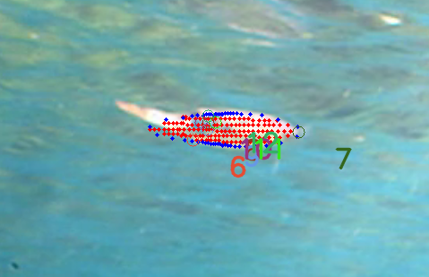

Here we put on points defining the smooth part of the body, (ie no fins or tentacles), put the points (20-39) in regular spaces around the body, with the points exactly on the edge of the body.

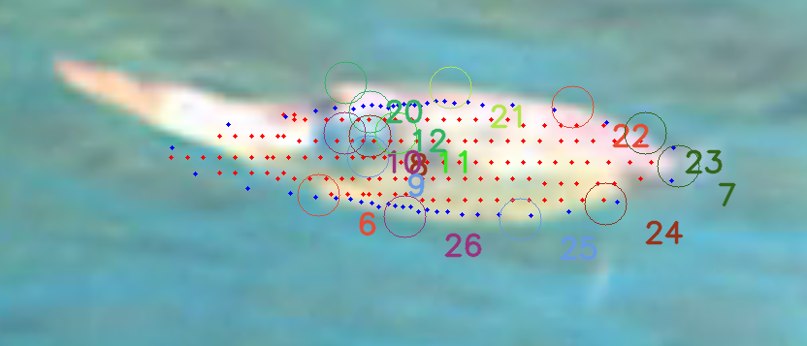

Now you can press “I” and get the mesh will readjust to match the boundary better. Add more points to places that don’t seem to match and try I again.

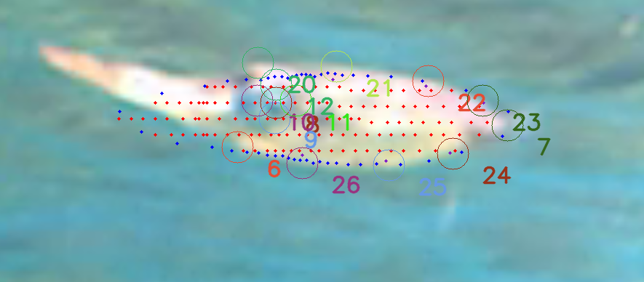

Here are examples of other postions:

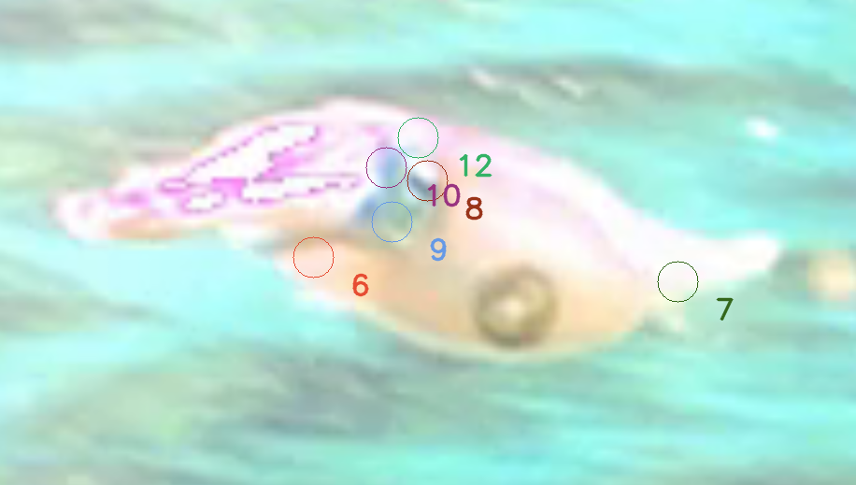

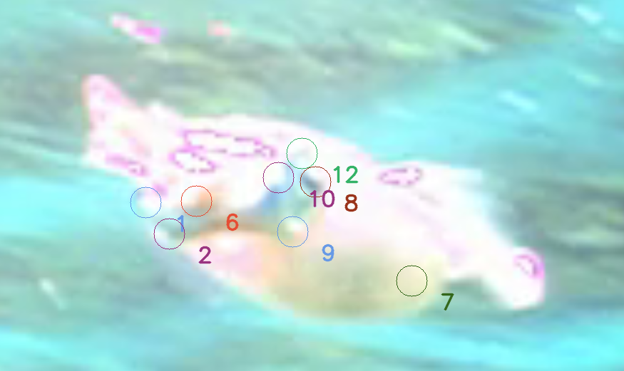

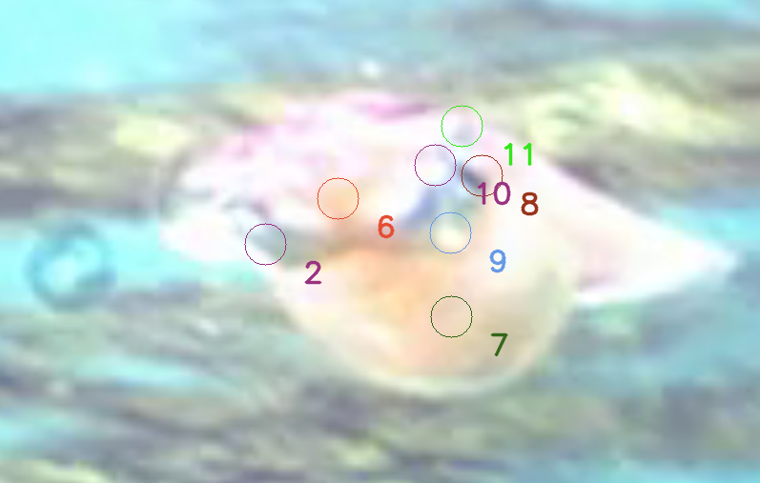

Here are the points to mark out an ROI for the background water column. The numbers will be from 40 to 43 and will move in a clockwise fashion. The line segments 40-41 and 42-43 should be horizontal and the line segments 41-42 and 43-40 should follow the solar rays. These should be placed in the water column below the wave ripples and above the substrate.

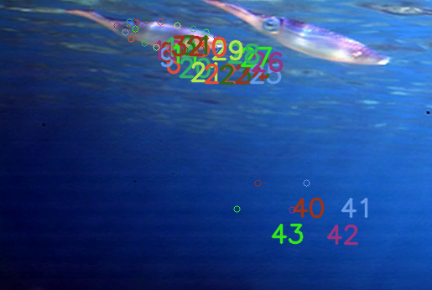

# **Extracting data from the Polarization H5 files for MIDOM:**

From the file ReadSLTpixeloutputFromPolarzationH5190912.py

## **IMU data only:**

# **Description of keys used in the program:**

*Basic protocols for using this program:  
  
For the VSLAM tracking part:*

*List of basic keyboard commands:*

*; goes forward one frame on the video for both cameras*

***l*** *goes backward one frame on the video for both cameras.*

***. or >*** *is fast forward 250 frames for both cameras*

***, or <*** *is rewind 250 frames for both cameras*

***x***  *opens a dialog into which you can put in the desired frame you want to move to. This does not work on a mac.*

***v*** *switches between the two coincident cameras.*

***o*** *goes forward one frame only in camera1 leaving camera2 in the same place.*

***p*** *goes backward one frame only in camera1 leaving camera2 in the same place.*

***SPACE*** *pauses or lets the video run.*

***k***  *Set the program to rewind mode where the video goes backwards during normal tracking procedures. This is much slower than the non-rewind mode because opencv does not have a real rewind feature.*

***BACKSPACE*** *toggles between object tracking mode and fiducial object tracking mode.*

***Double Click*** *on the frame re-centers the frame on that point and leaves the center of the frame available for operations.*

*‘ selects the center point of the frame as a tracked point for the object.*

***End***  *deletes the selected point for the selected insect on the*

*current frame only.*

***\**** *Deletes the entire path of the current insect number on the current video frame, and sets the insect number to empty.*

***n***  *Zooms into the image.*

***m***  *Zooms out of the image.*

***g*** *sets the zoom to none.*

***+*** *merges and computes the tracked paths.*

***h*** *calculates the moving average of all the paths. The length of the average mask can be inputted in the subroutine of the keyboard key.*

***j*** *This goes to various frame numbers along the path, corresponding the to the beginning, 1st quartile, median, 3rd quartile, and the end.*

***[*** *de-increments the current insect number, the insect number is the number used for tracking a particular animal.*

***]*** *increments the current insect number.*

***/*** *goes from tracking mode to error mode. The error mode is not currently being used and may be deleted.*

***d*** *plots the 3D path of the current insect number.*

***Z*** *sets the program to an ergonomic tracking mode where the video frame gets smaller right around the focal point and the object is selected from the mouse position when the mouse moves and then stops for a few seconds. The object is selected and incremented to the next frame with the projected position of the object calculated from the previous two frames. As is does so it plays through several frames before the next frame so the user can see the movement in the video, making the object easier to see.*

*ESC closes out the program, properly and safely closing all the H5 files and saving a backup of the H5 file.*

*s has various images saving possibilities.*

*b this selects for the forward subtraction functionality where the image before is image registered for the current image and subtracted from the current frame. This is not always helpful. The registration does not work too well.*

*w The reflections of animals can be tracked. If you have both the insect and the reflection of the insect in the frame but not the coincident frame. This uses the calculated plane of the water, taken from the orb_map and fitted to a plane. The plane needs to be manually inputted into the program.*

*e This output the paths in the program into a CSV that can be put into Meshlab. Many things still need to be manually put in this routine.*

*r This makes output graphs for the physical properties of the maps. This is still under development.*

*t This gets the fiducial measurements from another project. The path to the other project must be put in manually.*

*y This measures the error of the entire path modified with a subframe delay. This is where you find the optimum subframe delay for your system. It loops through an array of them to find the minimum.*

*I developmental UV map for blender from the video.*

*TAB This saves a sequence of images for crowdsourcing. This was done with a previous functionality that will need to be updated. Where you get approximate pictures for a crowdsourcer to do more finely.*

*1 turns on or off written annotations*

*6 turns on or off the guiding lines*

*7 extracting aolp from polarization videos*

***Squid keys:***

*a This is a selection functionality. In the Squid mode this is used for making the outline of the ROI. check the 9 button for more information.*

*SPACE BAR This sets the video from which the image was taken to run so that one can better determine if the fish is swimming toward the camera or away.*

*p ?????*

*q moves through whether or not the fish is toward the camera, or away from the camera, or parallel to the camera. The q button sequentially moves through these options.*

*Mesh movement buttons:*

*Rotation:*

*y……pitch up*

*u……pitch down*

*t….fish roll negative*

*o….fish roll set to zero*

*r….fish roll position*

*w… fish yaw negative*

*e… fish yaw position*

*translation:*

*b… sends the mesh back*

*h… sends the mesh forward*

*j… sends the mesh right (toward the nose of the mesh)*

*k… sends the mesh left (away from the nose of the mesh)*

*v… sends the mesh down*

*d… sends the mesh up*

*other:*

*f This does a PnP fit between the SLT mesh and the specific marked points on the image. This returns the camera positions for the fit. This can also use a randomization in the inputs to determine an error for the PnP fit.*

*i This does a PnP fit between the SLT mesh and the specific marked points on the image AND the outline of the object selected by the user. This returns the camera positions for the fit. The points are selected from 20 to 39.*

*c ???*

*6 Resets the key points on the image corresponding to the key points on the mesh to the new points from the adjusted mesh.*

*1. Get all of the information correct on in Project main*

1. *put the desired project in the beginning part of the program labeled XXX*
2. *Run the program*
3. *Measure the snap by getting the snap in camera2 to the right place.*

*#For the mesh fitting or Squid part:*

# **The H5 data structure:**

**Data H5 files:**

The data used in this project are stored in H5 files.

They are read with h5py in python or can be read using HDFview.

This data comes from these sources:

My version of ORB_SLAM2

<https://github.com/scorpionjeger/vvtORB_SLAM2>

My version of PATMOS and MIDOM:

<https://github.com/scorpionjeger/vvt>

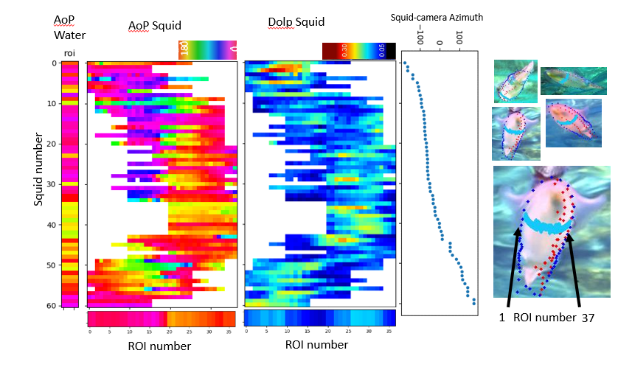

For this figure….

Name Squid_excel.h5 as f

In python the values are access with [] for each hierarchical level as in

f[“STL”][“100”][ "realsquid2.stl"] ["datOrdAltAlt"]

I believe in MatLab you access the levels by STL/100/realsquid2.stl/datOrdAltAlt or something like that.

Camera parameters orientation and location parameters

= datOrdAltAlt = f[“STL”][squid number][ "realsquid2.stl"] ["datOrdAltAlt"]

Here the squid number is an integer that corresponds with the excel row number.

From datOrdAltAlt the location of the camera is

cameraOrgin = array([datOrdAltAlt[9], datOrdAltAlt[10], datOrdAltAlt[11]])

The distance from the camera to the squid in units of squid length is the magnitude of the vector cameraOrgin

the relative azimuth of the camera to the squid is:

arctan2(cameraOrgin[1], cameraOrgin[0]) * 180 / 3.14159

Pitch of the squid

= f[“STL”][squid number][ "realsquid2.stl"] ["PitchTheta"]

Nose of the squid pointing down is a negative value

Each ROI is a list of triangles from the stl file. Each triangle in the STL mesh has a unique id.

Here is a list of all the ROI patterns

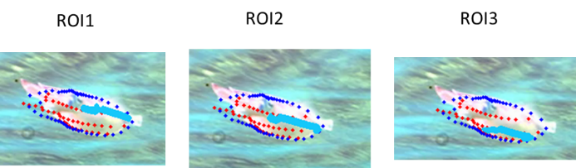

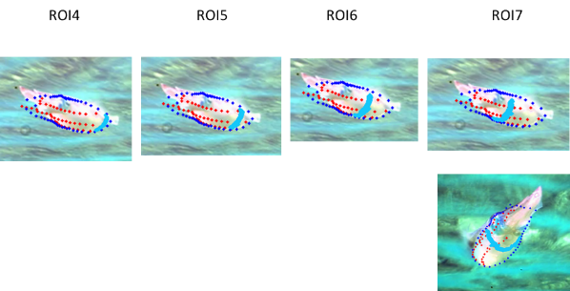

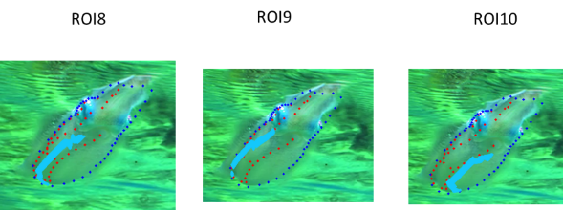

ROI 4 was used in the figure.

Roivalues and roidicMeshID have ordering of the roi “line”

roivalues=f[‘ROI’][str(i)][RoiString + "_data"]

roidicMeshID=f[‘ROI’][str(i)][RoiString + "_IDs"]

roivalues for each mesh triangle is an average of a 3x3 matrix for S0,S1,S2 in RGB respectively.

When comparing the ROI for each squid one must keep the order of the ROI segments and compare other squid measurements with the same ROI mesh index.

## **Organization of Squid_excel.h5 for MIDOM**

**Top hierarchy of keys:**

[u'ROI', u'STL', u'data', u'header']

**u'ROI':** A data structure for polarization data associated with pre-determined ROIs.

Keys for ROI as of 11/28/18:

[u'103', u'129', u'135', u'139', u'146', u'160', u'162', u'172', u'192', u'197', u'276', u'306', u'308', u'322', u'330', u'334', u'341', u'344', u'348', u'351', u'357', u'367', u'370', u'374', u'382', u'384', u'390', u'394', u'404', u'41', u'410', u'417', u'43', u'452', u'454', u'469', u'504', u'522', u'538', u'541', u'561', u'57', u'579', u'583', u'587', u'592', u'604', u'609', u'61', u'62', u'75', u'79', u'80', u'81', u'82', u'83', u'84', u'85', u'87', u'90', u'99', u'ROI1', u'ROI10', u'ROI2', u'ROI3', u'ROI4', u'ROI5', u'ROI6', u'ROI7', u'ROI8', u'ROI9']

Those marked ROI# contain the STL mesh information for the ROI segments and are used to produce the data in the numbered spots.

The keys for ROI# are:

[u'CameraInfo', u'LineOut', u'ROI cell list']

u'CameraInfo' is the camera parameters used to make the ROI

u'LineOut' is the line out that was used to find the mesh list for the ROI

u'ROI cell list' the list of mesh numbers in the ROI and it is ordered in the order specified by the line out.

The numbered items listed under ROI are associated with the squid number or an individual squid.

In each is listed datasets named ROI#_IDs and ROI#_data

ROI#_IDs is a list of the ROI mesh id’s that were visible in the frame. They are in the same order as the original list.

ROI#_data has the average Stokes value for each mesh. Listed in a 3x3 matrix for S0,S1,S2 in RGB respectively.

ROITot is the ID’s for all visible meshes.

ROIWC_data is the average RGB stokes value for the water column

ROIWC_Angles are the angles of the solar rays associated with the ROI.

**u'STL'**: This is a group….

Keys under STL as of 11/28/18

[u'1', u'103', u'129', u'135', u'139', u'146', u'160', u'162', u'172', u'192', u'197', u'2', u'20', u'276', u'28', u'3', u'306', u'308', u'322', u'330', u'334', u'341', u'344', u'348', u'351', u'357', u'367', u'370', u'374', u'382', u'384', u'390', u'394', u'4', u'404', u'41', u'410', u'417', u'43', u'452', u'454', u'469', u'504', u'522', u'538', u'541', u'561', u'57', u'579', u'583', u'587', u'592', u'604', u'609', u'61', u'62', u'75', u'79', u'80', u'81', u'82', u'83', u'84', u'85', u'87', u'90', u'99']

These numbers contain the keys [u'SquidExcelDetails', u'realsquid2.stl']

u'SquidExcelDetails' contain the details for the excel file where the Squid images are called

The group “realsquid2.stl” is named after the SLT that is used for the squid.

[u'0', u'1', u'10', u'100', u'1000', u'1001', u'1002', u'1003', u'1004', u'1005', u'1006', u'1007', u'1008', u'1009', u'101', u'1010', u'1011', u'1012', u'1013', u'1014', u'1015', u'1016', u'1017', u'1018', u'1019', ………………

u'988', u'989', u'99', u'990', u'991', u'992', u'993', u'994', u'995', u'996', u'997', u'998', u'999', u'CameraRoll', u'PitchTheta', u'RotAroundY', u'datOrdAlt', u'datOrdAltAlt']

u'CameraRoll' this is the camera roll which is assumed to be 0.

u'PitchTheta', This is the pitch of the squid after the optimization calculation

u'RotAroundY' This is the rotation matrix for PitchTheta

u'datOrdAlt', camera parameters before rotation optimization

u'datOrdAltAlt' camera parameters after rotation optimization

in each number:

[u'CellMesh', u'PixelArray', u'PixelWeight', u'areaTriangle', u'clipPOlygon']

u'CellMesh', The triangle coordinates in3D space

u'PixelArray', The array containing all the pixels in the projected CellMesh

u'PixelWeight', How much of each square pixel is in the projected triangle. For averaging purposes

u'areaTriangle', Pixel area of the projected triangle.

u'clipPOlygon' The pixel coordinates of the projected triangle.

**u'data':** This is a group that contains all the annotations for the key body parts of the squid.

Under data:

[u'camera1', u'camera2', u'combined']

Both u'camera2' and u'combined' are empty

u'camera1' is the list of annotations listed under “insect#” which is used to mark each important part of the squid.

**u'header':** Contains the camera calibration information for the system.

Under header

[u'Camera1CalibrationValue', u'Camera2CalibrationValue']

## **Organization of the H5 file used in GoPro-VSLAM tracking for PATMOS**

**Top hierarchy of keys:**

* **data** --- this is separated into camera1, camera2, and combined groups. The camera groups contain the pixel information for the tracked points on the path, and the combined group contains the calculations of combining the two paths.
  + **camera1** --- each camera group is divided into groups of animal paths that are labeled as insect#.
    - **insect0** --- this is an example insect# and it is divided up into frame numbers of the video frame.
    - **18050 ---** contains an array for each frame number with the first two being the x and y pixel value and the last two being the x and y pixel error. For example: [814.3,704.4,4.0,4.0]
    - **insect1**
    - **insect2**
    - **insect3**
    - **fiducial0_10** 
      * **43465** --- contains an array for each frame number with the first two being the x and y pixel value and the last two being the x and y pixel error. For example: [814.3,704.4,4.0,4.0]
      * **43476**
  + **camera2** --- similar to camera1
  + **combined** --- this is organized into the calculations of each tracked object.
    - **fiducial0_T** --- This is the result of the fiducial calculation.
      * **Fiducial_Rotation** --- This is the rotation matrix from the virtual frame to the Fiducial measurement frame.
      * **Fiducial_Translation** --- This is the translation vector from the virtual frame to the Fiducial measurement frame.
      * **Fiducial_fromMinClasicRotMat** ---
      * **Fiducial_fromMinClasicRotMatParams** ---
      * **Fiducial_fromMinClasicRotMatTrans** ---
    - **fiducial0_2_fiducial0_2 ---** This is an example measurement for fiducial point 2. 
      * **38295 ---** This is the frame number on a particular measurement
        + **3Dpoint** --- this is the average of the points cloPo1 and cloPo2
        + **3DpointError** --- this is half the distance between the points cloPo1 and cloPo2
        + **CameraAngularError1** --- this is an error for the angular part of the measurement. Was used with the Kalman filter.
        + **CameraAngularError2** --- this is an error for the angular part of the measurement. Was used with the Kalman filter.
        + **CameraOriginError1** --- this is an error for the angular part of the measurement. Was used with the Kalman filter.
        + **CameraOriginError2** --- this is an error for the angular part of the measurement. Was used with the Kalman filter.
        + **Error1** --- this is the error of pixel point of the tracked object from camera 1 in a 2D array … [Pixel x error value, Pixel y error value]
        + **Error2** --- this is the error of pixel point of the tracked object from camera 2 in a 2D array … [Pixel x error value, Pixel y error value]
        + **PixelErrorAngle1** --- propagated error from the pixel error
        + **PixelErrorAngle2** --- propagated error from the pixel error
        + **cameraData1** --- this is the vector containing the position data for camera 1 in the current frame.
        + **cameraData2** --- this is the vector containing the position data for camera 2 in the current frame minus the framedelay.
        + **cloPo1** --- is the point of closest approach on the line defined by the camera1 origin and the vector pointvect1 to the line defined by the camera2 origin and the vector pointvect2.
        + **cloPo2** --- is the point of closest approach on the line defined by the camera2 origin and the vector pointvect2 to the line defined by the camera1 origin and the vector pointvect1.
        + **point1** --- this is the pixel point of the tracked object from camera 1 in a 2D array … [Pixel x value, Pixel y value]
        + **point1Error** --- this is the error of pixel point of the tracked object from camera 1 in a 2D array … [Pixel x error value, Pixel y error value]
        + **point2** --- this is the pixel point of the tracked object from camera 2 in a 2D array … [Pixel x value, Pixel y value]
        + **point2Error** --- this is the error of pixel point of the tracked object from camera 2 in a 2D array … [Pixel x error value, Pixel y error value]
        + **pointvect1** --- this is the vector emanating from the camera 1 origin through the pixel value into the virtual world.
        + **pointvect2** --- this is the vector emanating from the camera 2 origin through the pixel value into the virtual world.
      * **43476**
      * **FrameDelay** --- delay in frames between the two cameras
    - **insect0_insect0** --- this is an example measurement from the combination of both cameras for object 0. It is organized in frame numbers based on the frame in camera 1. 
      * 18972
        + **3Dpoint** --- this is the average of the points cloPo1 and cloPo2
        + **3DpointError** --- this is half the distance between the points cloPo1 and cloPo2
        + **CameraAngularError1** --- this is an error for the angular part of the measurement. Was used with the Kalman filter.
        + **CameraAngularError2** --- this is an error for the angular part of the measurement. Was used with the Kalman filter.
        + **CameraOriginError1** --- this is an error for the angular part of the measurement. Was used with the Kalman filter.
        + **CameraOriginError2** --- this is an error for the angular part of the measurement. Was used with the Kalman filter.
        + **Error1** --- this is the error of pixel point of the tracked object from camera 1 in a 2D array … [Pixel x error value, Pixel y error value]
        + **Error2** --- this is the error of pixel point of the tracked object from camera 2 in a 2D array … [Pixel x error value, Pixel y error value]
        + **KalmanCov** --- this is the Kalman covariance which is not currently used.
        + **KalmanPoint** --- this is the point defined by the Kalman calculation with is not currently used.
        + **MovingAveragePoint** --- This is the moving average point for the path which is currently used.
        + **PixelErrorAngle1** --- propagated error from the pixel error
        + **PixelErrorAngle2** --- propagated error from the pixel error
        + **cameraData1** --- this is the vector containing the position data for camera 1 in the current frame.
        + **cameraData2** --- this is the vector containing the position data for camera 2 in the current frame minus the framedelay.
        + **cloPo1** --- is the point of closest approach on the line defined by the camera1 origin and the vector pointvect1 to the line defined by the camera2 origin and the vector pointvect2.
        + **cloPo2** --- is the point of closest approach on the line defined by the camera2 origin and the vector pointvect2 to the line defined by the camera1 origin and the vector pointvect1.
        + **point1** --- this is the pixel point of the tracked object from camera 1 in a 2D array … [Pixel x value, Pixel y value]
        + **point1Error** --- this is the error of pixel point of the tracked object from camera 1 in a 2D array … [Pixel x error value, Pixel y error value]
        + **point2** --- this is the pixel point of the tracked object from camera 2 in a 2D array … [Pixel x value, Pixel y value]
        + **point2Error** --- this is the error of pixel point of the tracked object from camera 2 in a 2D array … [Pixel x error value, Pixel y error value]
        + **pointvect1** --- this is the vector emanating from the camera 1 origin through the pixel value into the virtual world.
        + **pointvect2** --- this is the vector emanating from the camera 2 origin through the pixel value into the virtual world.
      * **18973**
      * **18974**
      * **FrameDelay** --- delay in frames between the two cameras
    - **insect1_insect1**
    - **insect2_insect2**
    - **insect3_insect3**
* **header** 
  + **Camera1CalibrationValue** --- this is the camera calibration array for camera 1
  + **Camera2CalibrationValue** --- this is the camera calibration array for camera 2

## **OBR_SLAM2 output h5 file for PATMOS:**

* **F10000** --- The data entries are listed by video frame number listed with and F before the number
  + **CameraPos** --- Camera position data with values labeled in the header below.
  + **MapData** --- Map data with values labeled in the header below.
* **F10001**
* **F10002**
* **F10003**
* **header** 
  + **CameraCalibrationHeader** --- This is the description of the camera calibration array given in CameraCalibrationValue.
    - **fx**
    - **fy**
    - **cx**
    - **cy**
    - **k1**
    - **k2**
    - **p1**
    - **p2**
    - **k3**
  + **CameraCalibrationValue**
  + **camera header** --- This is the array in ORB_SLAM2 that contains the camera position at each frame.
    - **TwcClone.m[0]** --- X axis of the camera (x coordinate)
    - **TwcClone.m[1]** --- X axis of the camera (y coordinate)
    - **TwcClone.m[2]** --- X axis of the camera (z coordinate)
    - **TwcClone.m[4]** --- Y axis of the camera (x coordinate)
    - **TwcClone.m[5]** --- Y axis of the camera (y coordinate)
    - **TwcClone.m[6]** --- Y axis of the camera (z coordinate)
    - **TwcClone.m[8]** --- Z axis of the camera (x coordinate)
    - **TwcClone.m[9]** --- Z axis of the camera (y coordinate)
    - **TwcClone.m[10]** --- Z axis of the camera (z coordinate)
    - **TwcClone.m[12]** --- camera origin position (x coordinate)
    - **TwcClone.m[13]** --- camera origin position (y coordinate)
    - **TwcClone.m[14]** --- camera origin position (z coordinate)
  + **map header** 
    - **i** --- an indexing for the map points currently in the map.
    - **Max num of points or n** --- the maximum number of points currently in the map.
    - **Observations** --- the number of times the map point has been observed.
    - **mnId** --- this is the ID of the map point
    - **nNextId** --- this is the next ID that will be assigned to a map point.
    - **World vector x** --- This is the position of the map point in the virtual world
    - **World vector y**
    - **World vector z**
    - **Pixel x** --- This is the pixel value corresponding to the map point
    - **Pixel y**
    - **Blue** --- RGB values of the pixel
    - **Green**
    - **Red**
    - **NormalVector x** --- This is a normal vector assigned to the point in ORB_SLAM2 but it seems to only be the difference vector between the map point and the camera origin.
    - **NormalVector y**
    - **NormalVector z**
    - **map point ref KF** --- reference of the Key Frame the map point was created in.
    - **Last Frame Seen**

# **Glossary:**

* **1080p or 720p** --- The p stands for a progressive scan of a camera as opposed to interlaced. In this mode, the camera takes the picture line by line as opposed to every other line for each consecutive pair of frames. The Number 1080 or 720 stands for the number of vertical lines.
* **Anaconda** --- a python platform created by Continuum that attempts to bring all opensource python tools under one framework. It makes it easier to install dependencies for python programs
* **cartesian coordinates** --- Standardized structure of coordinates for the use of making maps and other standardized two- and three-dimensional measurements.
* **codec** --- specialized compression paradigm for video files.
* **Conda** --- conda is a command used in Anaconda to accomplish activities such as program installations.
* **co-visible** --- covisability is a word coined for VSLAM programs. Map points are co-visible if they are viewed by more than one key frame. Each map point is associated with at least one keyframe, and a Keyframe contains a group of points visible in that frame. Two points are co-visible if the intersection of the sets of all points associated with the keyframes of both points is non empty.
* **Epipolar line** --- The epipolar line is associated with two cameras viewing the same space. In this scenario the epipolar line on one camera’s frame is the imaginary line that would be viewed from this camera if the line were to originate from the other camera and emanating through a specific pixel on that other camera.
* **Fiducial Object** --- and object that is used for spatial reference
* **fps** --- frames per second, the number of frames filmed by a camera per second.
* **GUI** --- Graphical user interface, or an interface to a program where the user can interact with shapes and structures instead of written commands.
* **Key Frame** --- an important frame in VSLAM calculations where the points are added into the map.
* **Mesh** --- The representation of a geometrical surface in three dimensions piecewise comprised of two-dimensional polygons such as triangles.
* **Moving averages** --- averages along a data path where the average consists of the average of all values a certain number, n, of data points before and behind the central value in time.
* **ORB** --- Oriented Fast Rotated Brief, this is a computer vision enabled feature detector and feature descriptor on images.
* **PCA ---** Principle component analysis. A statistical technique that searches for the principle coordinates, or natural coordinates, of a data set.
* **Pixel position** --- an image is made up of a pixel coordinate system. The pixel position is the x-y vertical horizontal coordinates of the image.
* **PnP --- Perspective from n Points** is the programmatic procedure for getting the pose of a camera for the 3D perspective of an image from the measurement of pixel values that correspond to the 3D values of an object.
* **Point Cloud** --- a group of points in three-dimensions that can approximate a three-dimensional structure.
* **SLAM** --- Simultaneous Localization and Mapping. This is a computational paradigm, originated in the field of robotics, where the moving device maps the area it is in while simultaneously measuring where the device is in that environment with a set of environmental position measuring sensors.
* **Spline** --- A spline is a piecewise function of joined polynomials.
* **Standard Tessellation Language (STL) surface** --- A specialized paradigm of listing values of the vertices, faces, and edges of a mesh that can be programmatically accessed.
* **RGB** --- red green and blue components of an image
* **VSLAM** --- Visual Simultaneous Localization and Mapping, this is a method of SLAM that uses a camera as the measurement device.
* **YAML** --- YAML Ain't Markup Language. Yes, that is the name of the acronym. It is a data input paradigm for many programing languages.